Build Instructions:

A robotic wheelchair headrest that will follow the user’s head to provide the head with continuous lateral support

Developed by: Cliff Stephenson, Chris Fryer, Nick Fryer, Rafael Moya Castro, Lilith Cabalero Aguilar, Anthony Canepa, Juan Polanco, Daniel Prohasky, Peter McKenzie

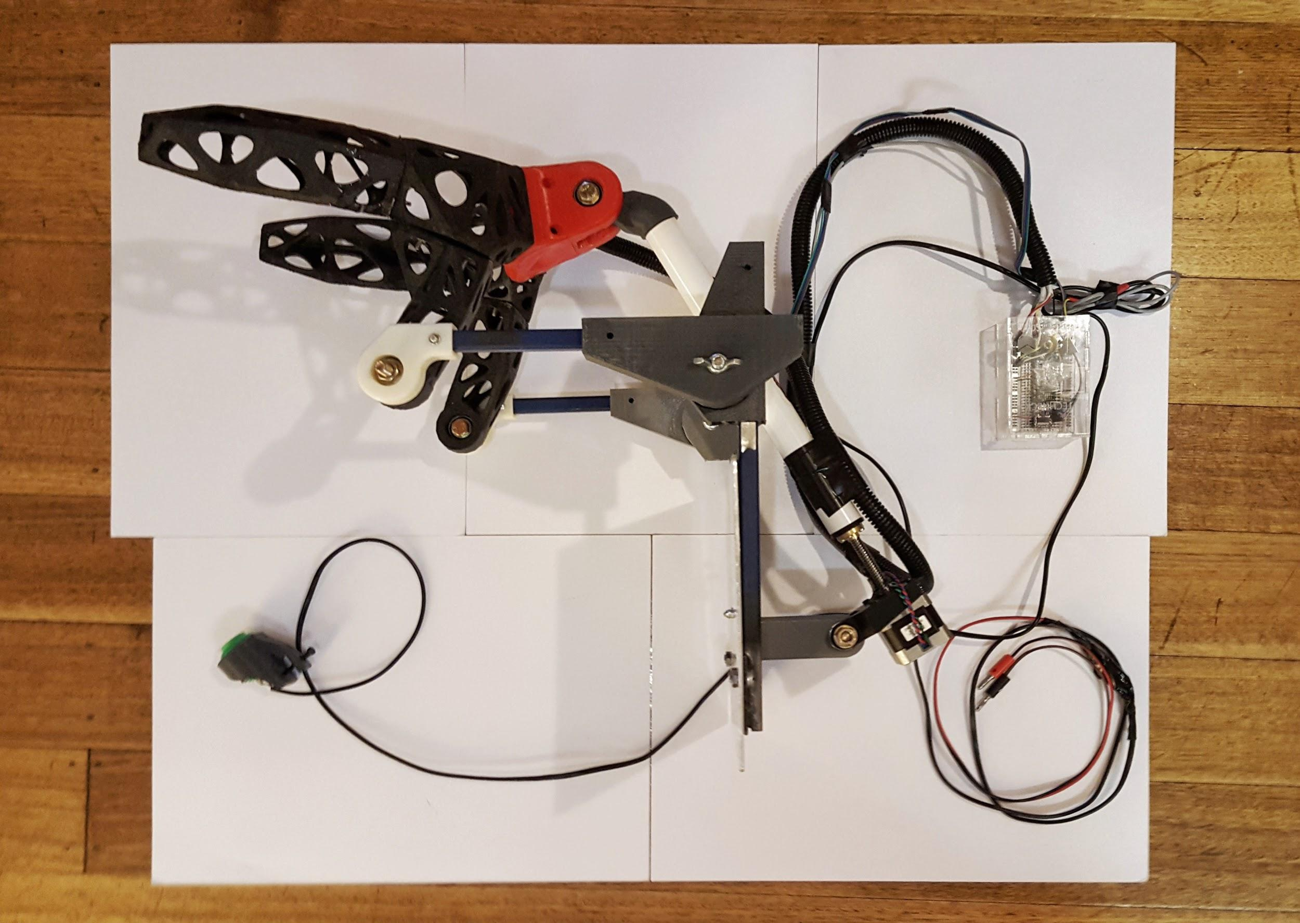

Approximate Cost: $352 AUD Time Required: 2 days

General Warnings and Cautions
- Read through entire manual before attempting to build this device.
- Do not attempt a step if you are unsure of what you are doing. Certain steps in this manual require experience with fabrication tools. <<General Warning>>. For assistance or clarification of any step, contact Insert contact info here.

User Assistance
For any questions regarding the assembly, operation, or specifications of this device, please visit Insert project website URL. You can also contact send an email to Email Address or call Phone number.

Icon Glossary
The following icons may be used throughout this manual—each with its own purpose.
- Caution: The caution icon is used to signify whenever someone attempting the procedure may injure themselves or damage their equipment.
- Note: The note icon is used to signify useful bits of information that complement the instructions.
- Reminder: The reminder icon is used to provide information for after the procedure is completed, such as tips for disassembly.

Purpose of Device:
Current wheelchair headrests have rigid mounting systems which limits its ability to provide the support to the user’s head when he or she wants to change posture. This can cause the user pain and discomfort when the user wants to bend forward but doesn’t have the muscular strength to control their head’s position. The robotic head rest is designed to provide the lateral support to the head as the user bends forward and back in their wheelchair. This can reduce pain and discomfort for the user and also increase their ability to move their head into the position they want.

Physical Description:
The robotic head rest is an electro-mechanical system that uses sensors that read’s the position of the head to control a motor that would pivot the head rest forward and backwards.
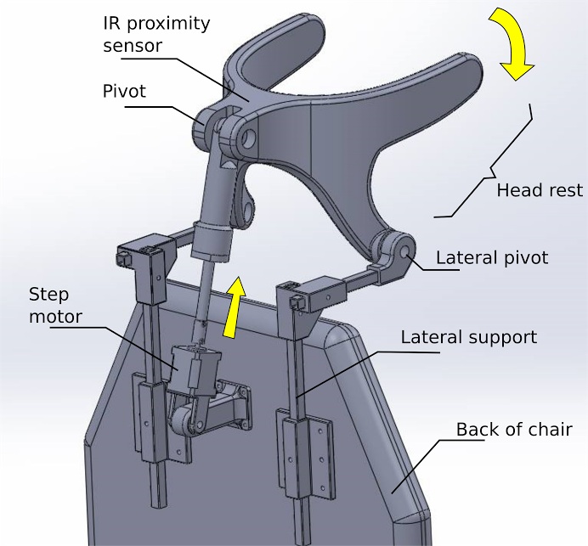
The sensor that reads the head’s position is an infrared (IR) proximity sensor embedded into the centre of a custom-made head rest. This sensor will send the distance between the back of the head rest and the back of the user’s head to an Arduino. The Arduino then processes the signal from the proximity sensor to filter noise. As shown in the image below, the Arduino will change the speed and direction of the motor depending on the distance between the sensor and the back of the head. For example; if it is greater than five centimetres, the headrest will move forward to meet the head’s new position. Additionally, if it is between five centimetres and two centimetres, then the headrest will not move because the headrest is in the ideal position in reference to the head.
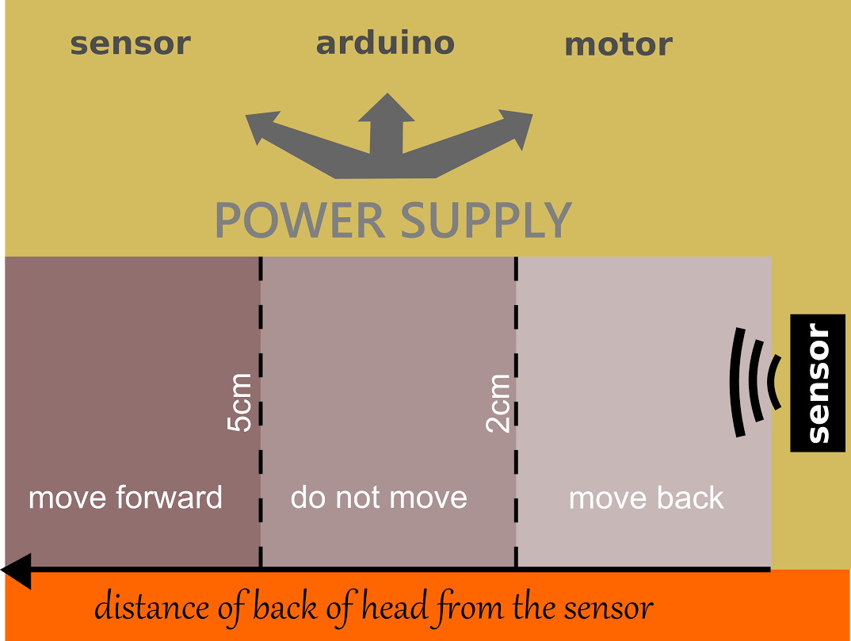
The motor is connected to a lead screw that will move the posterior pivot point of the head rest up or down. The other pivot of the head rest is a stationary point that allows only allows rotary motion which causes the head rest to rotate in the same plane that the user’s head will move to. This restriction of motion is critical as it provides lateral support to the head by preventing the user to move their head laterally. From interviewing a small population of need-knowers, it was found that rotating the wheelchair itself to face the user in different directions is acceptable and the current method used today.
This system is mounted onto a metal plate that has standard mounting holes to on the back of most wheelchairs. Most parts of the mounting system are comprised of 3D printed guide rails, and aluminium rods and brackets. The position of the brackets can be moved to adjust the pivot points to suit the user’s body structure and range of motion. Additionally, the system can be rotated away from the user at two hinge points to allow the user to be hoisted away from the wheelchair with speed and ease.
Furthermore, the user can mount a button near their joystick to control the system. Pressing the button once will initiate and return the system to start from its most upright position. Pressing the button again will engage the system for when the user is ready to use it again.

History of Development:
The project began at the TOM: Melbourne Makeathon by gathering a need-knower named Christian, his carer, and a group of compassionate engineers, architects and designers. The need-knower and his carer told the group that the carer attempted to create such a system but needed help to implement the idea. By using the technical knowledge, the skills and creativity of the entire team, the idea of the head rest was designed, built and tested over the 72-hour TOM Makeathon.
The results showed immediate benefits to the user after 20 minutes of practise. The need-knower was extremely happy that a working system was made that could already provide lateral support to the user’s head when they bend their neck. Nevertheless, the system needs to improve to make it a viable everyday system. Such improvements needed are: connecting the system directly to the wheelchair’s power supply, verification from an expert on the physiological effects of the system, stronger motor, and a more comfortable headrest.

Bill of Materials

Product Name
Assembly Name: |  |  |  | Approval Date:
Assembly Number: |  |  |  | Part Count:
Assembly Revision: |  |  |  | Total Cost:
Part ID | Part Name | Description | Qty | Units | Supplier | Unit Cost | Cost
A | Stepper motor with linear action | Stepper Motor with 28cm Lead Screw: Bipolar, 200 Steps/Rev, 42×38mm, 2.8V, 1.7 A/Phase | 1 |  | Core Electronics | $81.59 | $81.59
B | Stepper motor driver | DRV8825 Stepper Motor Driver Carrier, High Current | 1 |  | Core Electronics | $12.04 | $12.04
C | CPU | Nano V3.0 Board (Arduino Nano V3.0-Compatible) | 1 |  | Core Electronics | $15.17 | $15.17
D | Proto board | Breadboard - Translucent Self-Adhesive (Clear) | 1 |  | Robotgear | $7.54 | $7.54
E | Range sensor | Sharp Analog IR Distance Sensor GP2Y0A41SK0F (GP2D120) (4cm-30cm) | 1 |  | Robotgear | $15.95 | $15.95
F | Range sensor cable assembly | 3 Pin JST PH connector and cable for Sharp sensors | 1 |  | Robotgear | $1.65 | $1.65
G | End stop | Switch SPDT Snap Action with 15.6mm Bump Lever | 2 |  | Robotgear | $1.20 | $2.40
H | Voltage regulator - for Nano Vin | 9V, 1A Pololu Step-Down Voltage Regulator D24V10F9 | 1 |  | Robotgear | $8.95 | $8.95
I | Bearings (8mmx22mmx7mm) | 10 608ZZ Ball Bearings - PREMIUM ABEC-5 Rated - ID: 8mm; OD: 22mm; t: 7mm | 1 |  | Balistix | $20.00 | $20.00
G | 3D printer filament | 1.75mm Black PLA 3D Filament 1kg Roll | 1 |  | Jaycar | $53.95 | $53.95
K | Headers | 28 Pin Header Terminal Strip - 0.1" pitch male | 2 |  | Jaycar | $0.85 | $1.70
L | Power cable 4m |  |  |  | Jaycar | $4.36 | $4.36
M | Sensor cable extension 12m |  |  |  | Jaycar | $5.40 | $5.40
N | Cable extension sheath |  |  |  | Jaycar | $3.30 | $3.30
O | Jumper wire + solid core wire |  |  |  | Jaycar | $9.30 | $9.30
P | Heat shrink |  |  |  | Jaycar | $1.45 | $1.45
Q | Electrical tape |  |  |  | Jaycar | $3.45 | $3.45
R | Duct tape |  |  |  | Bunnings |  | $10.00
S | Fixings (M3) | bolts, washers and lock nuts | 15 |  | Bunnings | $3.00 | $45.00
T | Terminal block 12 way | power connector | 1 |  | Jaycar | $1.55 | $1.55
U | Ultrasonic sensors | arduino compatible 5V, sensor angle <15 degrees, detection distance 2cm-450 cm | 1 |  | Core Electronics | $5.01 | $5.01
V | Button | Push Button 33mm - Green | 3 |  | Core Electronics | $1.55 | $4.65
W | IR break beam emitter/detectors | IR Break Beam Sensor - 5mm LEDs | 3 |  | Core Electronics | $12.57 | $37.71
X | Pipe | ID24mm PVC | 30cm |  | Bunnings
Y | Steel rod | Square section 13mmx13mm | 150cm |  | Bunnings
 | Total |  | 0 |  |  |  | $352.12

Tools Required:
- 3D printer
- Soldering Iron
- Heat gun
- Glue gun
- Screw driver
- Epoxy glue
- Saw
- CNC aluminium cutting machine
- Sewing needle
- Calliper
- Laser cutter
- Pliers
- Drill
- Scissor
- Knife
- Ruler/Measurement tape

Parts Inventory:
- 1 )Head rest S1
- 2) Head rest S2
- 3) Head rest S3
- 4) Head rest S4
- 5) Head rest S5
- 6) Head rest S6
- 7) Head rest S7
- 8) Steel support right
- 9) Bracket right
- 10) Pivot right
- 11) Steel support left
- 12) Bracket left
- 13) Pivot left
- 14) Upper pivot
- 15) PVC pipe
- 16) PVC to Worm Drive Connector
- 17) Motor Pivot
- 18) Step motor support
- 19) Button support
- 20) IR proximity sensor
- 21) Stepper motor
- 22) Cables
- 23) Arduino board
- 24) Alarm button
- 25) Microswitches
- 26) Aluminium board

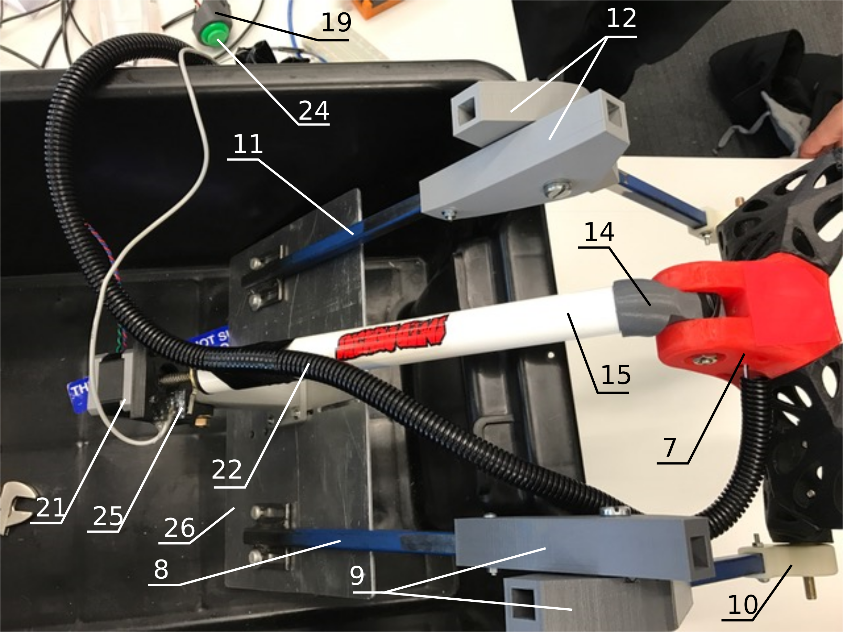

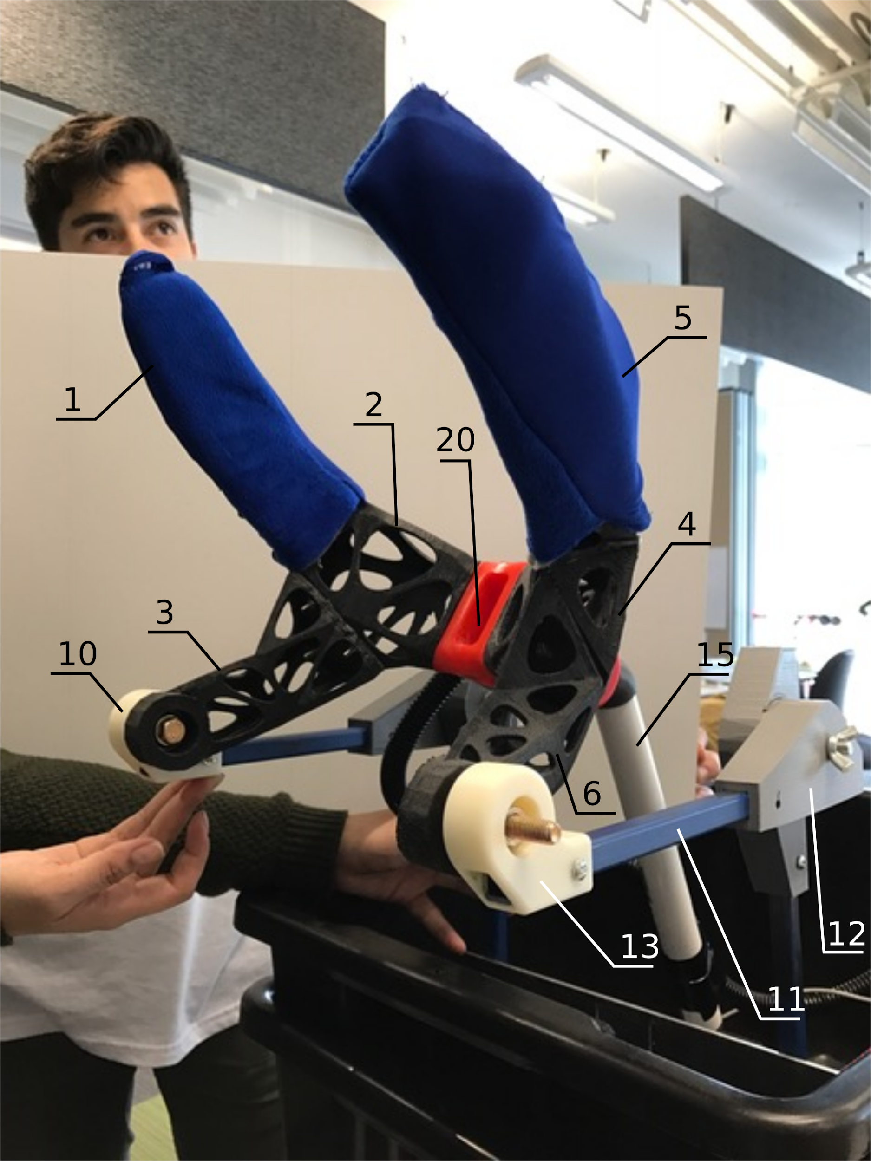
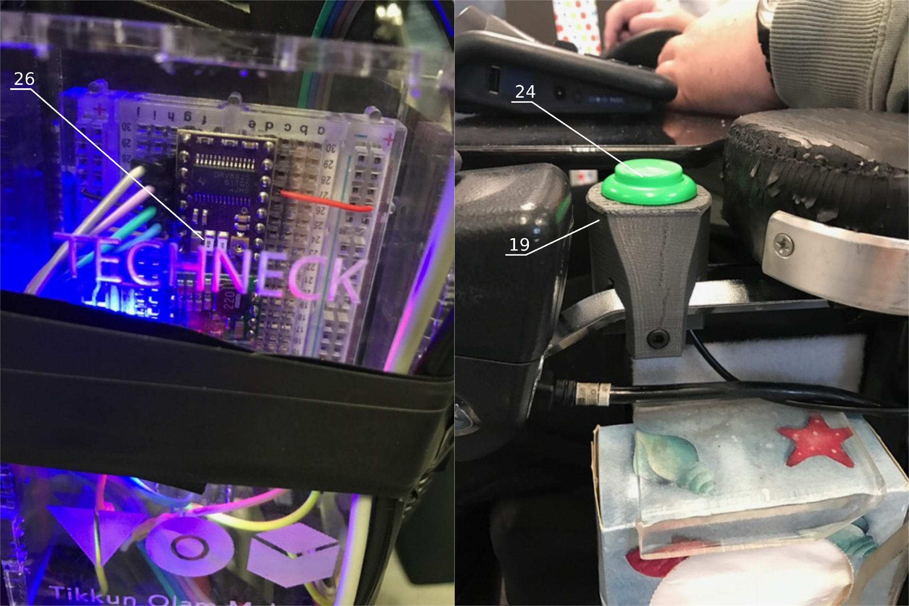

Steps Overview:
Mechanical Subassembly
- 3D print the parts
- Fabricate the metal parts
- Assemble the headrest
- Assemble the motor and attachments
- Assemble the rods, pivots and brackets.

Electronics Subassembly
- Build circuitry breadboard
- Configure Arduino
- Mount electronics and components onto wheelchair

Subassembly 1: The Mechanical Subassembly

Approximate Cost: $260 AUD Time Required: 1.5 days

Step 1: 3D Printing Parts

Parts and Tools Used In This Step:
- 180 mm x 180 mm x 200 mm 3D printer capable of producing large ABS prints
- ABS Filament

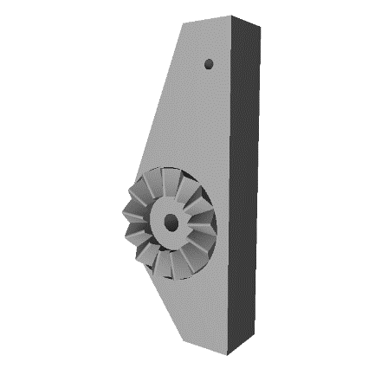 | 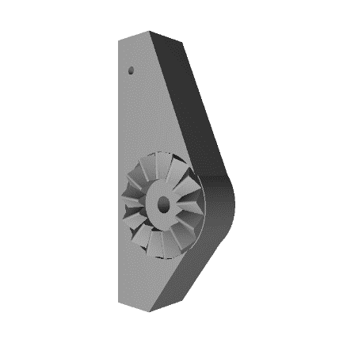 | 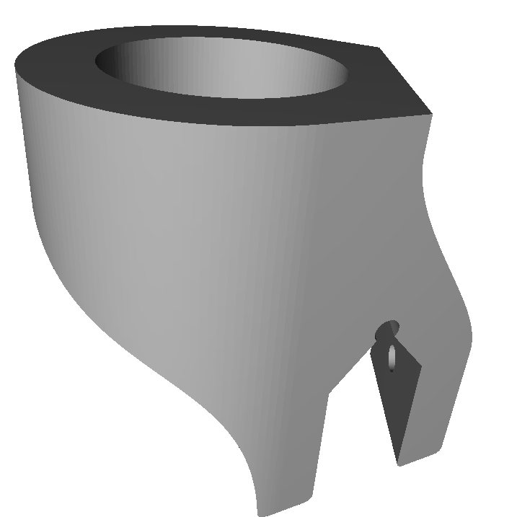
Bracket Part A (print twice) | Bracket Part B (print twice) | Button Mount
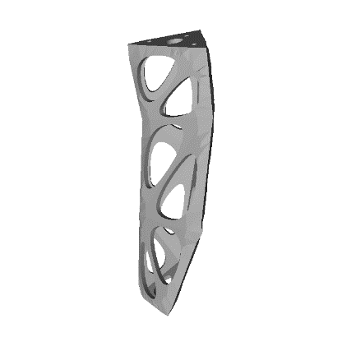 | 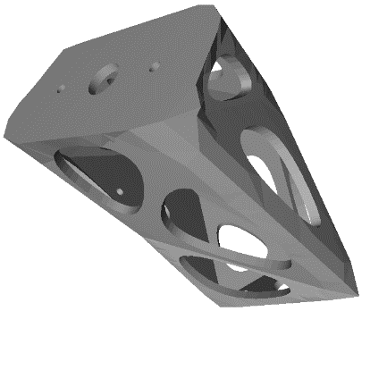 | 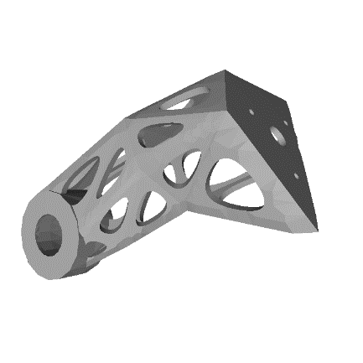
Headrest S1 | Headrest S2 | Headrest S3
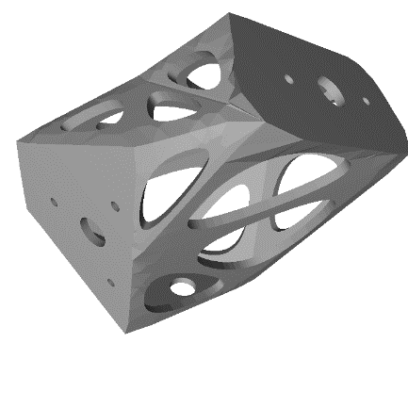 | 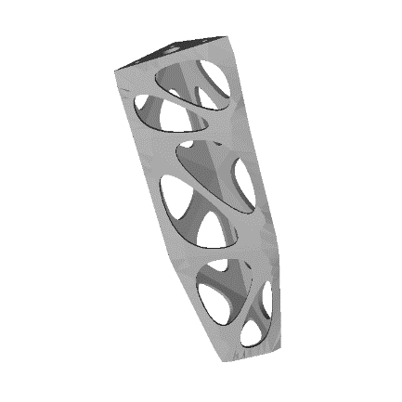 | 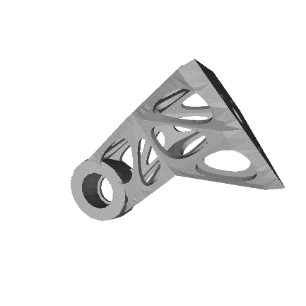
Headrest S4 | Headrest S5 | Headrest S6
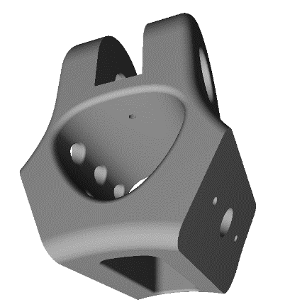 | 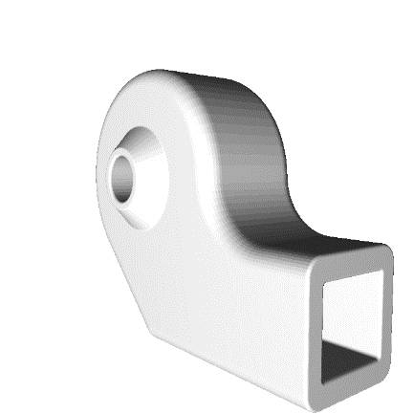 | 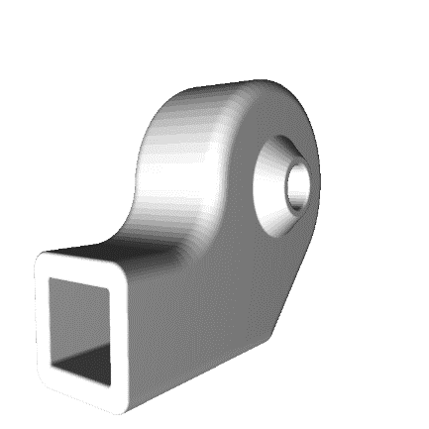
Headrest S7 | Headrest Pivot Left | Headrest Pivot Right
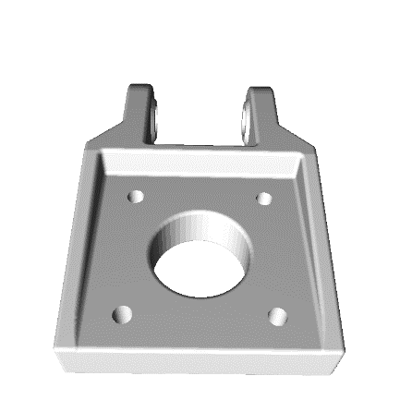 | 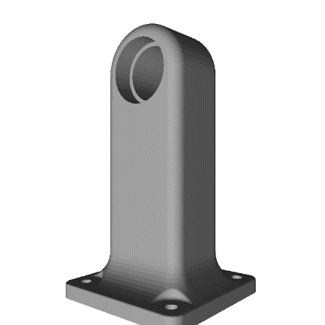 | 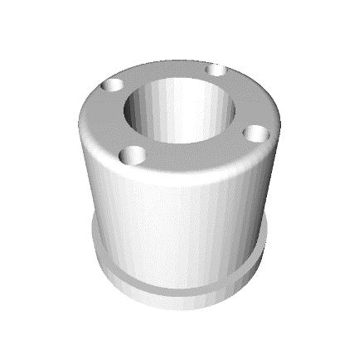
Motor Mount | Motor Pivot | PVC to Worm Drive Connector
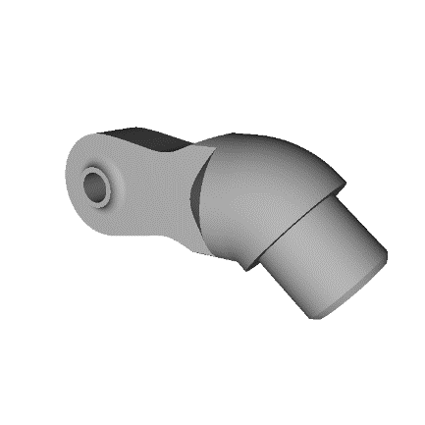
Upper Pivot

Instructions:
- Use 3D printers to create the plastic parts of the system. The parts must be printed using a rigid plastic and using printing settings that will create strong parts. Most parts made during the creation of this system used ABS with at least 80% in-fill, three shells, and 0.3 mm layer Z-resolution.
- The parts in listed with images above must be downloaded and then printed.

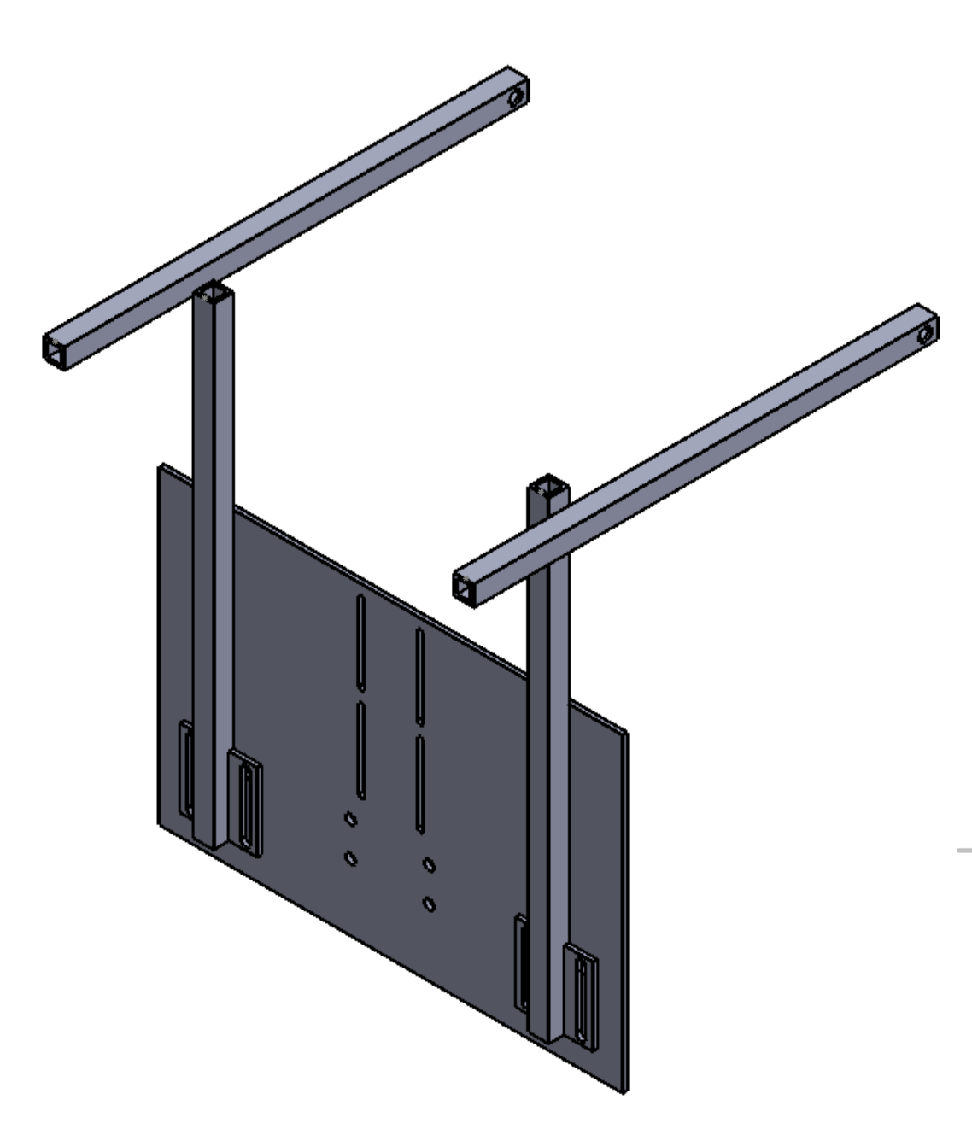

Step 2: Fabricating the metal parts

Parts and Tools Used In This Step:
- 5 mm thick aluminium plate
- 13 mm wide square aluminium rods
- Welder
- CNC cutting machine
- Metal cutting saw

Instructions:
- Base Supports: (repeat twice to make two parts)
  - Using the Base Support.pdf as a guide, cut two base support parts using the square aluminium rides and a metal cutting saw.
  - Cut the rectangular attachments with slots using a metal cutting saw and then welded it onto the base of the rod were.
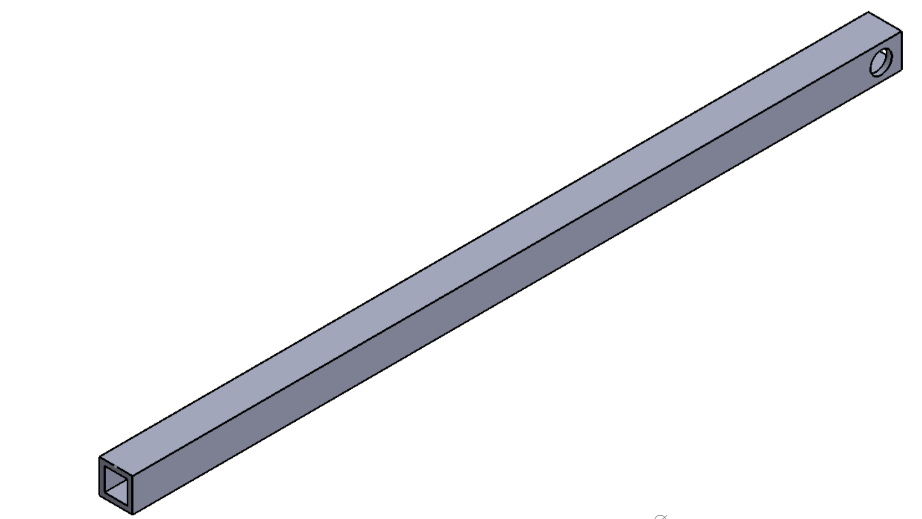
- Base Support 2 Extensions: (repeat twice to make two parts)
  - Likewise, using the Base Support 2extension.pdf as a guide, cut two base support extension parts using the square aluminium rides and a metal cutting saw.
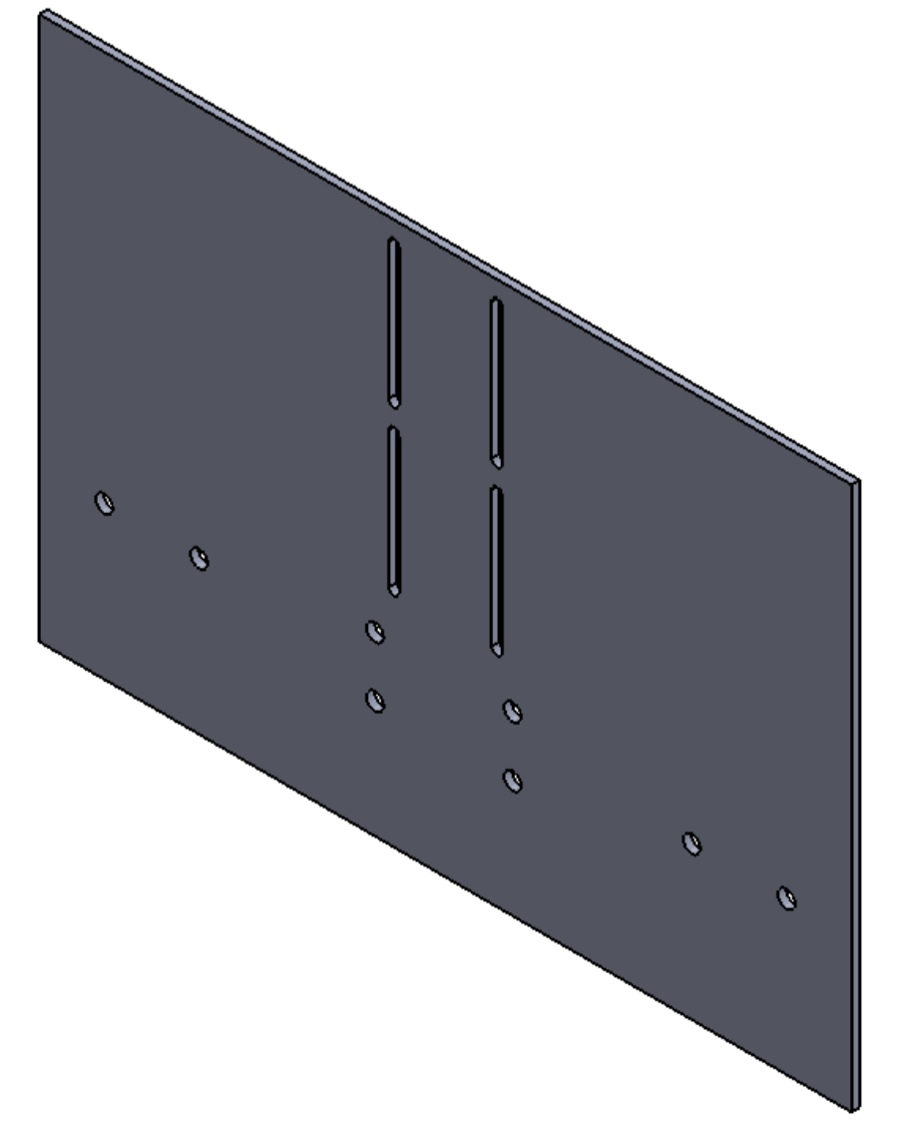
- Chair backplate:
  - Using Chair Support.pdf as a guide, cut the aluminium plate using a CNC cutting machine.

Step 3: Assemble the Headrest

Parts and Tools Used In This Step:
- Screw driver
- Pliers
- Printed parts: Headrest S1, Headrest S2, Headrest S3, Headrest S4, Headrest S5, Headrest S6, and Headrest S7.
- M3 Bolts and nuts

Instructions:

- Fix Headrest S1 and Headrest S3 to Headrest S4 using M3 nuts and bolts as shown in the image below
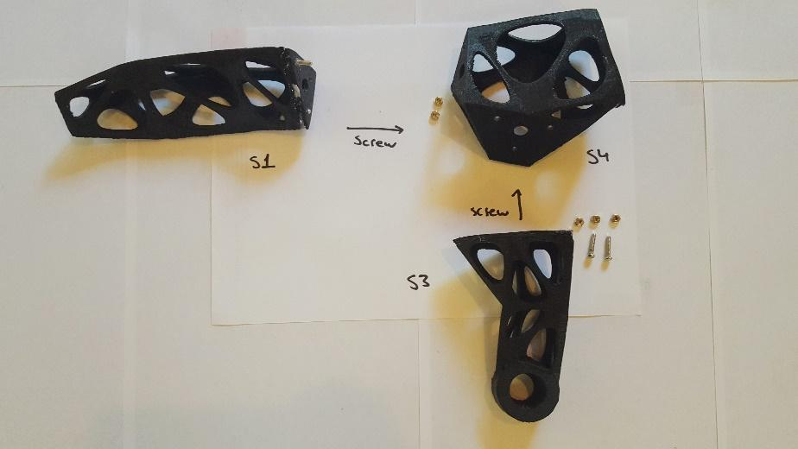
- Repeat the same for Headrest S5 and Headrest S6 to Headrest S2.
- Fix the assembled parts to Headrest S7 using M3 nuts and bolts as shown in the images below.

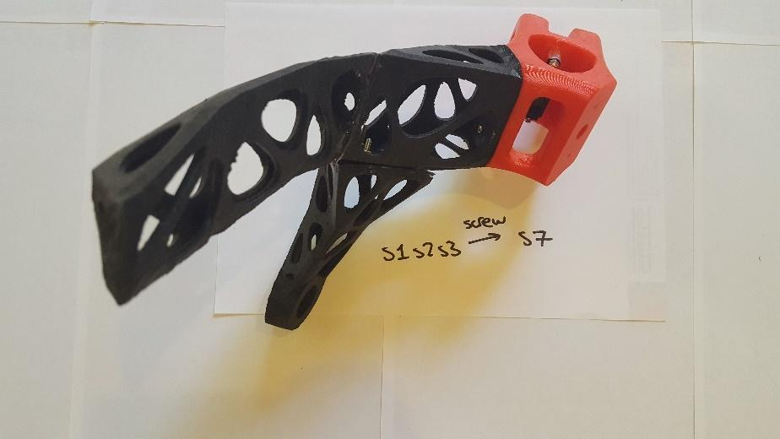

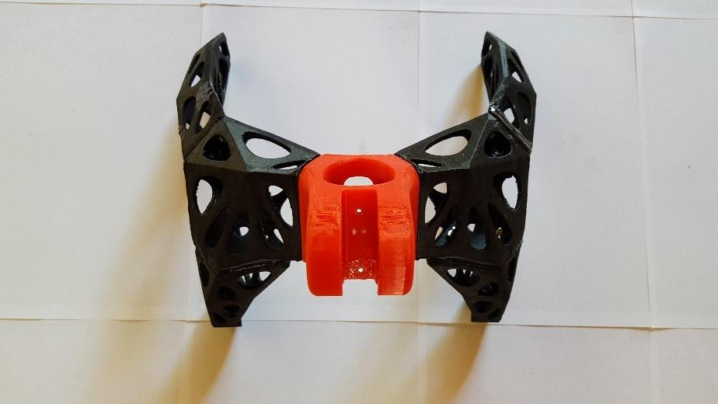

Step 4: Assemble the Motor and Attachments

Parts and Tools Used In This Step:
- Screw driver
- 24 mm PVC Pipe
- Printed parts: PVC to Worm Drive Connector, Upper Pivot, and Motor Mount
- M3 Bolts and nuts
- M8 50 mm bolts, nuts and washers
- Stepper Motor with lead screw and lead screw nut
- Microswitch and cables
- Soldering iron
- Epoxy

Instructions:
- Cut the PVC pipe to a length of 260 mm
- Fix the PVC to Worm Drive Connector part to the lead screw nut with screws
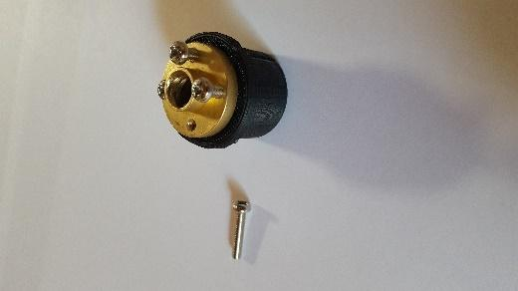
- Attach the PVC to worm drive connector’s other end to the PVC pipe. Then insert the Upper Pivot to the other end of the PVC pipe.
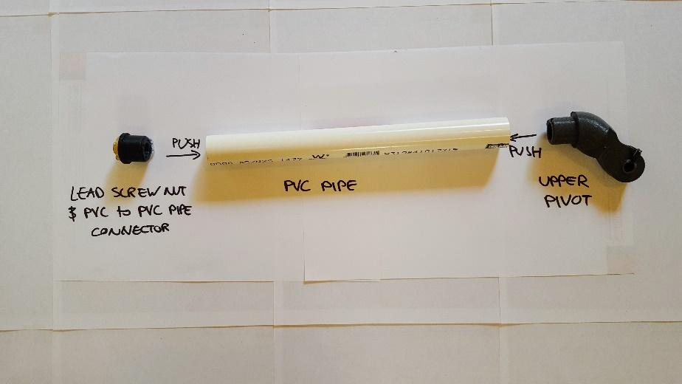
- Solder two wires onto the microswitch so that they are connected when the switch is pressed.
- Using epoxy, glue this down to the top of the motor mount so that it sits perpendicular as shown in the images below.
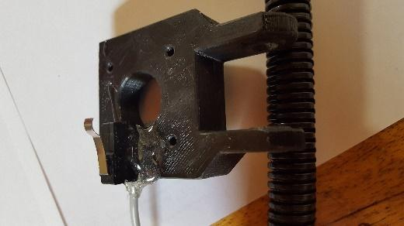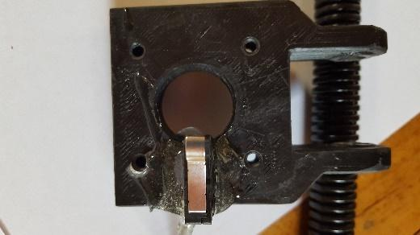
- Mount the stepper motor to the Motor Mount using screws as shown in the image below
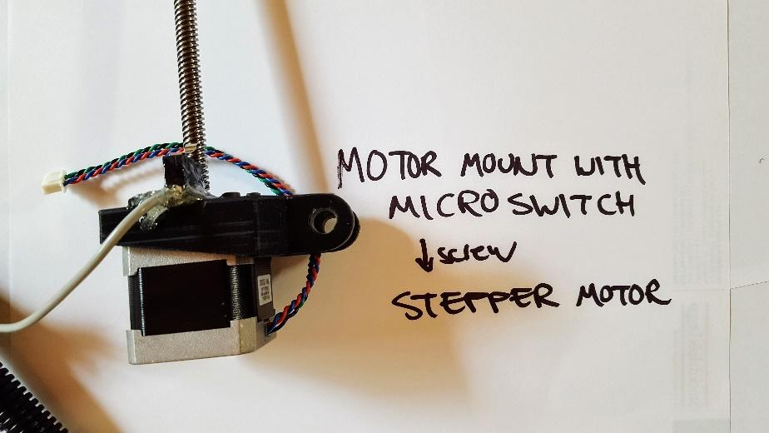
- Screw the stepper motor’s lead screw through the lead screw nut attached to the PVC pipe as shown in the image below.
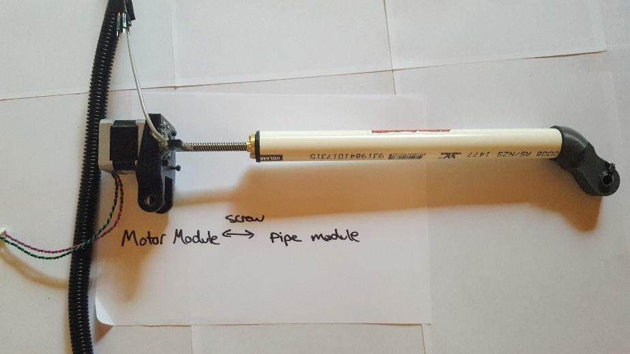

Step 5: Assemble the rods, pivots and brackets

Parts and Tools Used In This Step:
- Screw driver
- Pliers
- Printed parts: Motor Pivot, Bracket Part A, Bracket Part B, Headrest Pivot Left and Headrest Pivot Right
- M8 65 mm bolts, washers and wingnuts
- M3 Bolts and nuts
- Bearings

Instructions:
- Attach bearings on either side of the Motor Pivot part’s hole. Then fix the top to holes of the Motor Pivots to the bottom slot of the metal back plate using M3 bolts, nuts and washers on either side of the back plate. Tighten the screws enough so that the motor pivot can rotate along the back plate. This was found to decrease the torque forces acting against the stepper motor during the device’s use.
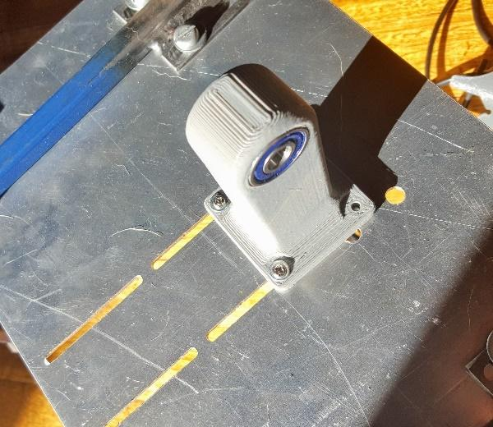
- Fix the Motor Mount to the Motor Pivot using an M8 bolt and nut with two washers on either side of the Motor Pivot as shown in the image below.
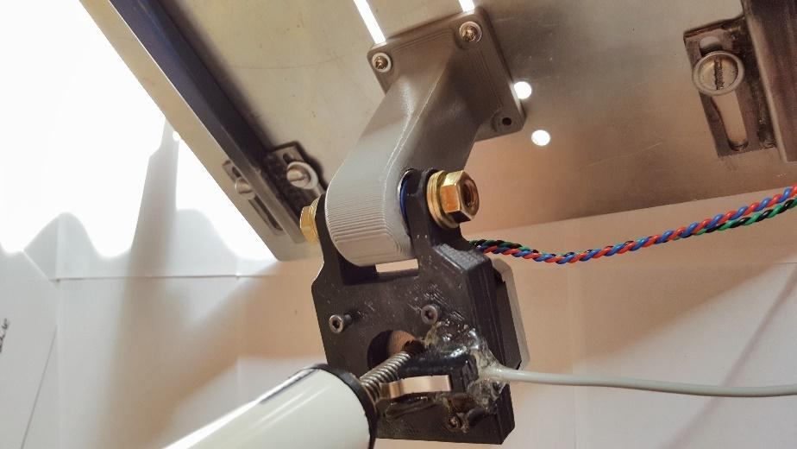
- Fix the Upper Pivot to Headrest S7 using the bearings and the M8 bolt, nut and washers as shown in the image below. Note the order of the bolt, bearing, washers and nut.
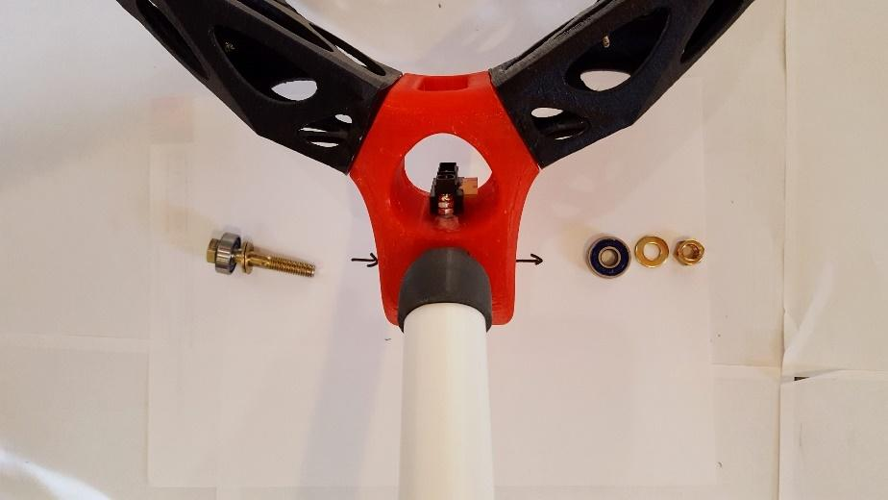
- Connect the Headrest Pivot Left to the left side of the headrest (Headrest S3) using M8 screws, nuts and bolts, and also bearings, as shown in the image below.
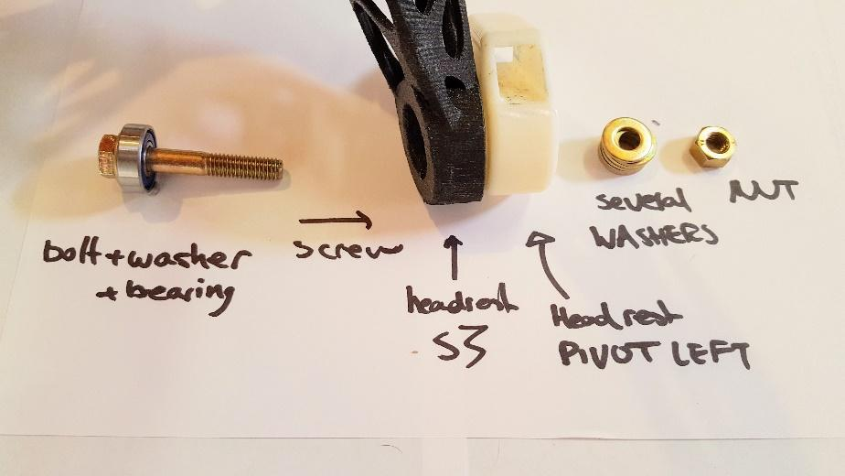
- Repeat for the other side of the headrest using Headrest S7 and Headrest Pivot right.
- Attach the two metal base supports onto the holes of the back plate using a 5.5 mm bolt, screw and nut as shown in the image below.
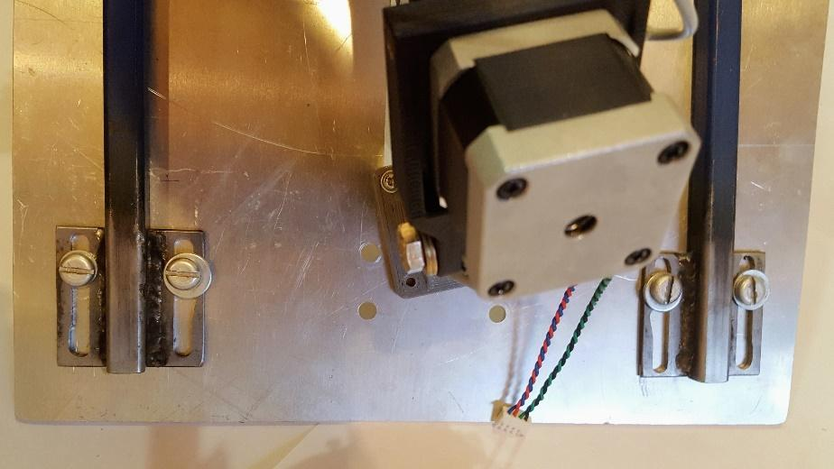
- Attach Bracket Part A on the other end of the left back support rod. This can be fixed onto the rod by drilling holes into the rod and using the hole to thread a nut and bolt through both the bracket and the rod. Repeat this using Bracket Part B on the right back support rod.
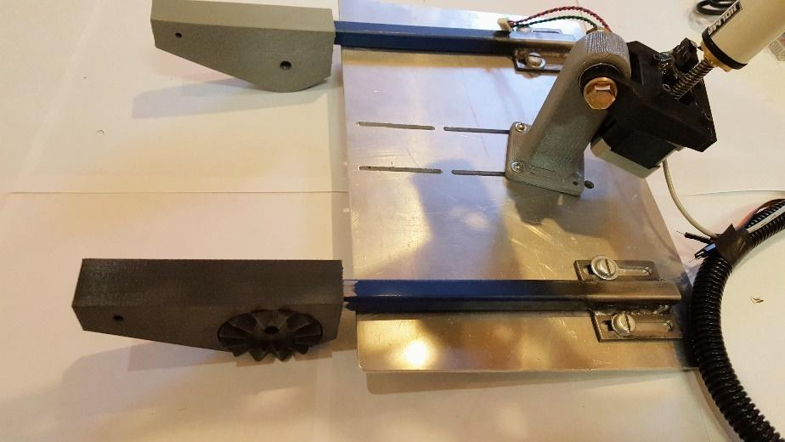
- Thread a Base Support Extensions through the hole of the left headrest pivot. Then thread the other end of the left Base Support Extension through Bracket Part B. Repeat for the right side. These rods can also be fixed by drilling holes through the rod and fixing it to the bracket using nuts and bolts.
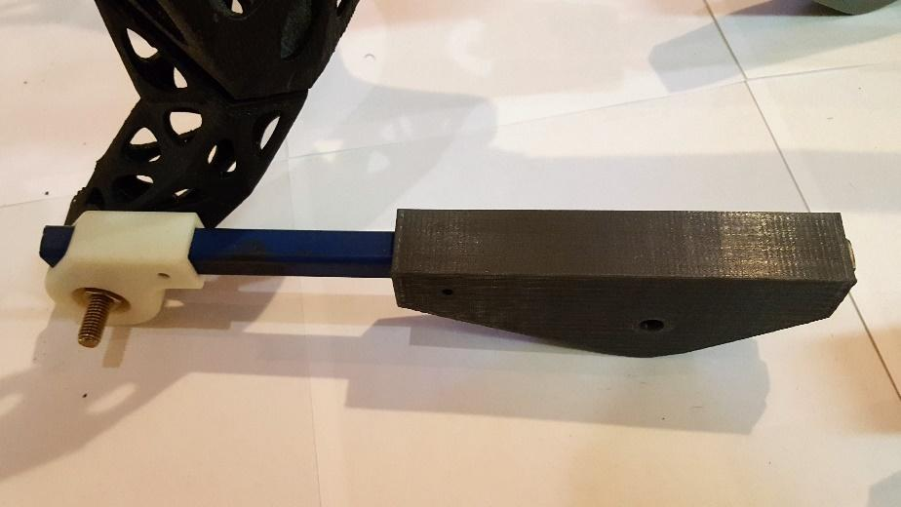
- Fix the left side’s Bracket Part A with the left side’s Bracket Part B using the M8 65 mm bolts, washers and wingnuts as shown in the image below. Repeat this step for the right side. Note that this enables the quick release function to allow the headrest to be rotated away from the user to allow the user to easily be hoisted out of their wheelchair.
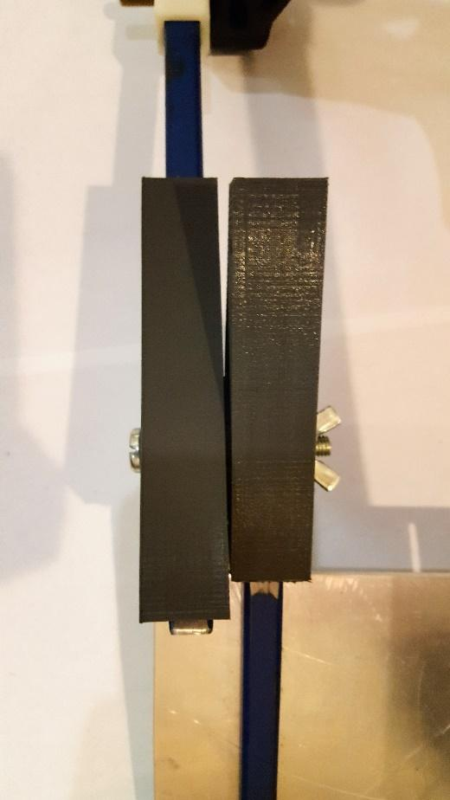

Subassembly 2: The Electrical Subassembly

Approximate Cost: $92 AUD Time Required: 0.5 days

Step 6: Build circuitry breadboard

Parts and Tools Used In This Step:
- Arduino Nano
- Wire
- 12-24 V DC Power Supply
- Microswitch
- LED
- 220 ohm resistor
- Stepper motor driver DRV8825
- 9 V, 1 A Polulu Step-Down Voltage Regulator D24V10F9
- IR Analog IR Distance Sensor
- Breadboard
- Stepper motor with linear action
- Soldering tools
- Epoxy

Instructions:
- Using the diagram below, wire up the components together. For the Push button, the microswitch, the stepper motor, the 12-24 V DC Power supply and the IR distance sensor require wires that are at least 1.5 m long. The wires going to the push button must be soldered in after mounting it within the printed Button Mount part as shown in the image below. The IR sensor must be mounted on to Headrest S7 using screws as shown in the image below.
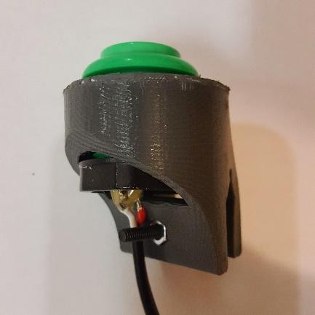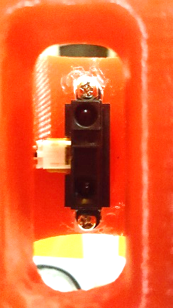
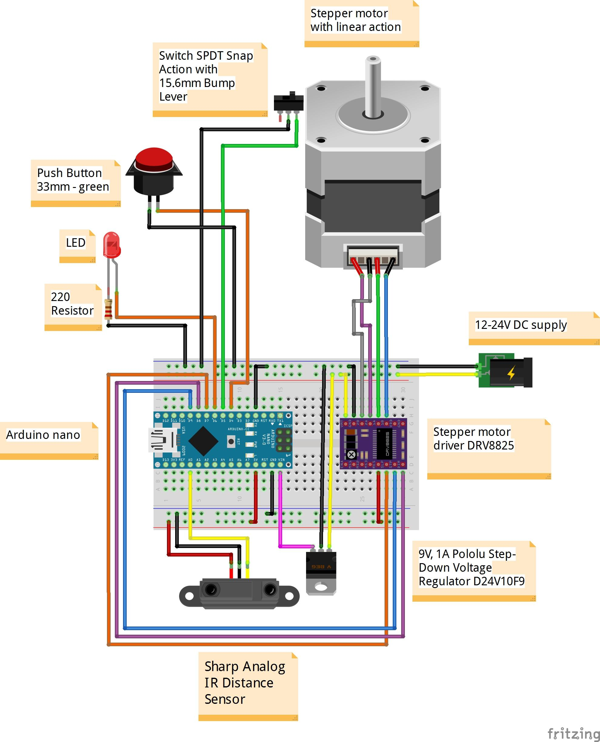

Step 7: Configure Arduino

Parts and Tools Used In This Step:
- Arduino Nano
- USB cord compatible with Arduino Nano
- Arduino software

Instructions:
- Download StepperDriver-master.zip, NewPing.zip, and BasicStepperDriverwithIR_r4.zip from https://tomglobal.org/project?id=5ca3885cb506a2297168aa43
- Compile and upload these sketches onto the Arduino Nano.

