Build Instructions: Tricycle for Quad Amputees
Developed by: Team Recycle

Mandy and Rob, David, Nir, Will, Aileen, Llewellyn and Andrew

Insert Product Image

Approximate Cost: AUD $500 Time Required: 500 hours

Purpose of Device:
Team ReCycle were tasked to design and construct a tricycle with the following requirements:
- To allow a person with four prosthetic limbs (below knee and below elbow) to go bike riding with her children
- To be stable and safe to operate and meet road regulations, if appropriate
- To be able to be operated on well-made river tracks (i.e., not for mountain biking)
- To have brakes that could be operated by means of other than hand operation due to slow reaction times of prosthetic wrists
- To be fitted with a supplemental electric motor to assist reducing pedalling effort
- It needed to look normal and be a finished and presentable tricycle, not a rough prototype.
- It needed to be painted red

Physical Description:
ReCycle designed and constructed a tricycle base loosely around commercially available designs modified to suit the design requirements. The trike consisted of a standard 24 inch wheel bike frame and a specially built rear tricycle axle that incorporated a modified three speed braked hub, driving a purpose built differential gear and an electric cordless drill drive.
Mandy McCracken, our Need Knower, was unable to successfully pedal a conventional bike if her knees were bent beyond a 75 degree angle as her prosthetic legs tended to come off beyond this angle.
The conventional trike ergonomics were changed by stretching the frame by approximately 200mm and moving the seat approximately 100mm to the rear. This allowed Mandy to pedal without bending her knees beyond the required angle.
To allow for the increased frame length, new, longer handle bars were made and fitted to her prosthetic hand angle.
A conventional wheel rim bike brake was fitted to the front wheel, operated by her inner leg via a pad mounted below the seat.
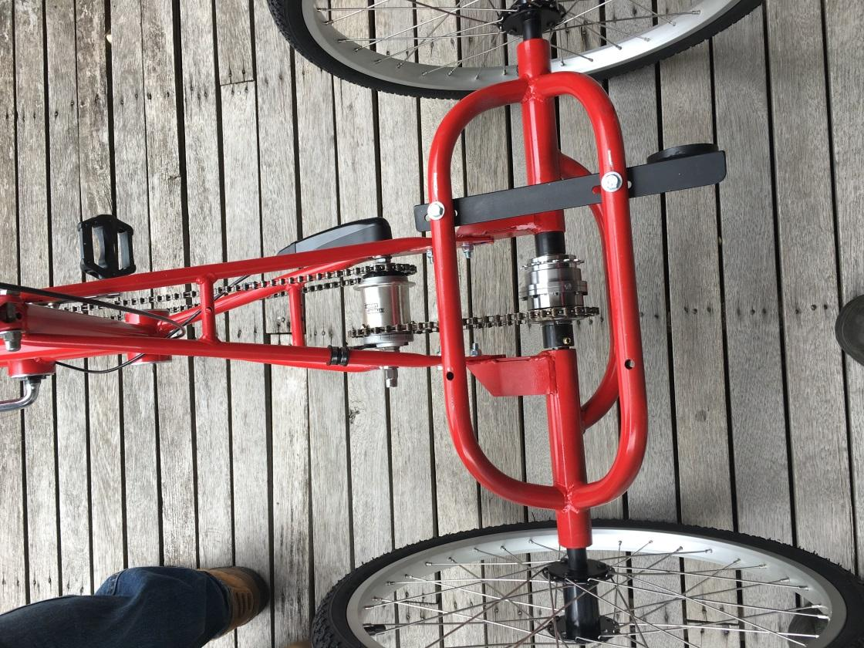
The electric drive was constructed from a donated Bosch brushless cordless drill. A control system was designed incorporating a small computer to control the drill motor, This included hall-effects sensors to detect pedal sprocket speed and wheel speed so that the motor was de-energised when pedalling stopped, for coasting or braking as per the Australian Deign Rules (ADR). As per the ADRs, pedalling is required when the electric motor is operating. Mandy can adjust how fast the motor turns via a rotary switch mounted on the handle bars. Final details of this drive system are being developed.

History of Development:
Prior to TOM, Mandy had made several visits to a professional bike modifying organisation who had attempted to modify a conventional two wheel bike to suit her. Unable to resolve stability, braking and ergonomics issues, this was ultimately unsuccessful.
TOM Australia provided Mandy with an opportunity to work with a team of engineers to create a fully engineered tricycle better suited to her needs.
The trike was developed in an interactive process with Mandy testing mock-ups of various seat positions, frame lengths and pedal throws until a satisfactory combination was achieved. We found in particular that she could not pedal comfortable a conventional pedal throw of XXmm and required a shorter throw of XXmm.
The electric drive has proved to be the most difficult design component due to the lack of information on the drill’s “black box” control system. While the Mandy is now using the trike with only pedals, the electric drive is currently receiving further development in the workshop. While we have fitted a 36 tooth pedal sprocket driving a 22 tooth hub, experience is proving that a 30 tooth chain sprocket would provide more satisfactory gearing.
It should be noted that the nature of this project is that the construction of a tricycle requires considerable welding (preferably TIG) and machining skills to modify and make the various components. Access to a lathe, milling machine and TIG welded is necessary to replicate our design.

Bill of Materials

Product Name
Assembly Name: |  |  |  | Approval Date:
Assembly Number: |  |  |  | Part Count:
Assembly Revision: |  |  |  | Total Cost:
Part ID | Part Name | Description | Qty | Units | Supplier | Unit Cost | Cost
 | Total |  | 0 |  |  |  | $0.00

Tools Required:
- A range of convential bike assembly tools including chain breaker and hub wrenches.
- TIG welder (MIG welder would also be suitable).
- Metal lathe of at least 3 inch centre height is necessary. A vertical milling machine is also preferable.

Purchased/Recycled Parts Inventory:
- 24 inch wheel bicycle with front brake
- Sturmy Archer three speed coaster braked hub pert number XXXX
- 130mm throw crank set
- Assorted cluster sprockets, and bike chains
- Spiral bevel gears from two identical 110mm angle grinders (purchased as complete angle grinders from local hardware for AUD$22 each)
- Two rear 24 inch bike wheels
- 22 tooth freewheeling bike sprocket (for motor drive)
- Four 6002Z sealed ball bearings
- Bicycle seat

ReCycle Manufactured Parts during TOM Makeathon:
- Rear Tricycle axle assembly
- Modified brake lever to operate thigh brake
- 27 tooth output sprocket to fit Sturmy Archer hub (modified cluster sprocket bored to fit on hub and bolted to hub spoke flange
- Differential gear assembly
- Extended handlebars, bent from 25mm dia steel tube
- Rear axle shafts and couplings
- Mounting brackets for:
  - Electric drill drive
  - Hub gear lever
  - Electric drive rotary switch

Subassembly 1: Frame Modifications
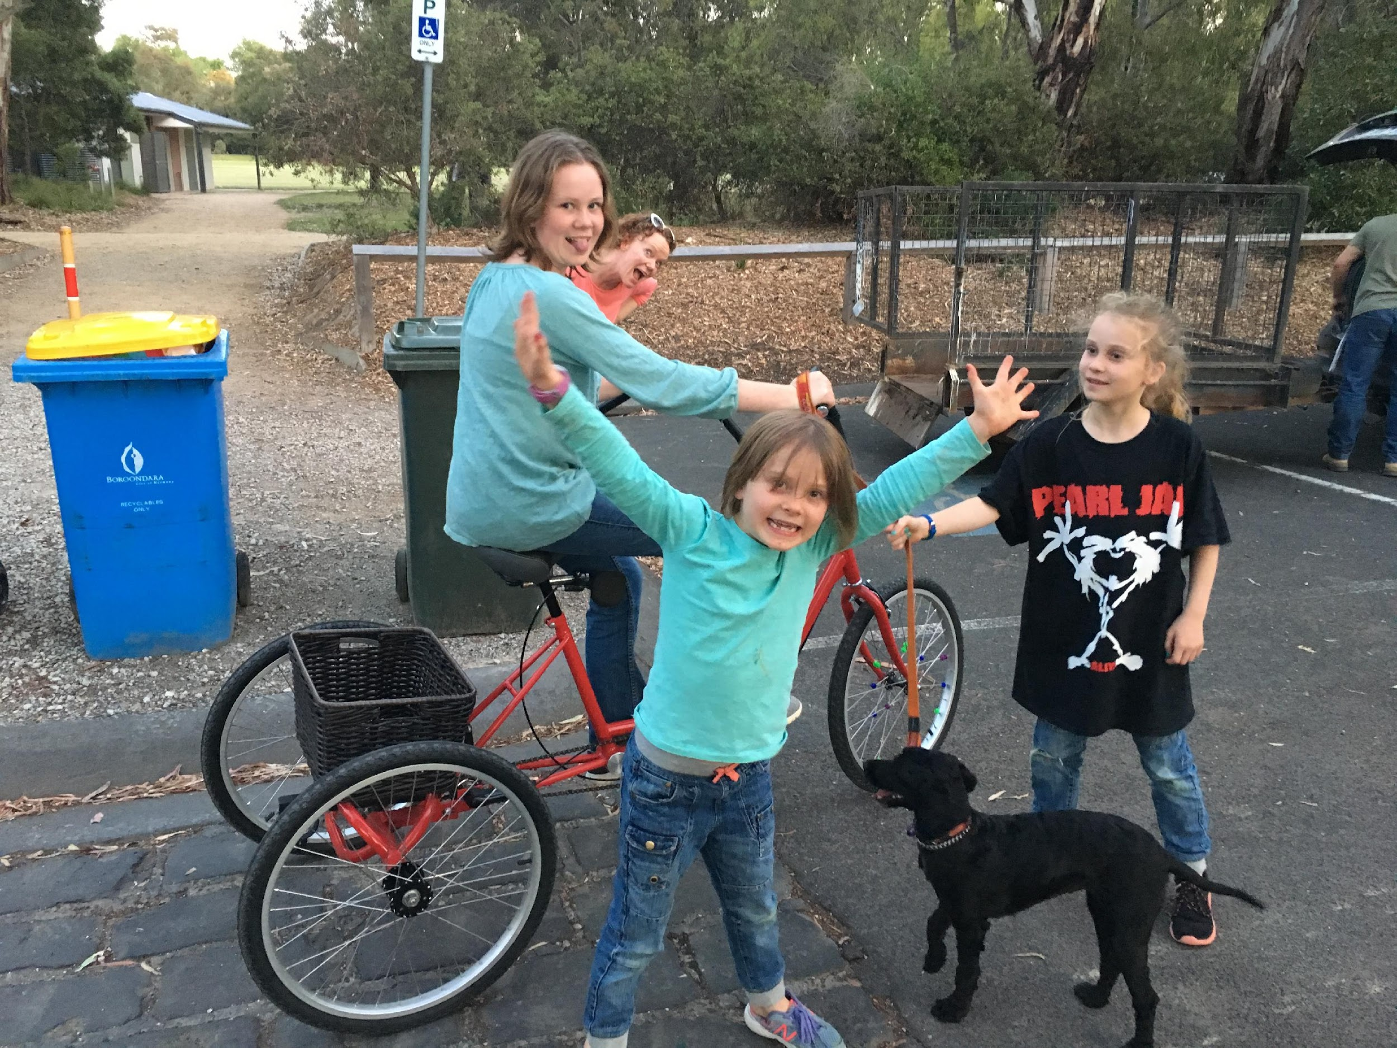
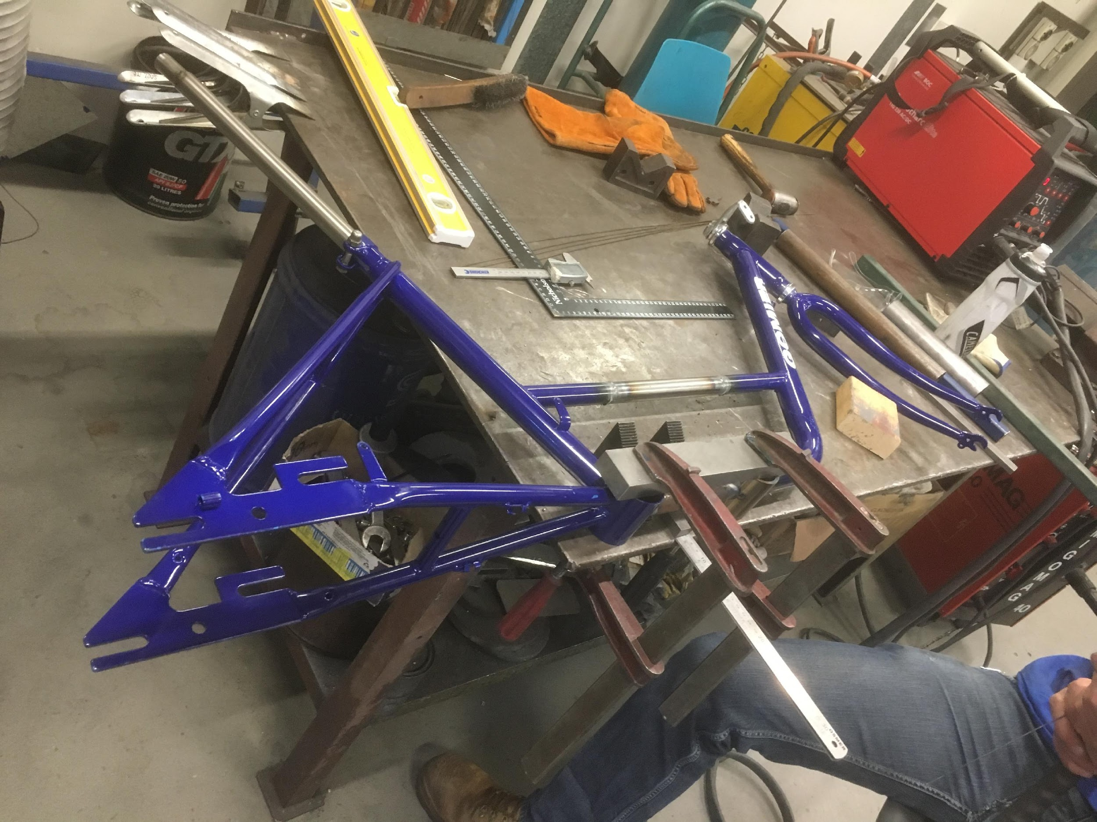

Approximate Cost: Nil Time Required: 6 hours

Parts and Tools Used In This Step:
- Second Hand Bicycle Frame
- TIG Welder
- Assorted pieces of steel plate and tubing.

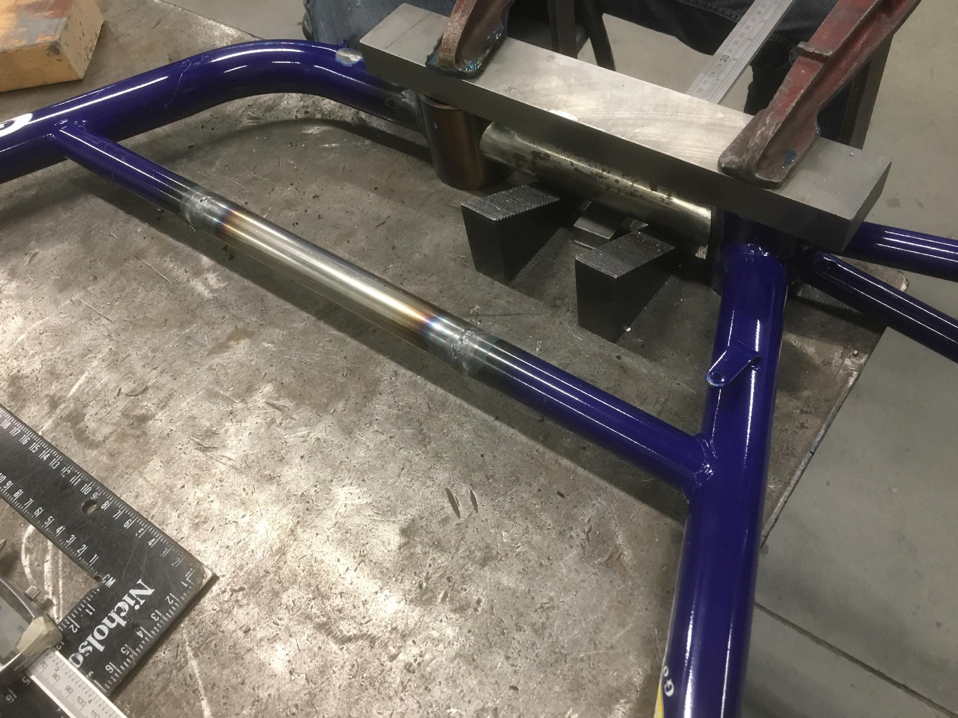

Instructions:
- Cut bike frame and through cross bars and clean up surfaces for welding
- Manufacture new sprocket housing from a piece of 50mm tube to match that fitted to frame.
- Cut pieces of pipe to match cross bars of 200mm in length and tack weld in place as per the drawing and photo.
- Temporarily assemble frame with cranks and seat and check pedalling position with Need Knower (note, we installed the front wheel and made a wooden stand for the rear of the bike for this testing)
- If satisfactory, proceed to weld up frame. If not, try different pedal crank lengths (from other old bikes - children’s bikes are a good source off short throw cranks) and seat heights and positions. If still not satisfactory, change lengths of (tack welded) tubes to adjust pedalling position. This is the most important step to get this right!

Subassembly 2: Rear Axle Assembly

Approximate Cost: $30 Time Required: 12 hours
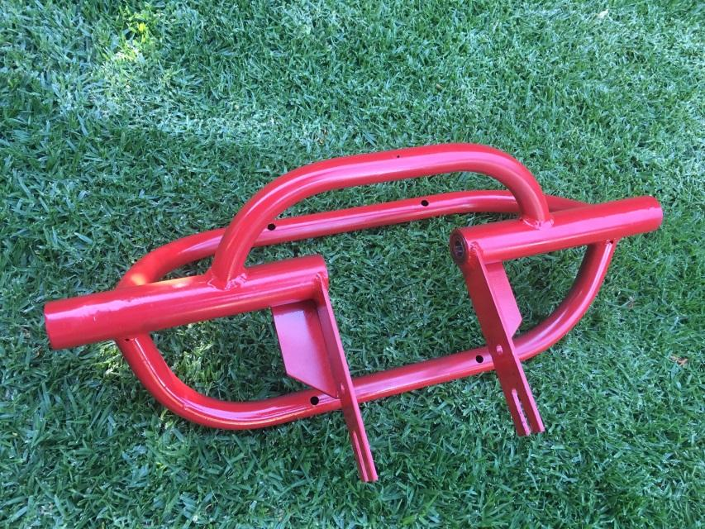

Parts and Tools Used In This Step:
- TIG welder
- Tube bender
- Assorted pieces of steel plate and tubing.

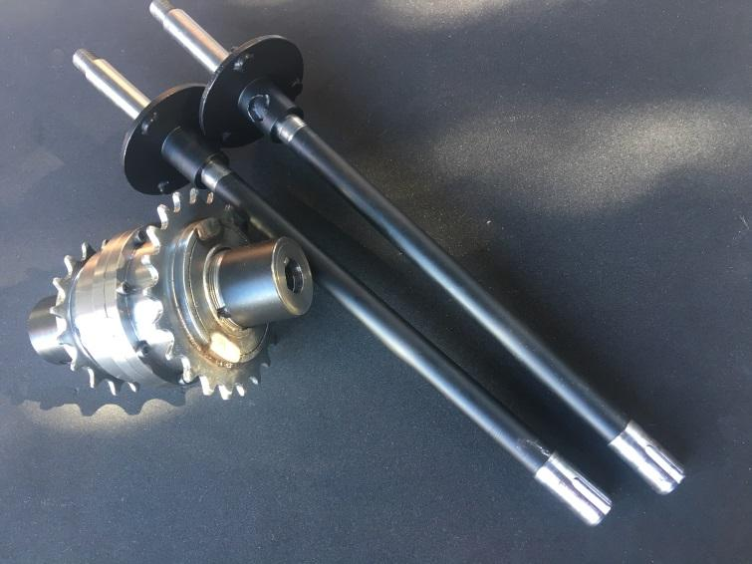
Instructions:
- Machine axle housing inserts to fit bearing OD of 28mm dia (sliding fit)
- Cut and bend pipes according to drawing
- Cut and shape flat bars to drawing
- Weld up assembly paying particular attention to ensure the two axle housings remain in alignment.
- Machine axles and couplings and wheel drive flanges to drawings.

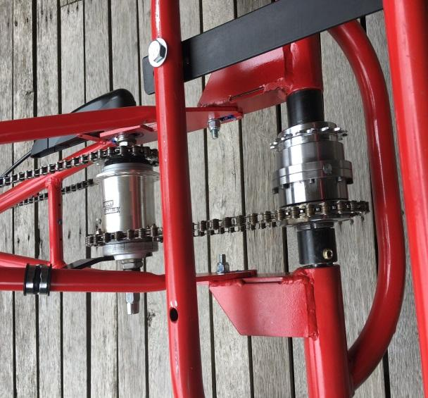
Differential Gear

Parts and Tools Used In This Step:
- Lathe
- Free machining steel
- 4mm socket head cap screws
- Bearings from the angle grinders

The manufacturing of this piece is a straight forward lathe machining job. Machine from free machining steel according to the drawings. Make sure that the threads for the hubs fit correctly.

In assembling the differential, it is important to ensure that all backlash is removed or the differential will bind in one direction. Machine a spacer to fit on the pinion shaft between the pinion gears that allows them to fit neatly with the teeth fully meshing on the larger spiral bevel gears. Then machine shims to go on the outside of the pinion gears to remove any play but allow free spinning. Do a trial assembly and if it rotates freely in both directions, open up and fil with grease and then set aside for assembly into the rear axle. If it binds in one direction, adjust the shims until it runs smoothly.

