________________________________________________________

Build Instructions: Natalie App

iPad application that displays a daily schedule with visual aids

Developed by: Sing Le, Elles Le, Oscar Lau, George Chen and Kellen Huang
In conjunction with: Jennifer Bur, Natalie Bur and Tamsin Bur
_________________________________________________________________________
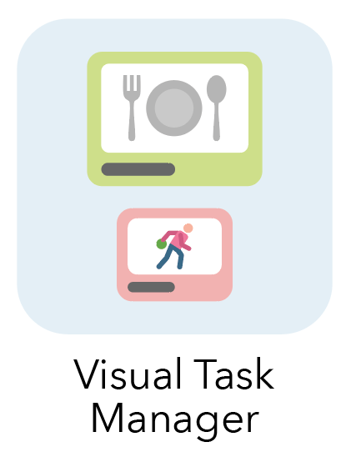
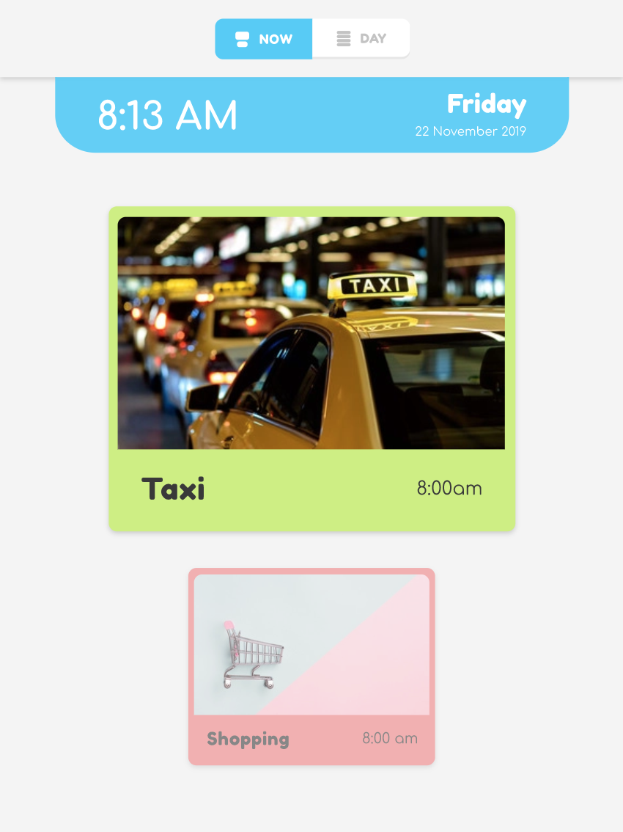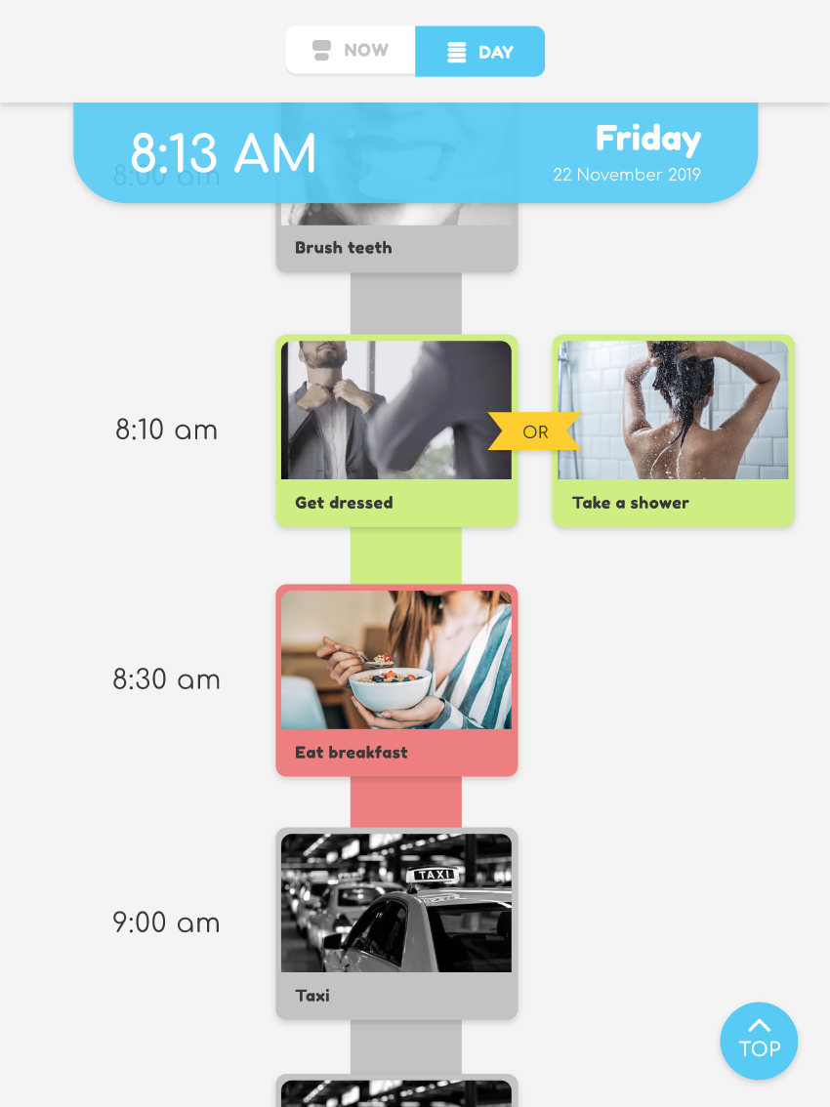
Approximate Cost: - Time Required: 1 - 3 hours

Version Control
Date | Description | Version | Author
30/10/19 | Digital Product File template creation | 0.0 | Ben Shemesh
23/11/19 | Started sections: title page, need-knower background, purpose of device, physical description | 1.0 | Kellen Huang
24/11/19 | Edited product file template to align with software product file. Completed product file documentation | 1.1 | Kellen Huang
9/12/19 | Updated how to to include changing time format to four digits | 1.2 | Kellen Huang

General Warnings and Cautions
- Read through entire manual before attempting to build this device.
- Do not attempt a step if you are unsure of what you are doing. Certain steps in this manual require experience with fabrication tools. <<General Warning>>.
  - For assistance or clarification of any step, contact Insert contact info here

User Assistance
For any questions regarding the assembly, operation or specifications of this device, please contact Insert contacts for help with device usage or manufacturing

Icon Glossary
The following icons may be used throughout this manual—each with its own purpose.
- Caution: The caution icon is used to signify whenever someone attempting the procedure may injure themselves or damage their equipment.
- Note: The note icon is used to signify useful bits of information that complement the instructions.
- Reminder: The reminder icon is used to provide information for after the procedure is completed, such as tips for disassembly.
- Need-Knower Specific: This part or method of manufacture has been designed specifically for a local Need-Knower.

Need-Knower Background
Jennifer’s daughter Natalie is a 24 year old woman with a severe intellectual disability on the autism spectrum from Moe, Victoria. Everyday she wakes but does not know what day it is or what activities she will be undertaking that day. This causes her distress and has resulted in negative behaviours.

History of Development
This project started at the TOM: Ballarat Makeathon event in 2019. Please see Appendix 1 History of Development and Meeting Notes for more details.

Purpose of Device
This iPad application will display her daily activity schedule which includes pictures of Natalie performing the task or the place of the activity to enable her to better understand her schedule for the day and what she is currently doing.

Scope
MVP
User Stories:
- As Natalie, I want to be able to see what activity I’m supposed to be doing at a certain time to be able to remind myself what I’m doing
- As Natalie, I want to be able to wake up in the morning and see what tasks I have on for the day to know what I should prepare for

Extra:
- As Natalie, I want to be able to hear what the activity is that I am doing as I cannot read
- As Natalie, I want to be able to see my memories again to show friends and family what I’ve been up to recently and how I was feeling*

Functionality
Now/Next Screen:
- Text to speech when cards is tapped
- Roll over to the next task after a certain amount of time (10 minutes)
- Now/next cards shows task name and one photo
- Loads as start screen
- Allow user to select a task when there are two options
  - Grey out unselected task
  - After certain time (5 minutes) only show one task*
  - If no task is selected, show both or generic activity card*
- Change the colour of the cards depending on how much time is left in the card*
  - Amber 15 minutes before
  - Red 5 minutes before
- Tick shows 15 minutes before the task ends, otherwise nothing (optional: starts a countdown timer)*

Day View:
- Text to speech when card is tapped
- Scrolls up and down for all the tasks
  - Starts on current time view*
- ‘Back to top’ button that scrolls back to current time*
- Scrolls down to next day after a certain time (6pm) and make it clear it’s tomorrow*

*Tasks that were unable to be completed during the weekend (23 - 24 November 2019)

Style Guide

Fonts Used

Colour Palette
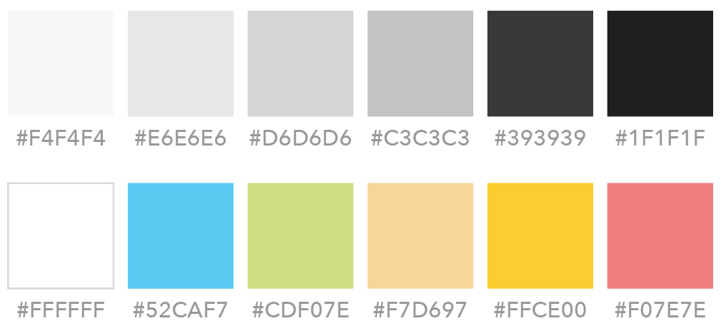

Screens
Screen | Description
App icon | File name: appicon.png
Home screen /  Now-next Screen | Features:  - Current task card is green  - Current task card is larger than next task card  - Next task card is slightly transparent and red  - Next task card is smaller than current task card  - When task card is clicked, task description is read out using text-to-speech
15 minutes before current activity ends  Note: unable to be completed during the weekend (23 - 24 November 2019) | 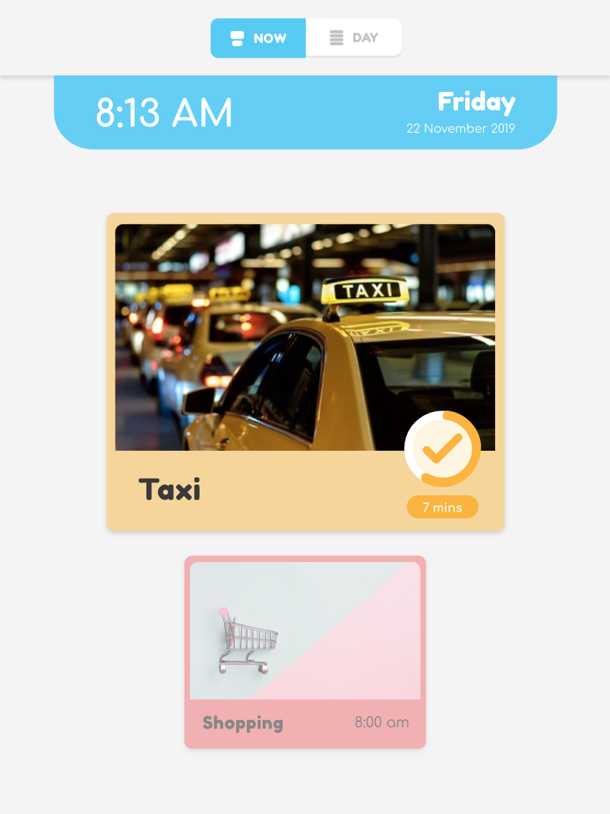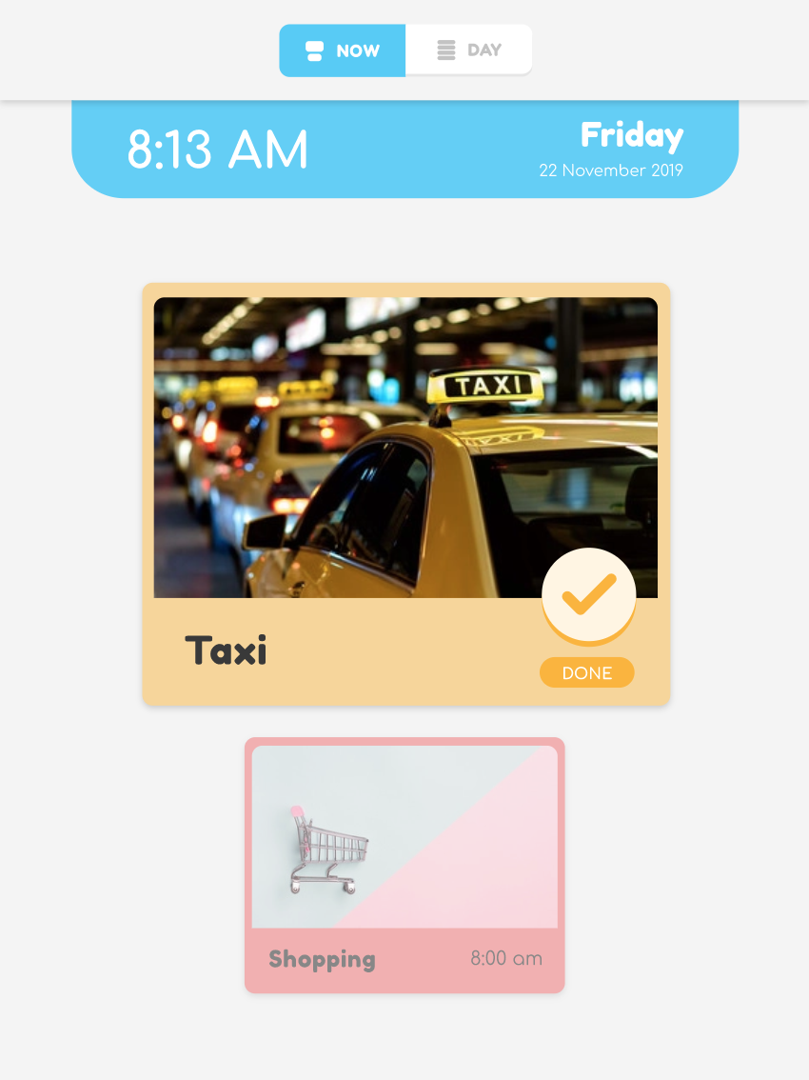  Features:  - Current task card turns amber  - Current task card has a 15 minute countdown timer in the bottom right hand corner with a clickable tick icon
When current activity ends / next activity begins  Note: unable to be completed during the weekend (23 - 24 November 2019) | 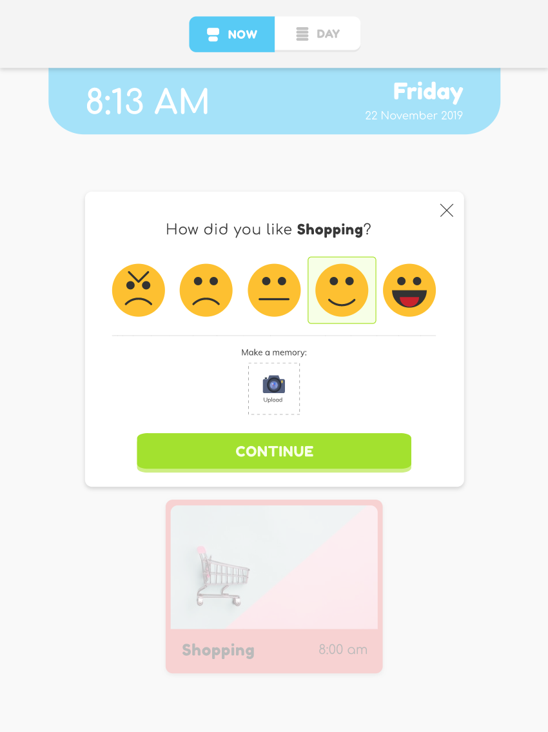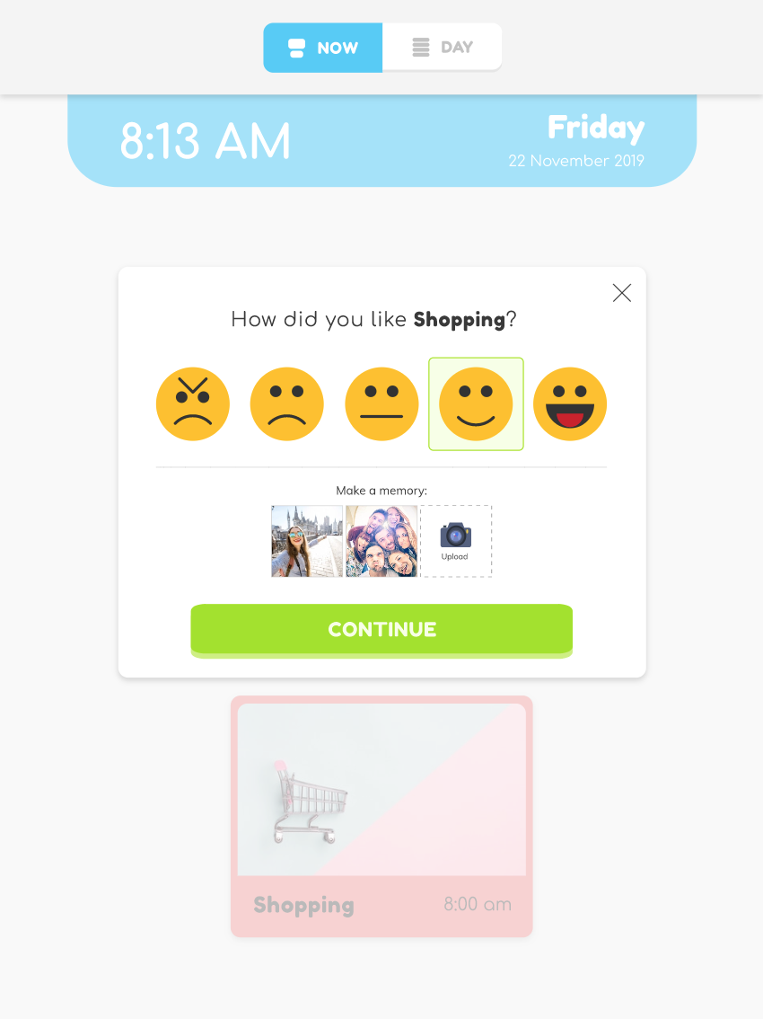  Features:  - Current task card is replaced with ‘feedback card’  - Feedback card asks ‘How did you like <task>?’ with 1 - 5 scale of emotions represented by emotion icons  - Feedcard card has the option to take and upload photos
When there is an option between two activities  *Tasks that were unable to be completed during the weekend (23 - 24 November 2019) | 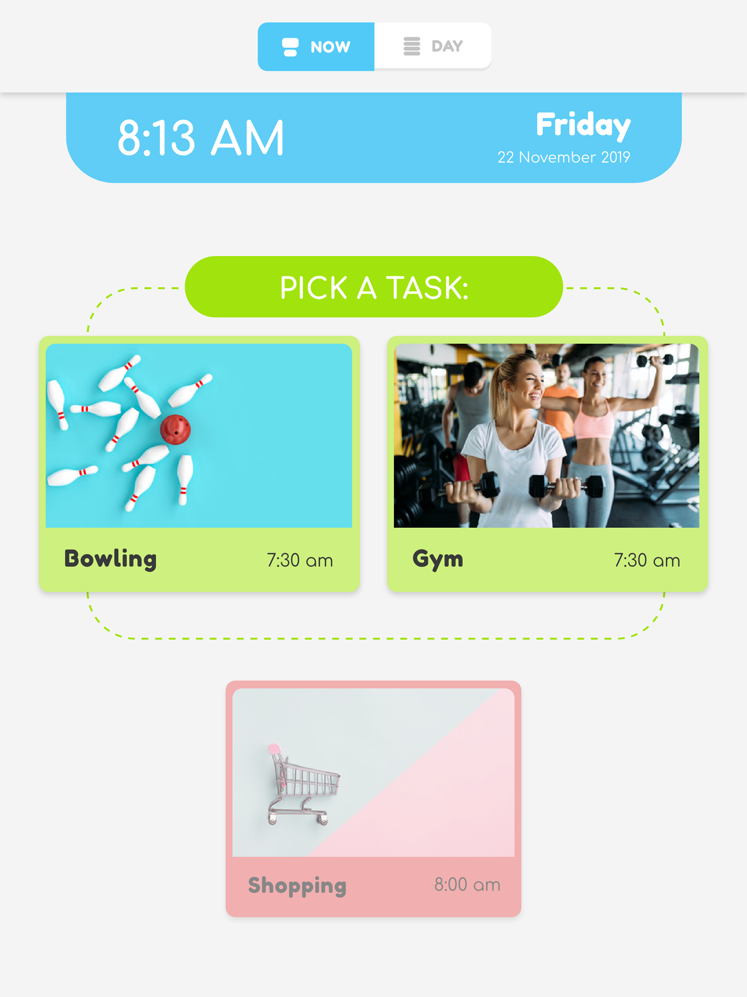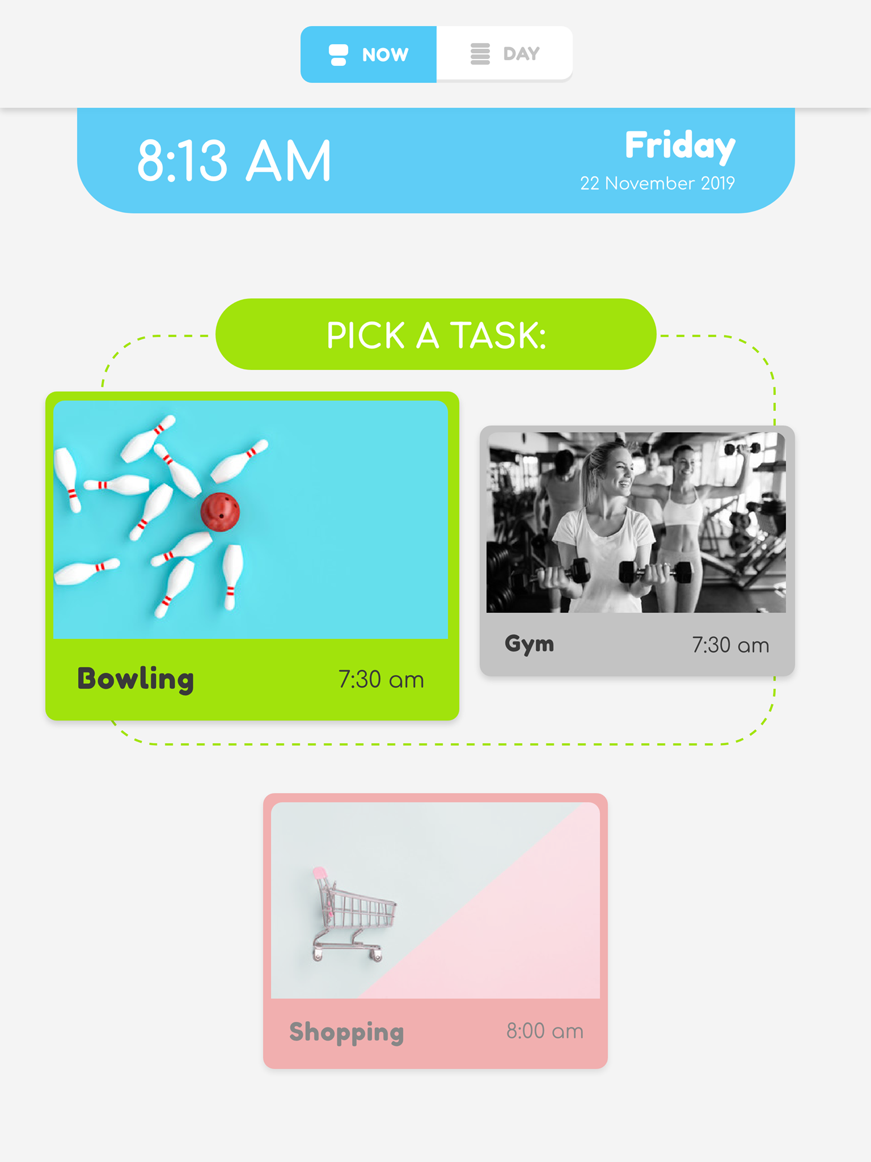  Features:  - Shows two task cards with the two options of activities and prompts user to select one task card  - When a task card is selected, the selected card enlarges and turns a brighter green  - When a task card is selected, the non selected card shrinks and is greyed out  - Selection can be edited within 5 minutes of task starting*  - After 5 minutes of task starting, user will unable be able to change selection*
Daily schedule screen  *Tasks that were unable to be completed during the weekend (23 - 24 November 2019) | 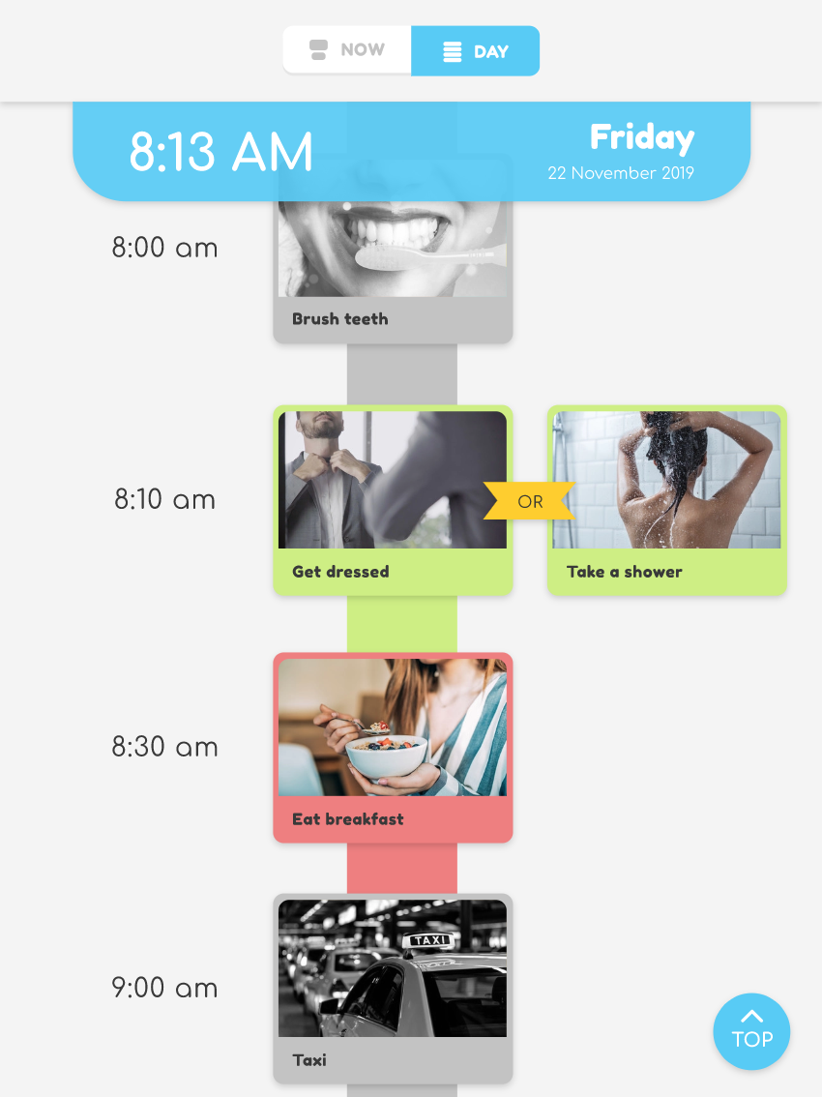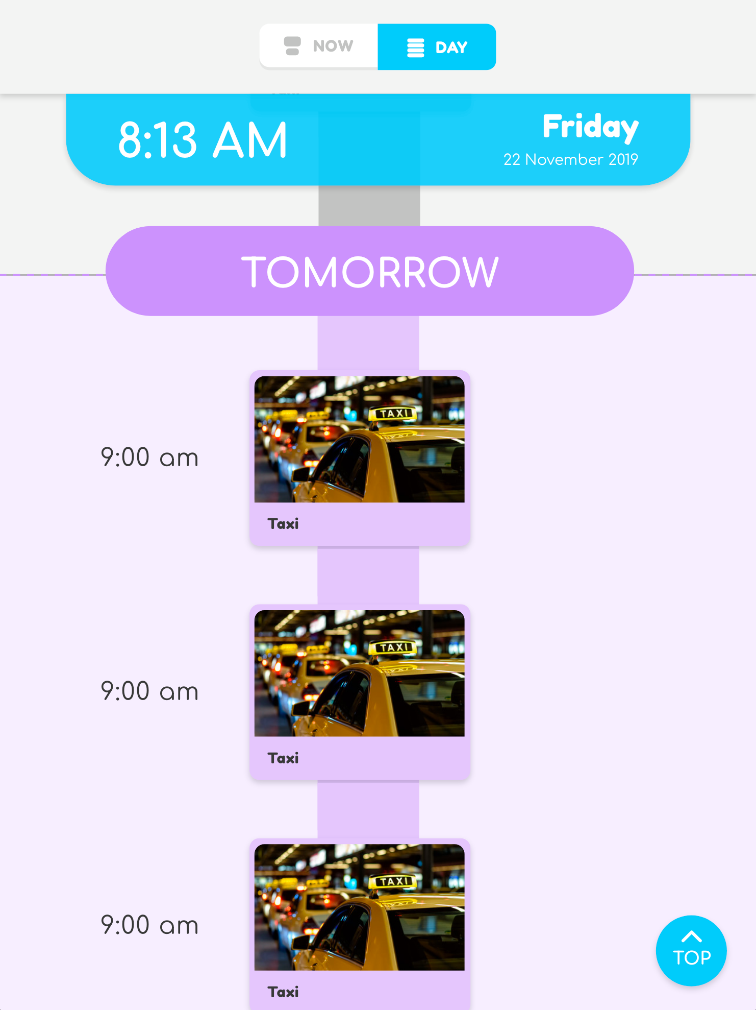  Features:  - Scrollable screen that shows all activities of the day  - Current and next activity cards are coloured green and red respectively  - Previous and future activity cards are greyed out  - Able to scroll down to the next day’s activity cards after a certain time (6pm)*  - It is clear the next day’s activity cards are for the next day. In this case, there is a large title in a colour outside of the colour palette and the section is also in a colour outside of the colour palette

Required Equipment and Software
No. | Item Description
1 | iPad
2 | iPad-to-USB cable
3 | Laptop/desktop computer
4 | Microsoft Excel (or similar program that can create .csv files)
5 | iTunes
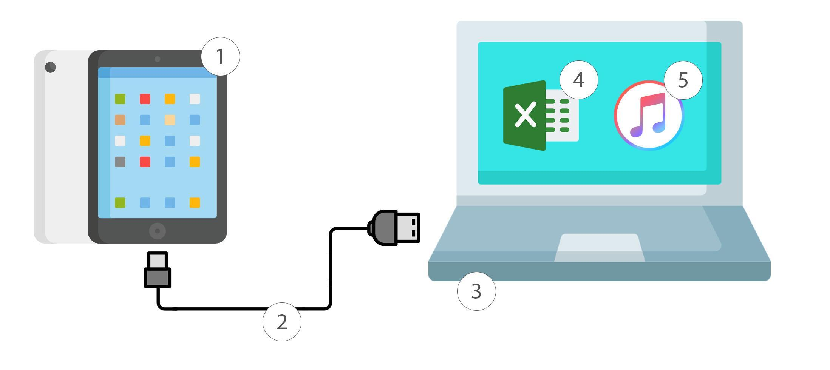

How to

Edit the Schedule and Photos
- Open the file “schedule.csv”
- Edit the file with Natalie’s most current schedule. Currently there are 4 weeks worth of schedules as of 24 November 2019
- The file follows the following format and naming conventions. Please stick to this format
Column 1 | Column 2 | Column 3 | Column 4
Date in the format  DD/MM/YY for example 10 November 2019 will be | Start time with 4 digits in 24 hour time without any punctuation. For example 8:30am will be the following | Description of task | Description of alternative task if there are two options. Leave blank if there is only one task
10/11/19 | 0830 | Wake up and do morning routine
10/11/19 | 0830 | Go bowling | Go swimming

- Please note, the time must be in a format with 4 digits, see the example in the table above. By default, Excel doesn’t allow zeroes as the first digit. To get around this, follow the steps below
  - Highlight the entire column containing the start times by clicking “B” (red box)
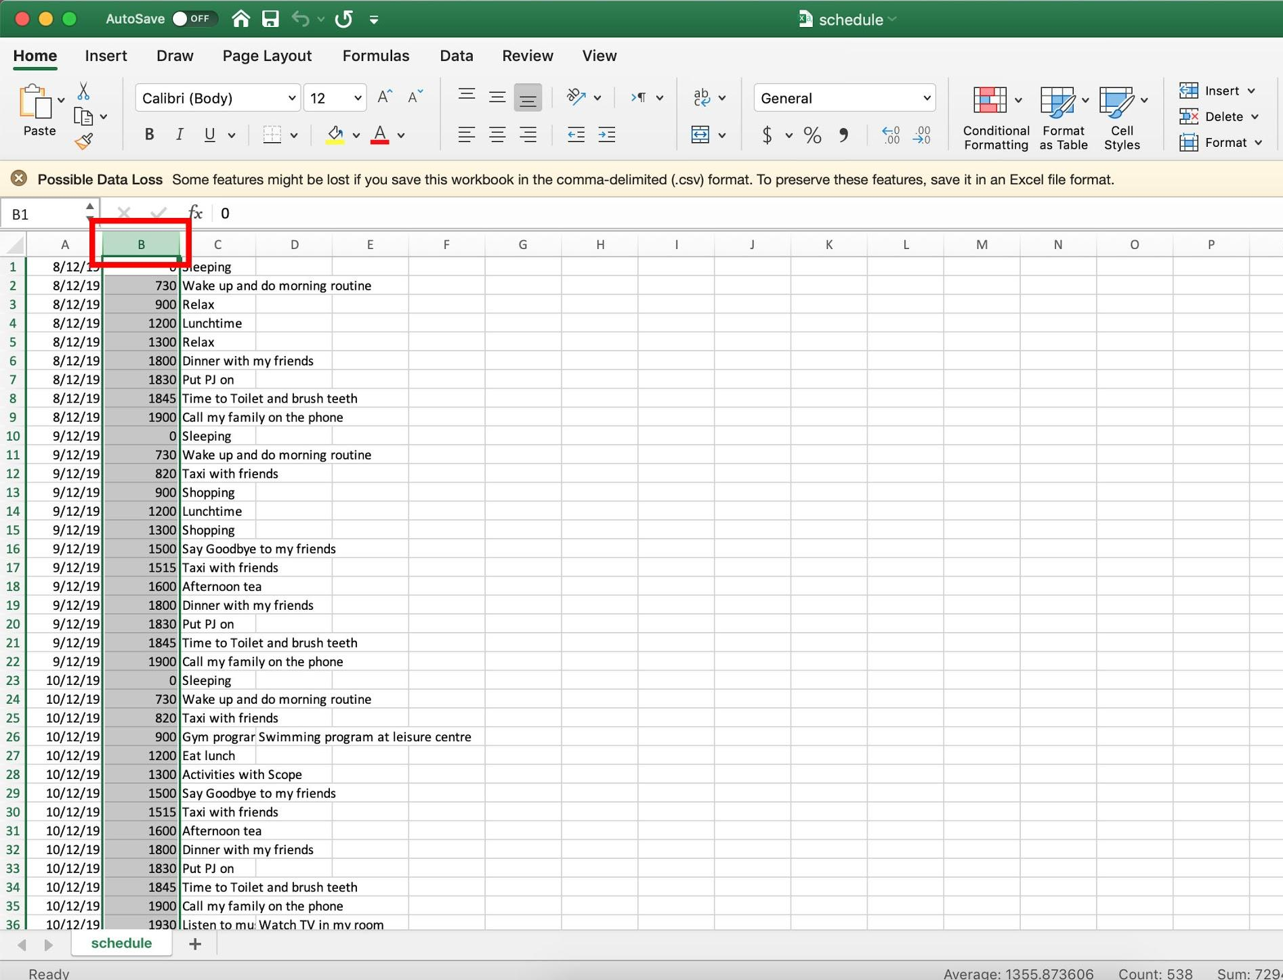
  - Click the dropdown arrow next to where it says “General” (red box) and then click “More Number Formats…”
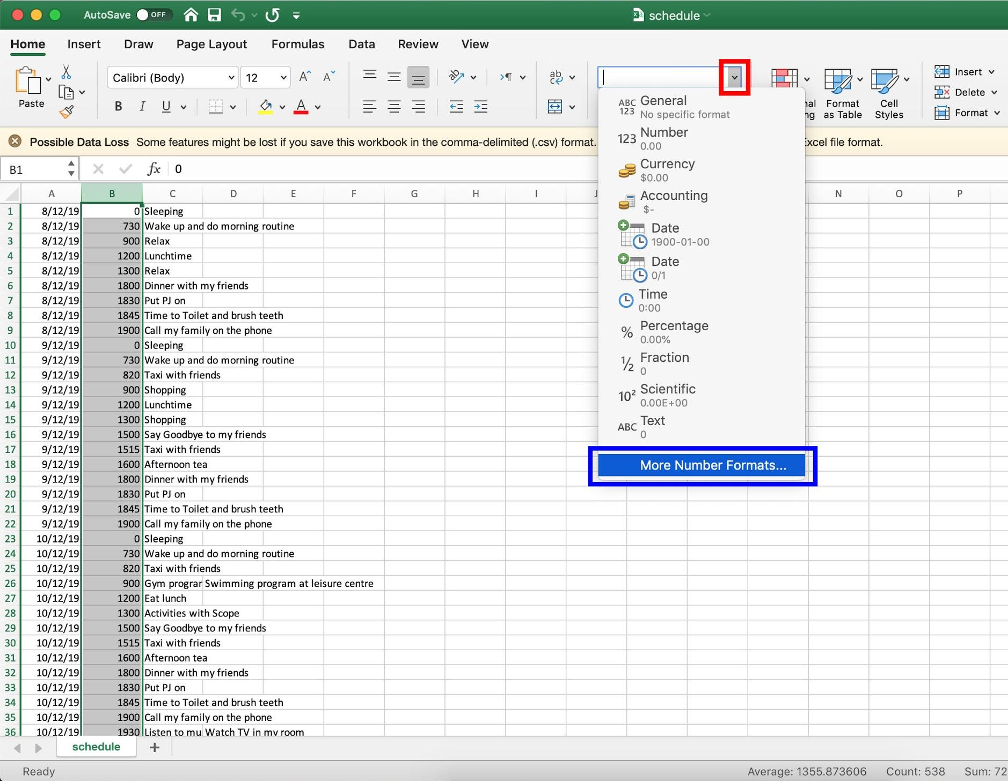
  - A popup dialogue will appear. Click “Custom” (red box) and then change the text to four zeroes “0000” (blue box). Then click OK.
  - The start time column should now be in a format with 4 digits like below
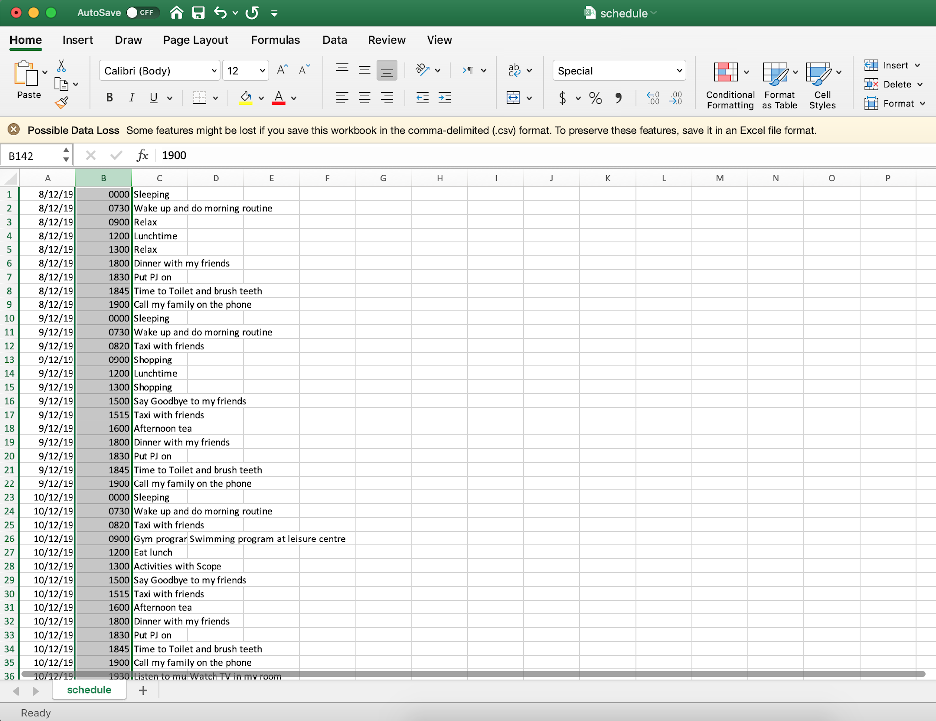
- Create a photo and name it exactly as the description you have typed without any punctuation and all lower case. Please only use .jpg format
For example the images in the table above are called:
- wake up and do morning routine.jpg
- go bowling.jpg
- go swimming.jpg
- Save the images to the “photos” folder

Update the Schedule and Photos on the iPad
- Plug the iPad to your laptop/desktop computer and open iTunes. Make sure the iPad can be seen on the computer; it should appear on the left hand side menu (red box)
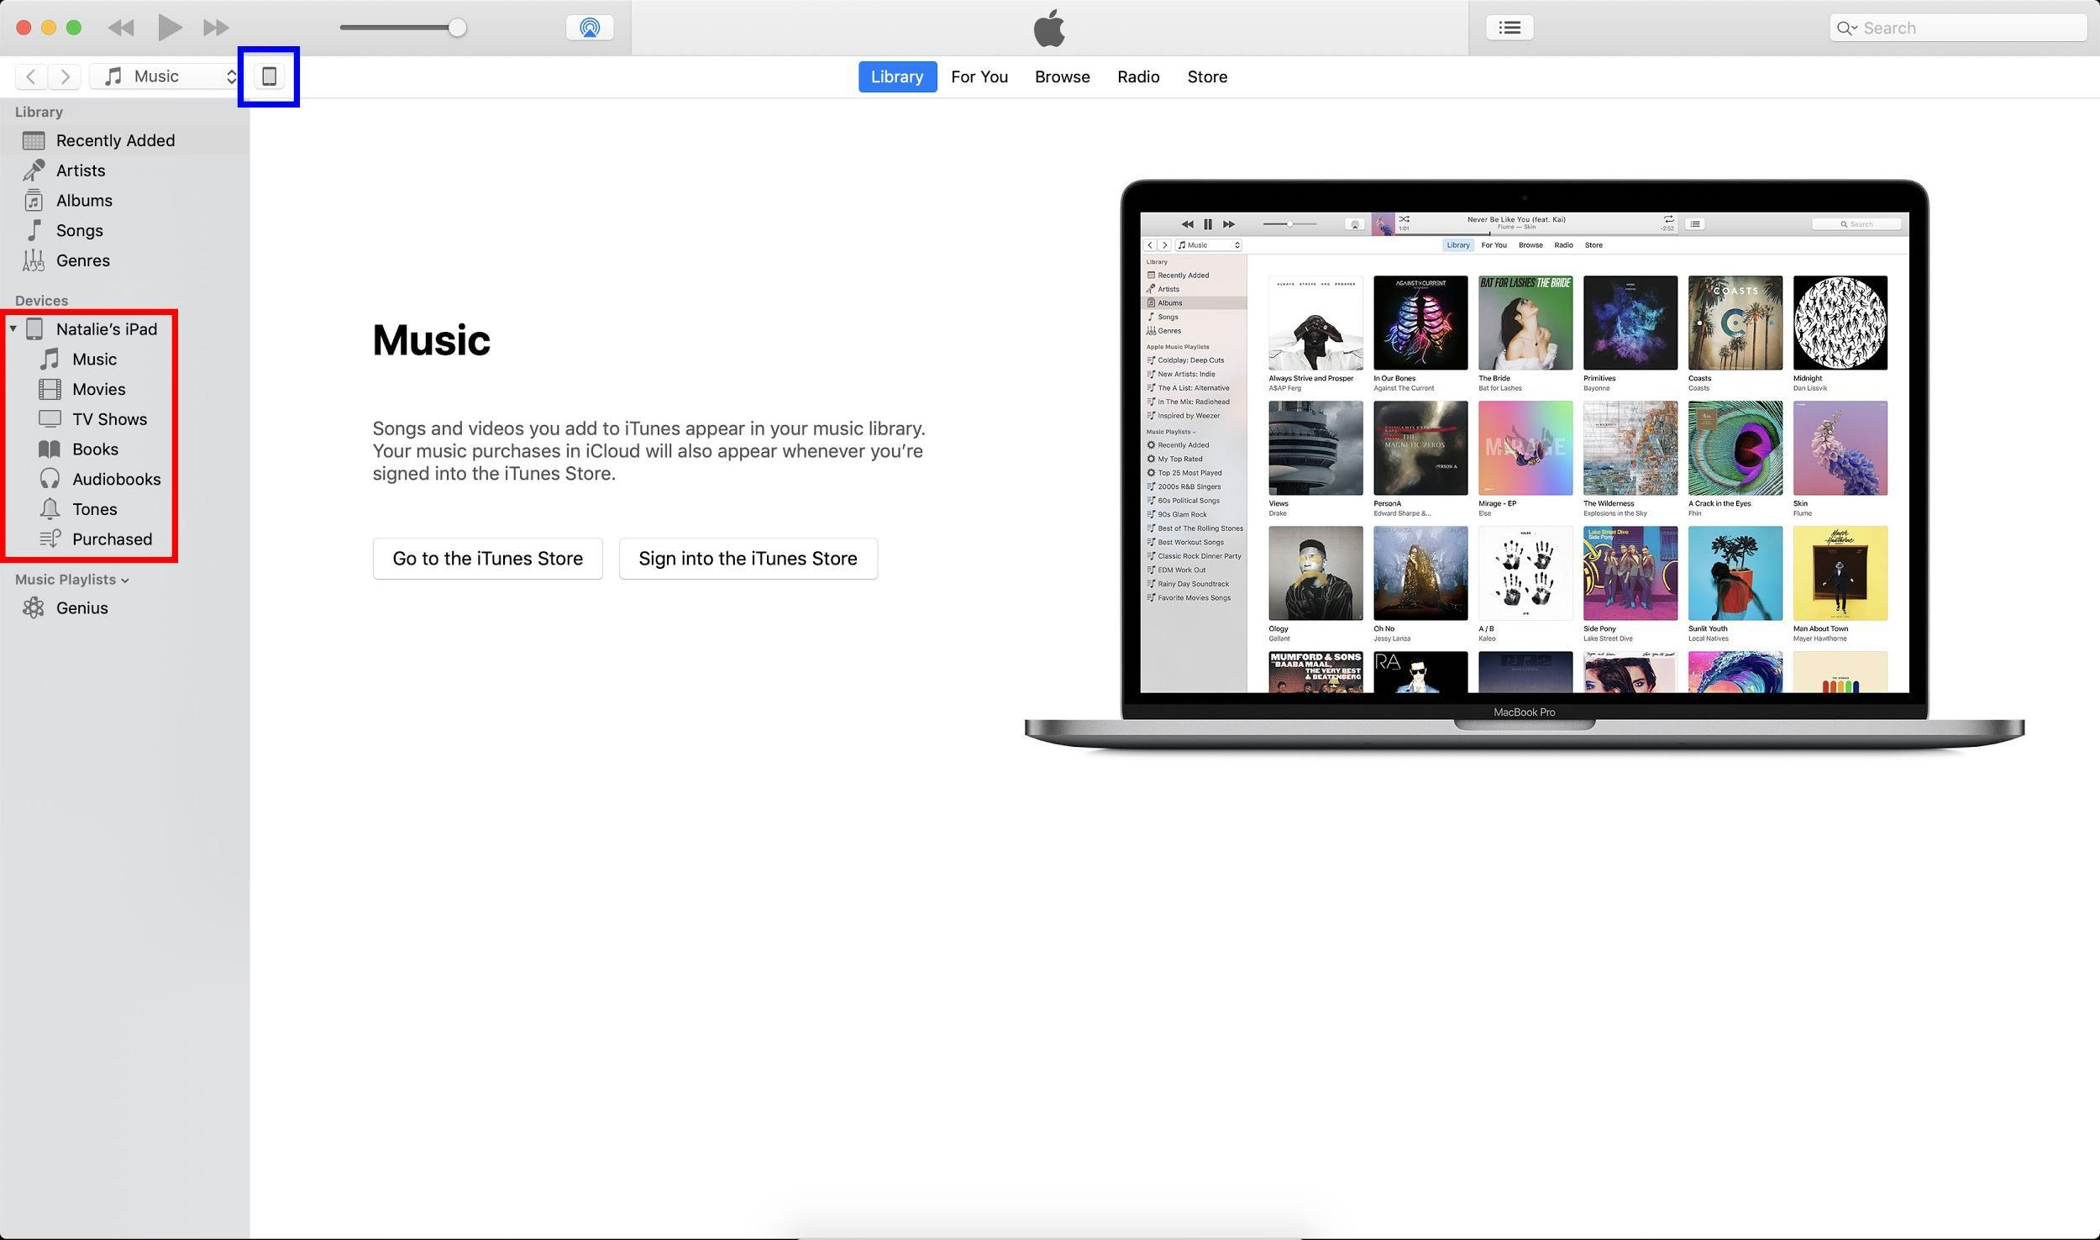

- Click the button with the phone icon, next to the "Music" dropdown menu to access the iPad settings (blue box)
- Click on ‘File Sharing’ on the left hand side menu (red box)
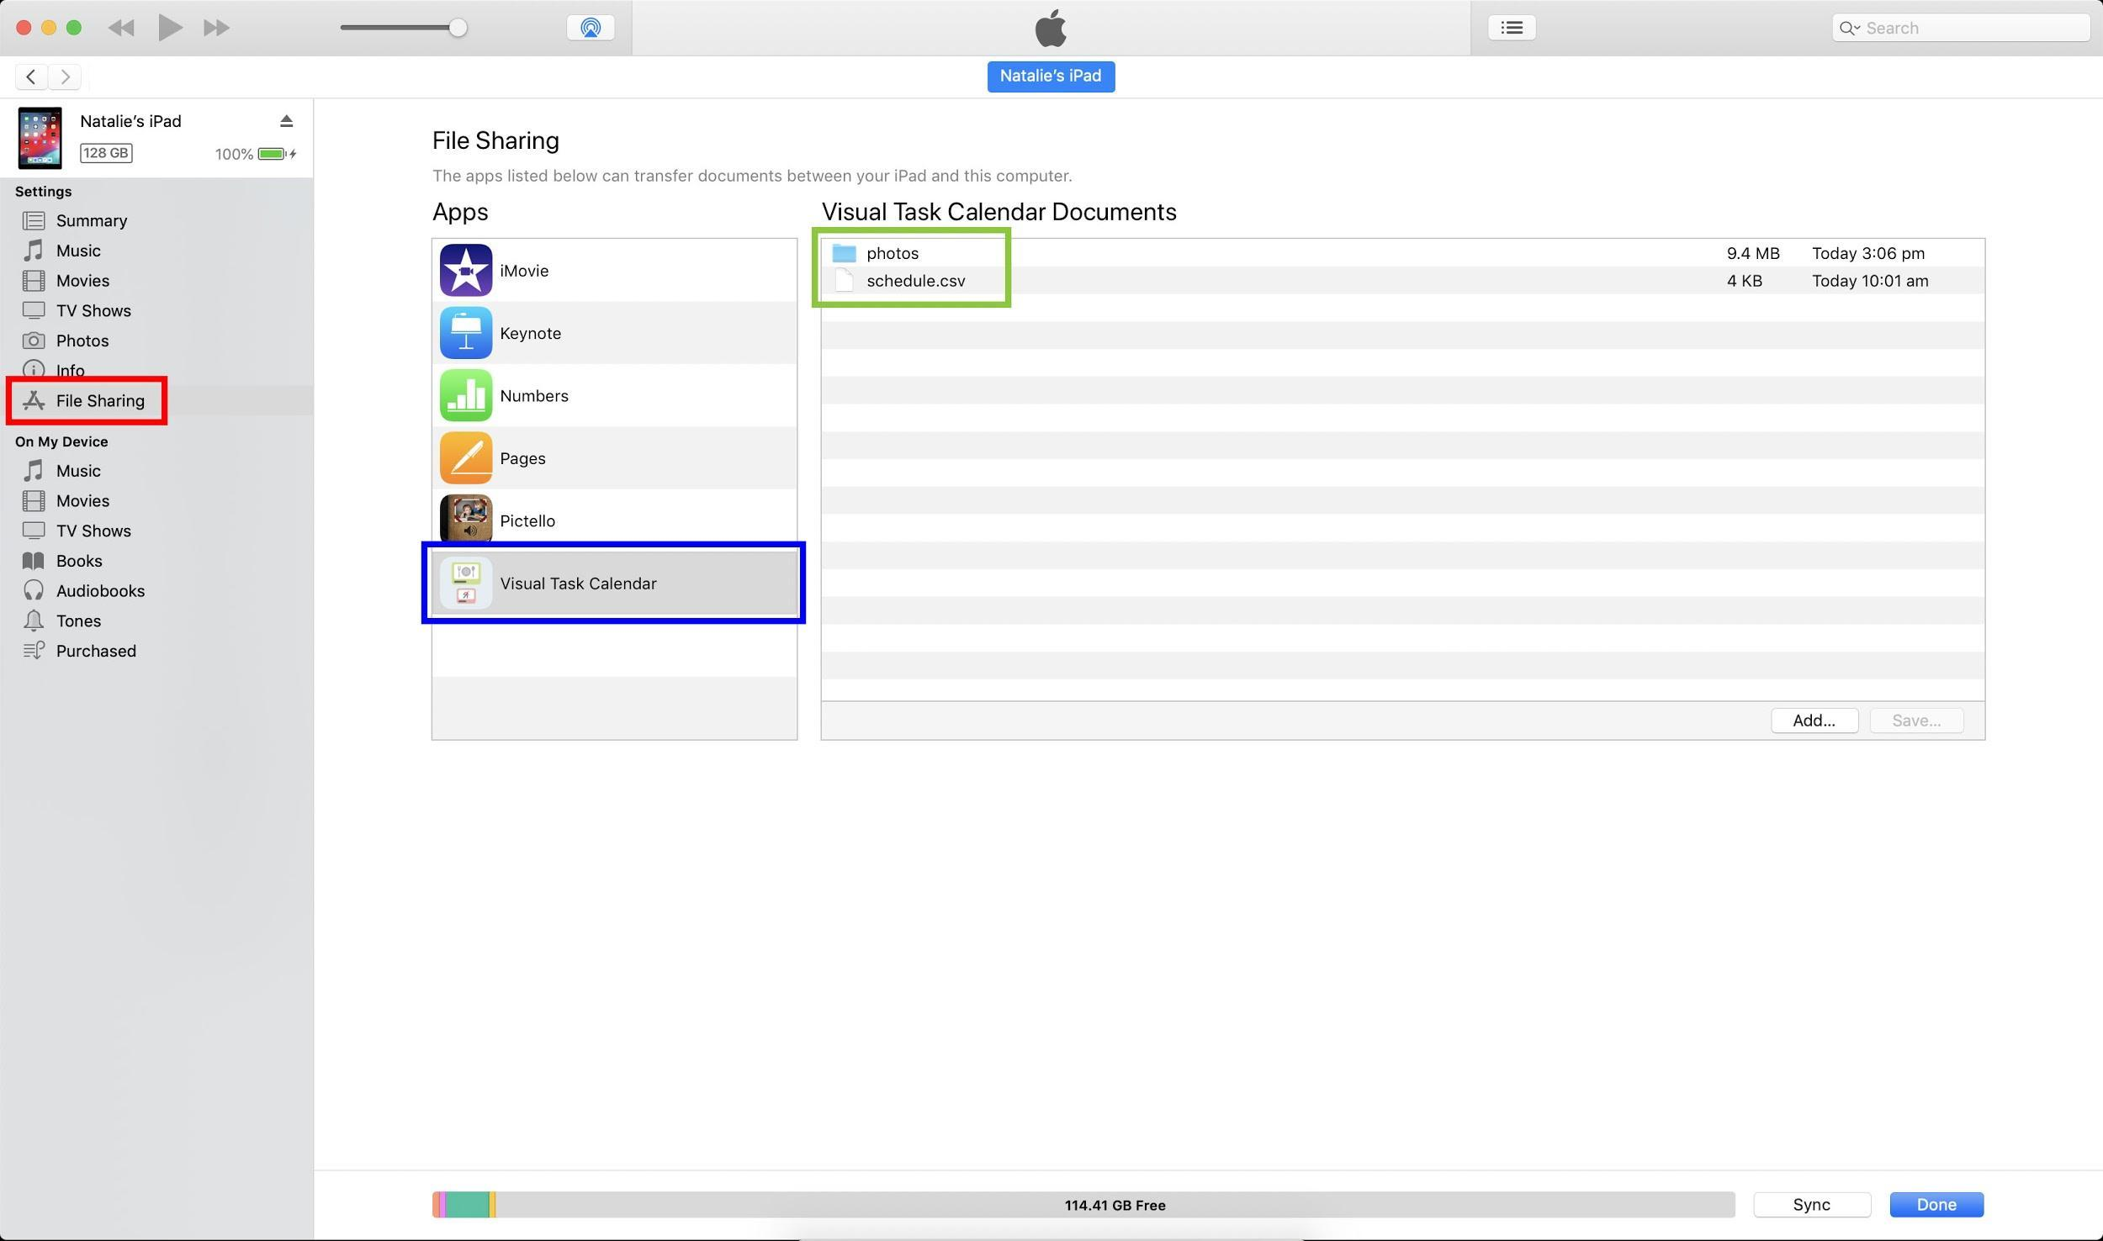

- Click on Visual Task Calendar App (blue box). You should see a “photos” folder and a "schedule.csv" file (green box)
- Click "add" (red box). A pop-up will appear. Locate your new "schedule.csv" file on your laptop/computer and select it (blue box). Then click “add” (green box)
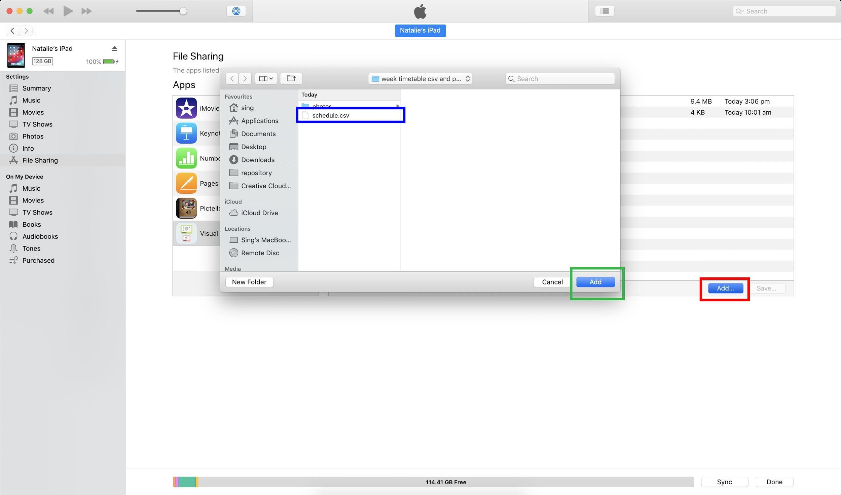
- Another pop-up will appear, click "replace"
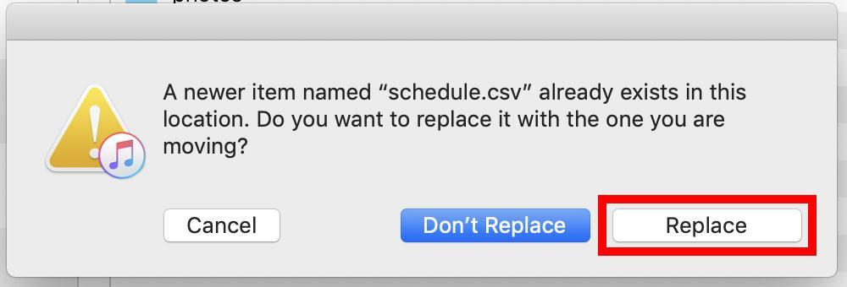

- Repeat steps 1 - 6 with any photos you have created or edited

Appendix

History of Development and Meeting Notes
Date | Description
16/10/19 | Team creation:  - Full stack developer  - Software developer x2  - UI/UX designer  - Marketing and design  - Product design engineering student
29/10/19 | PreTOM:  - Introductions between team and need-knower Jennifer Bur  - Getting to know and understanding Natalie and Jennifer  - Explanation of problem  - Q and A with Jennifer Bur (see Appendix 2. Design Brief Notes)
6/11/19 | Meeting 1:  - Problem definition  - Current user journeys  - Initial design decisions  - Initial tasks list  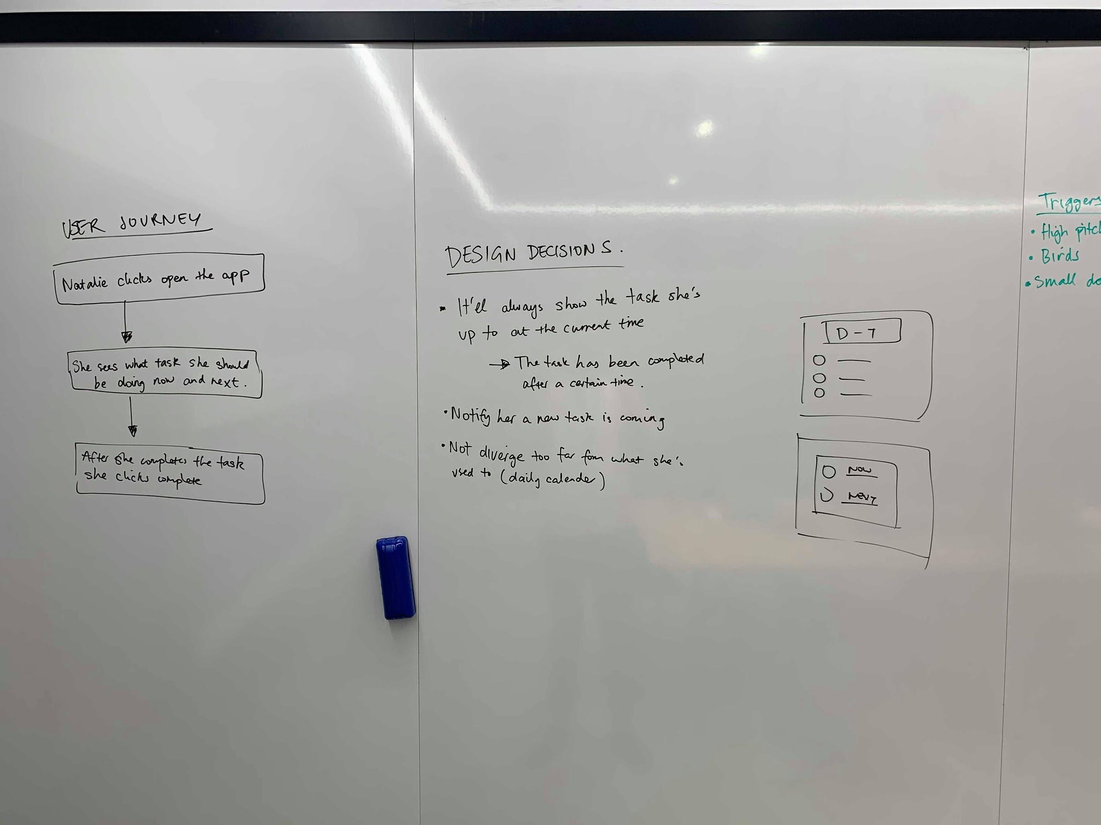  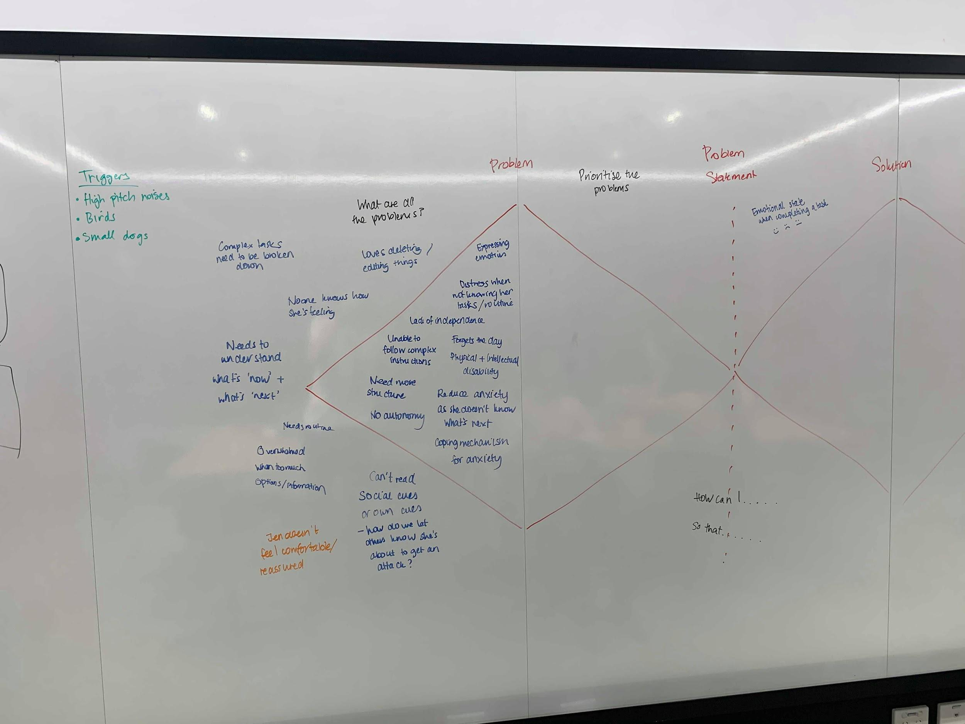  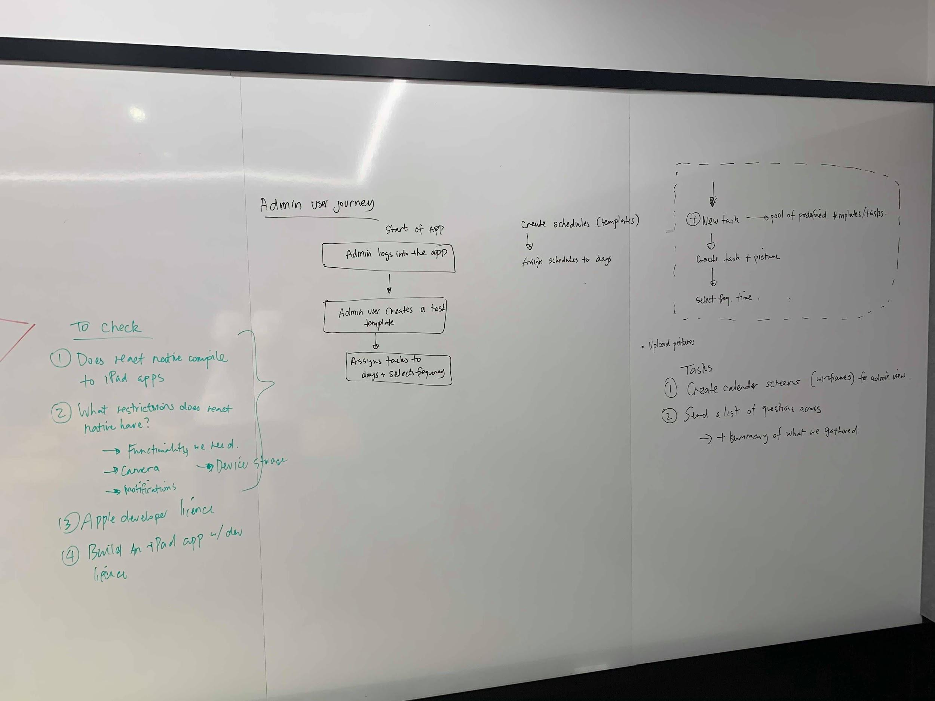
11/11/19 | Design Night 1:  Further questions and clarifications (see Appendix 3. Further questions)  Initial wireframes and feedback or admin and Natalie’s views  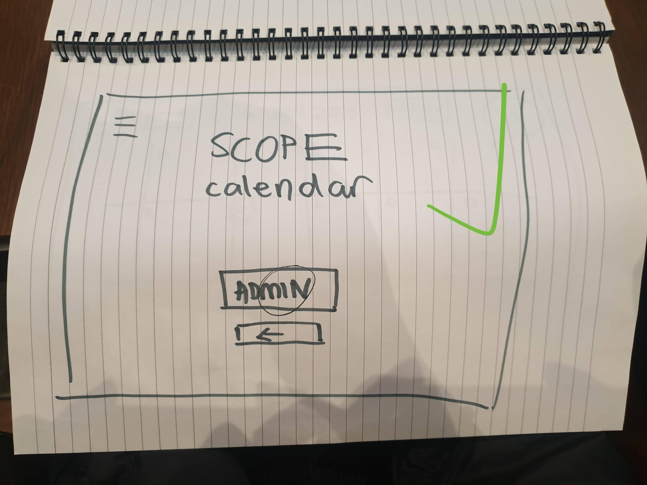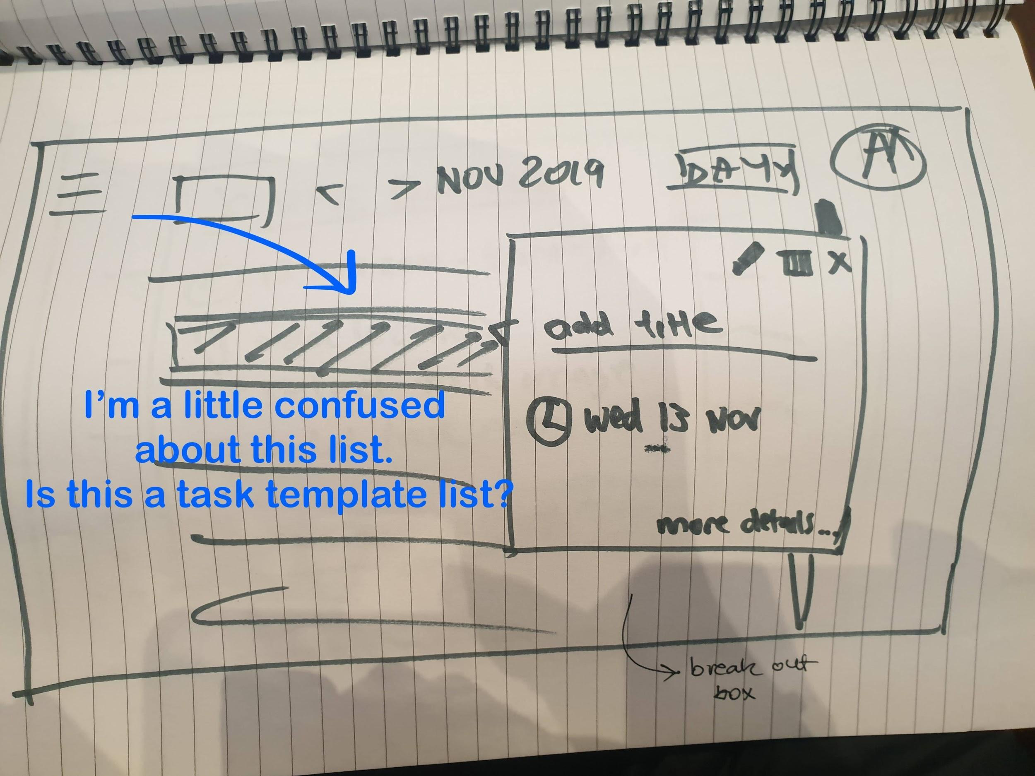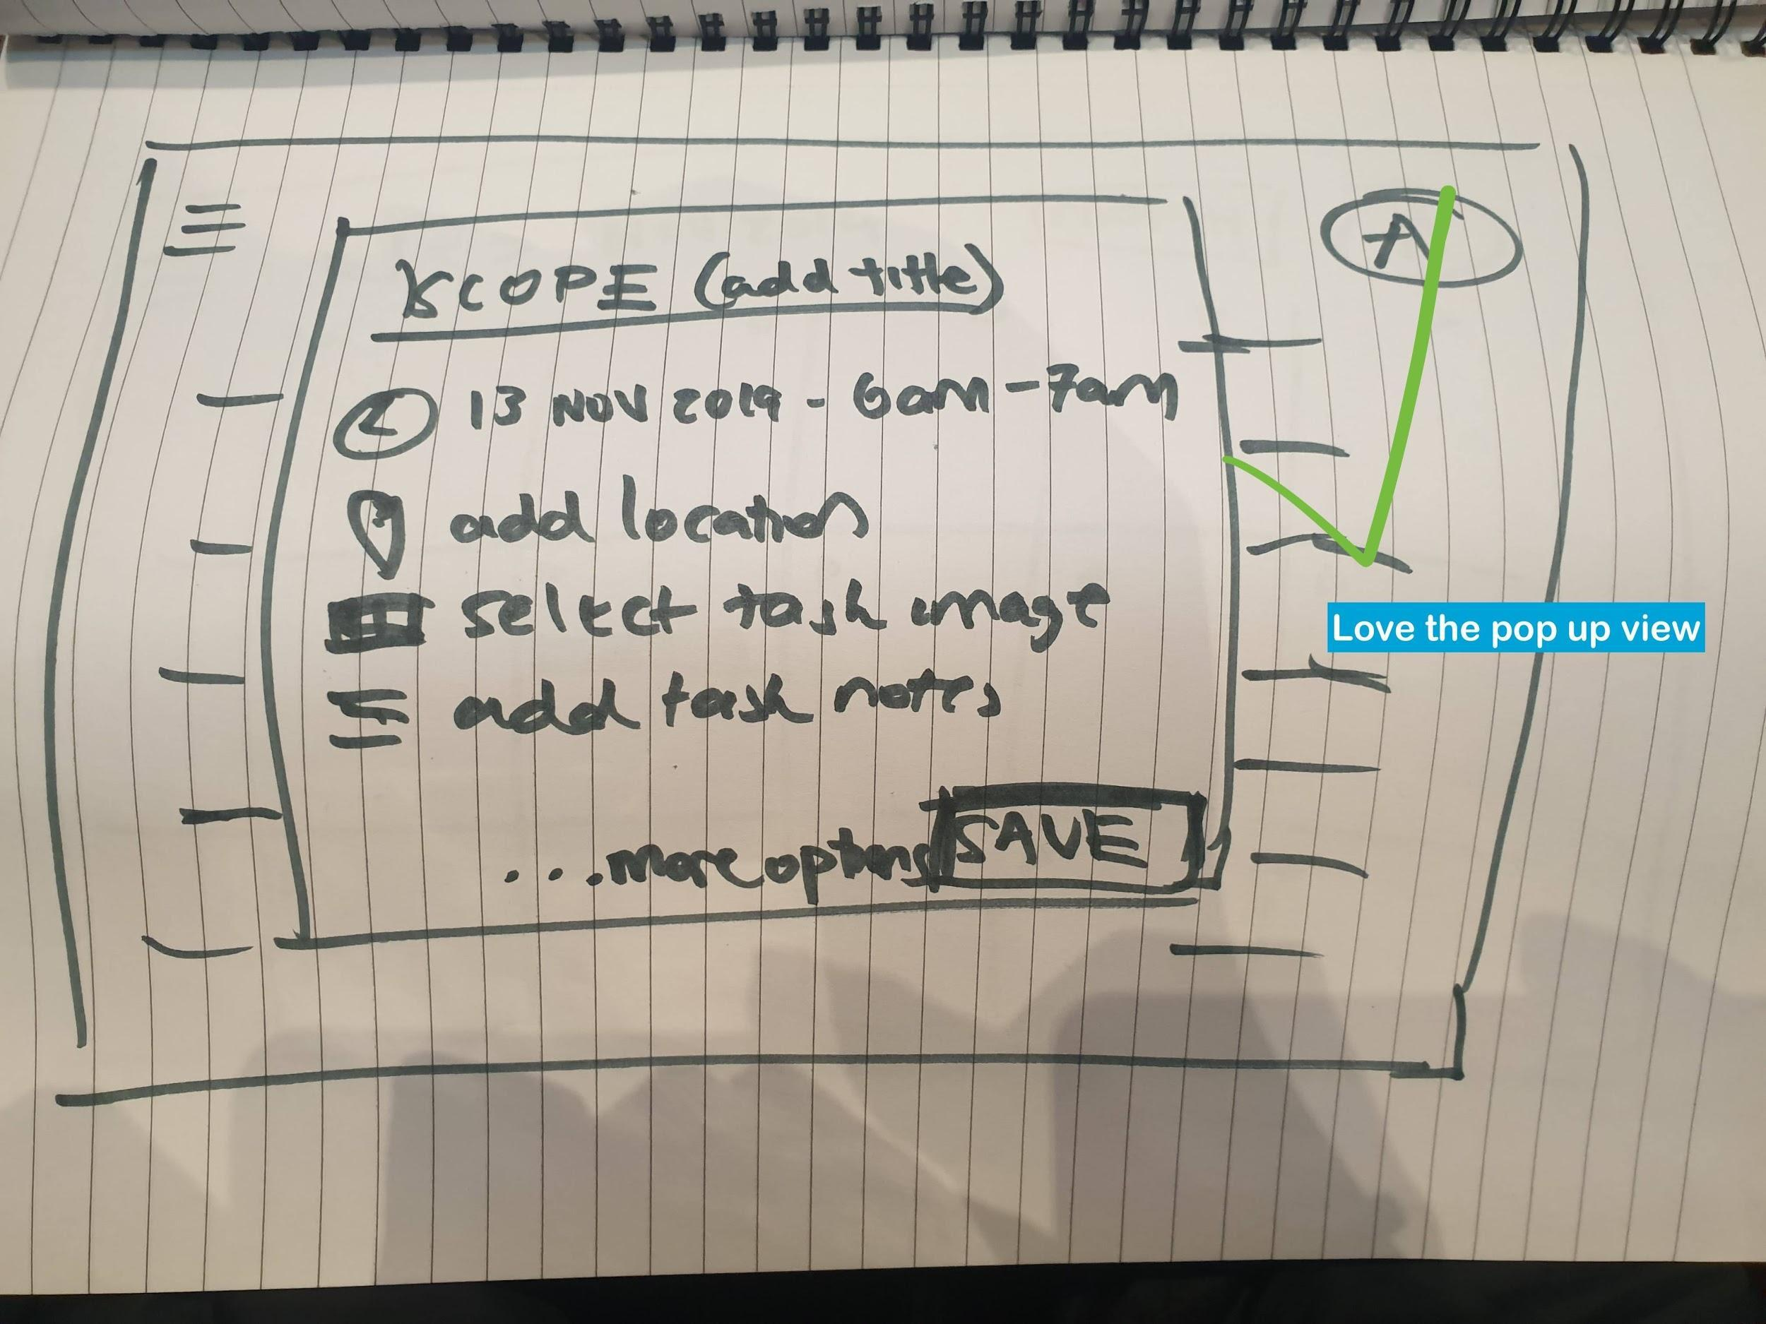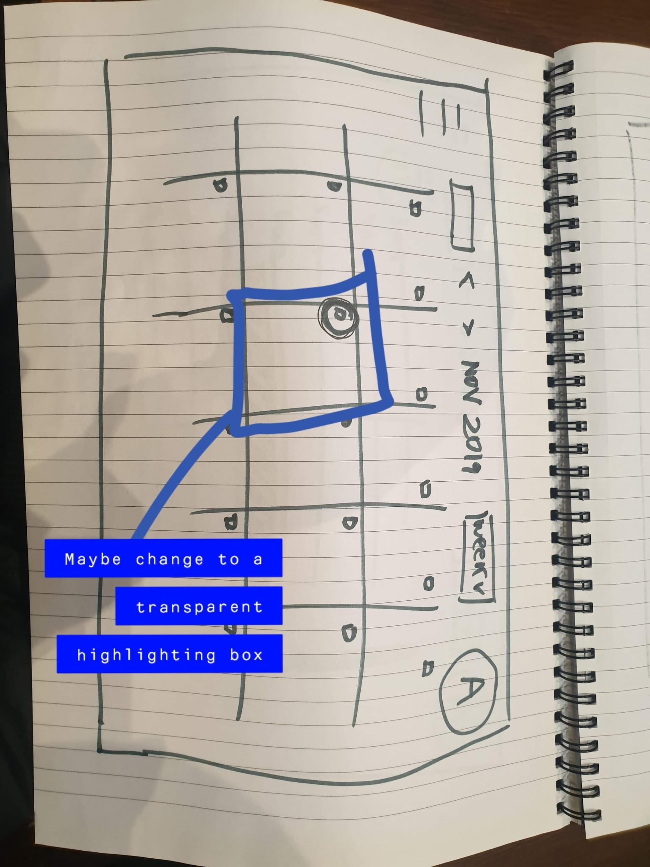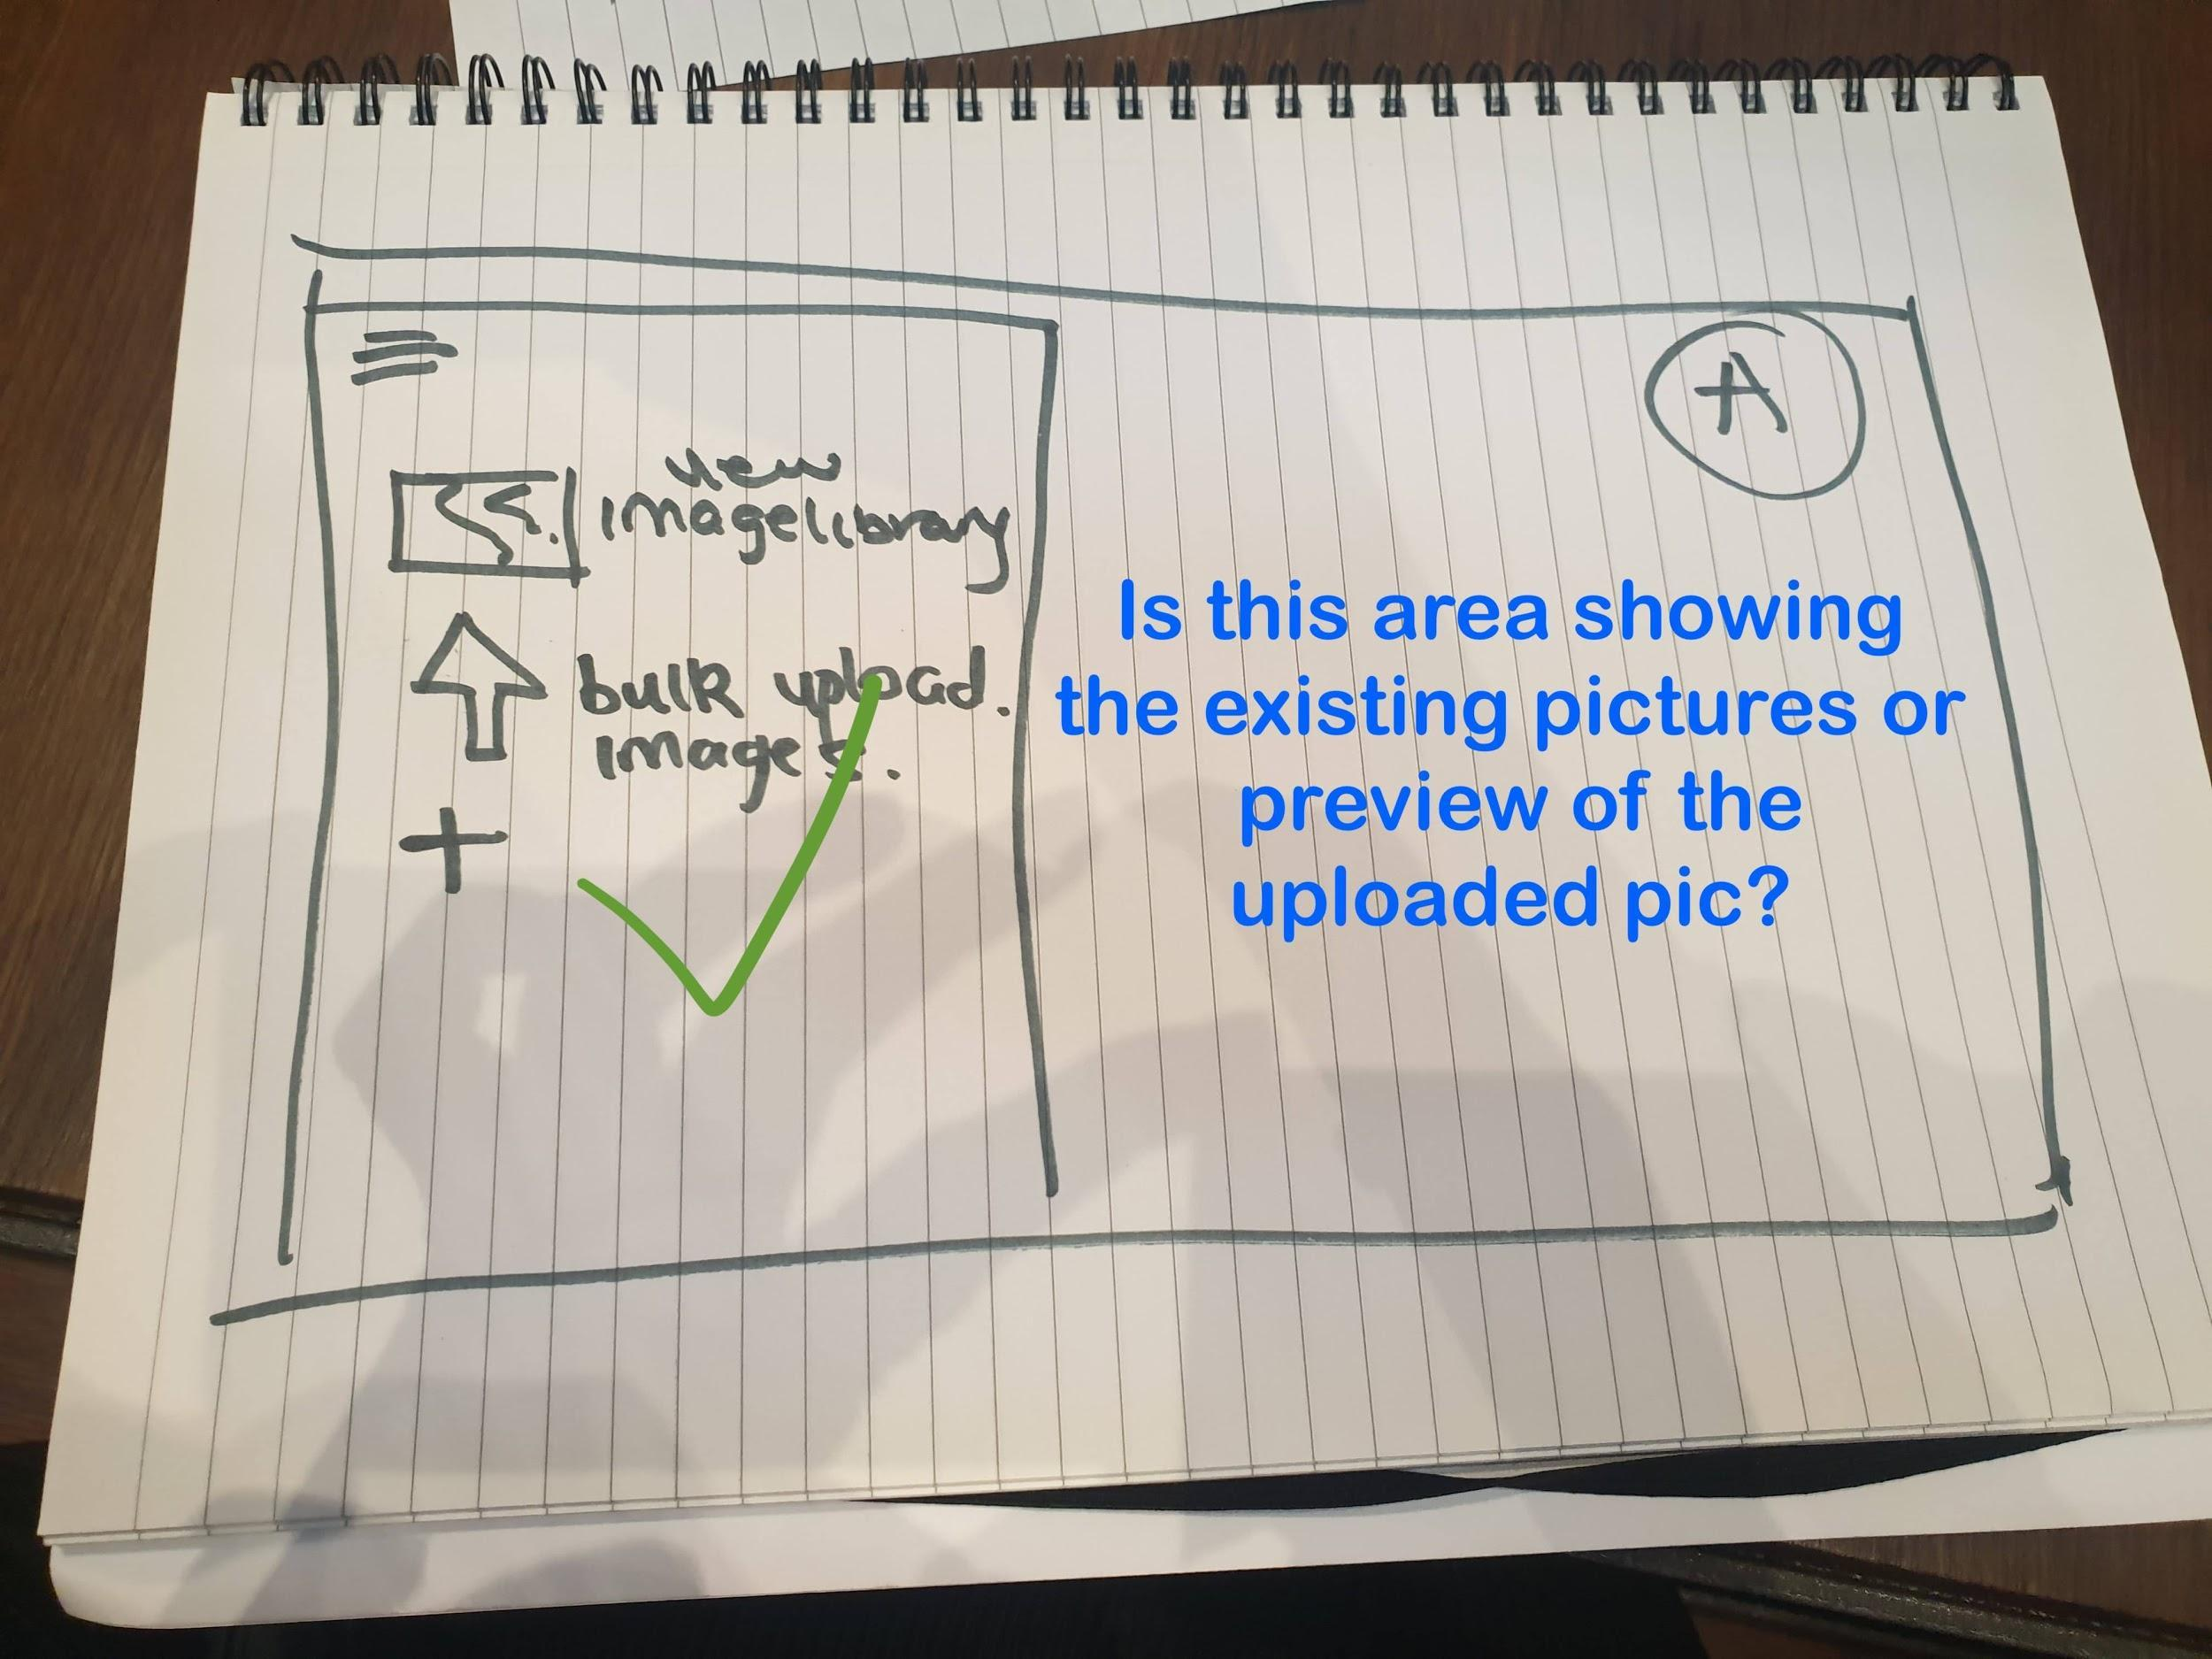  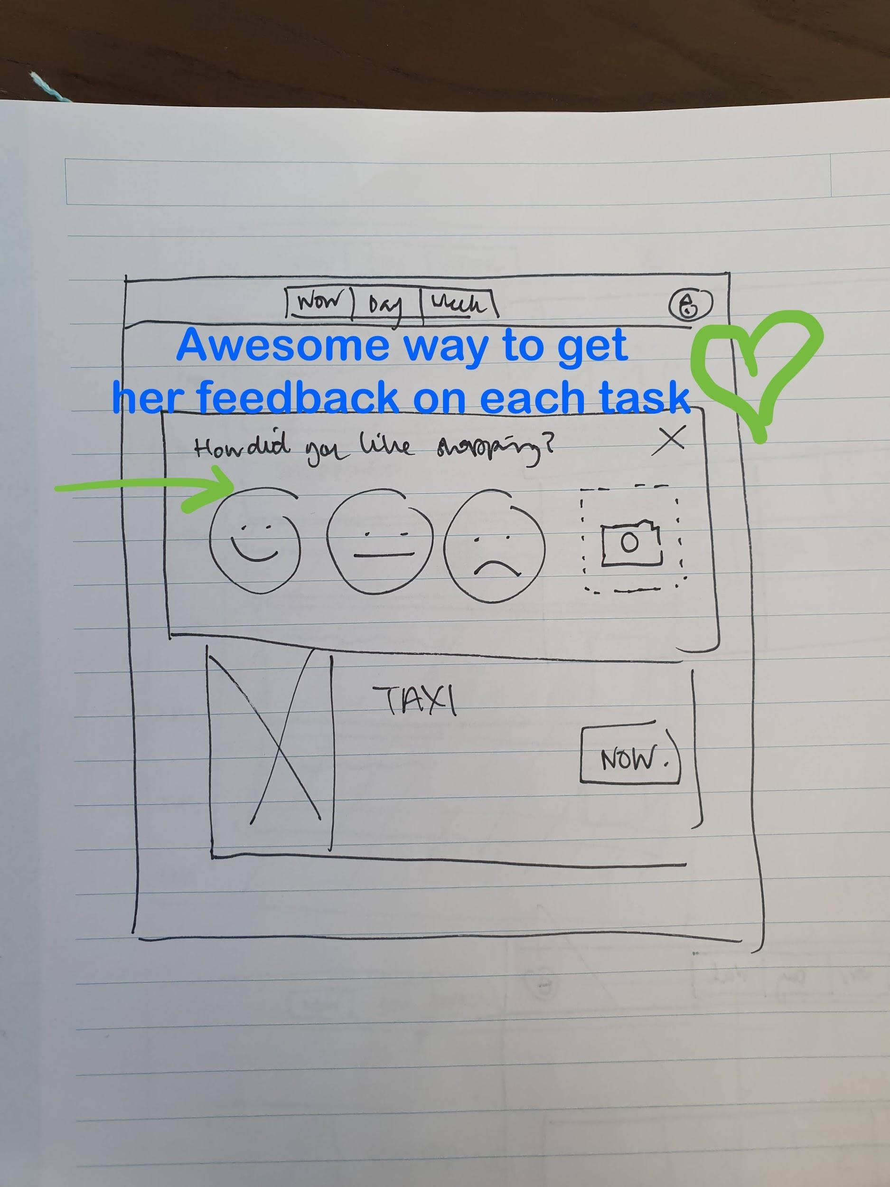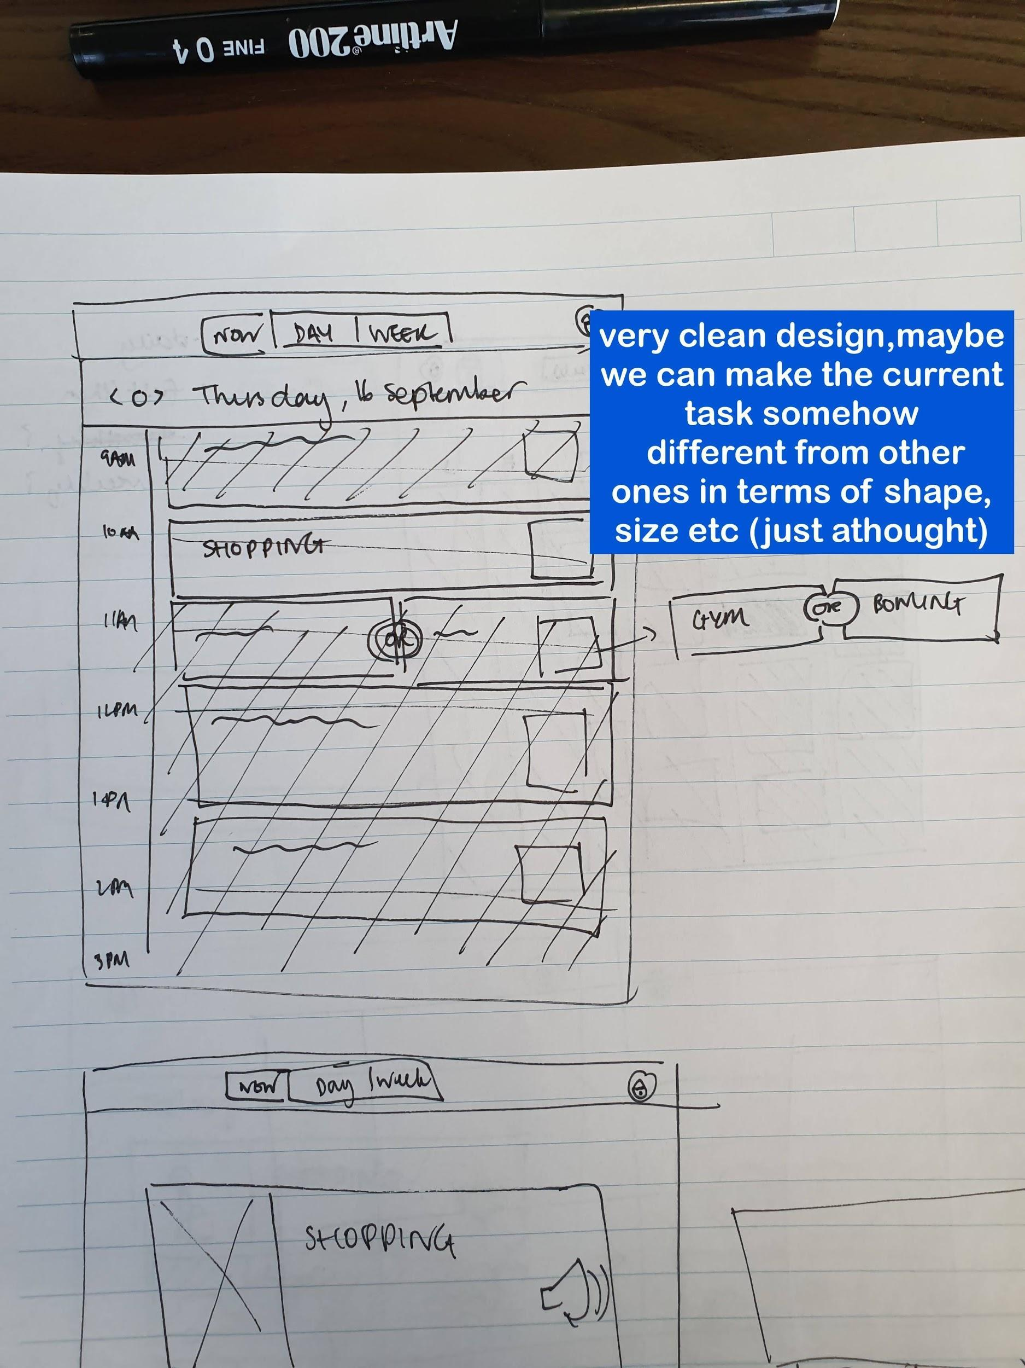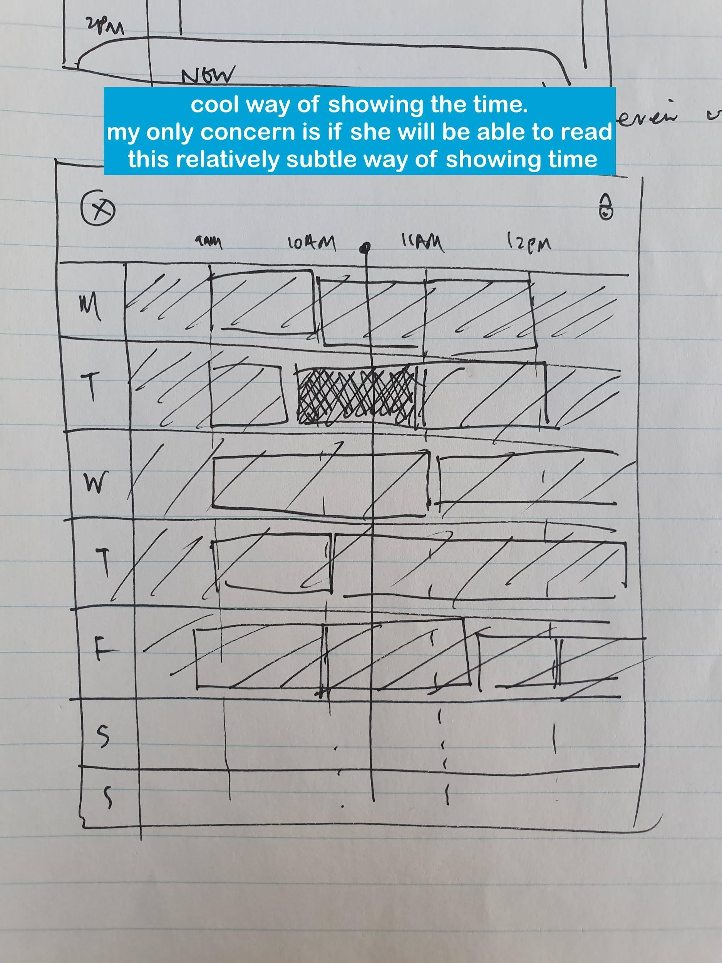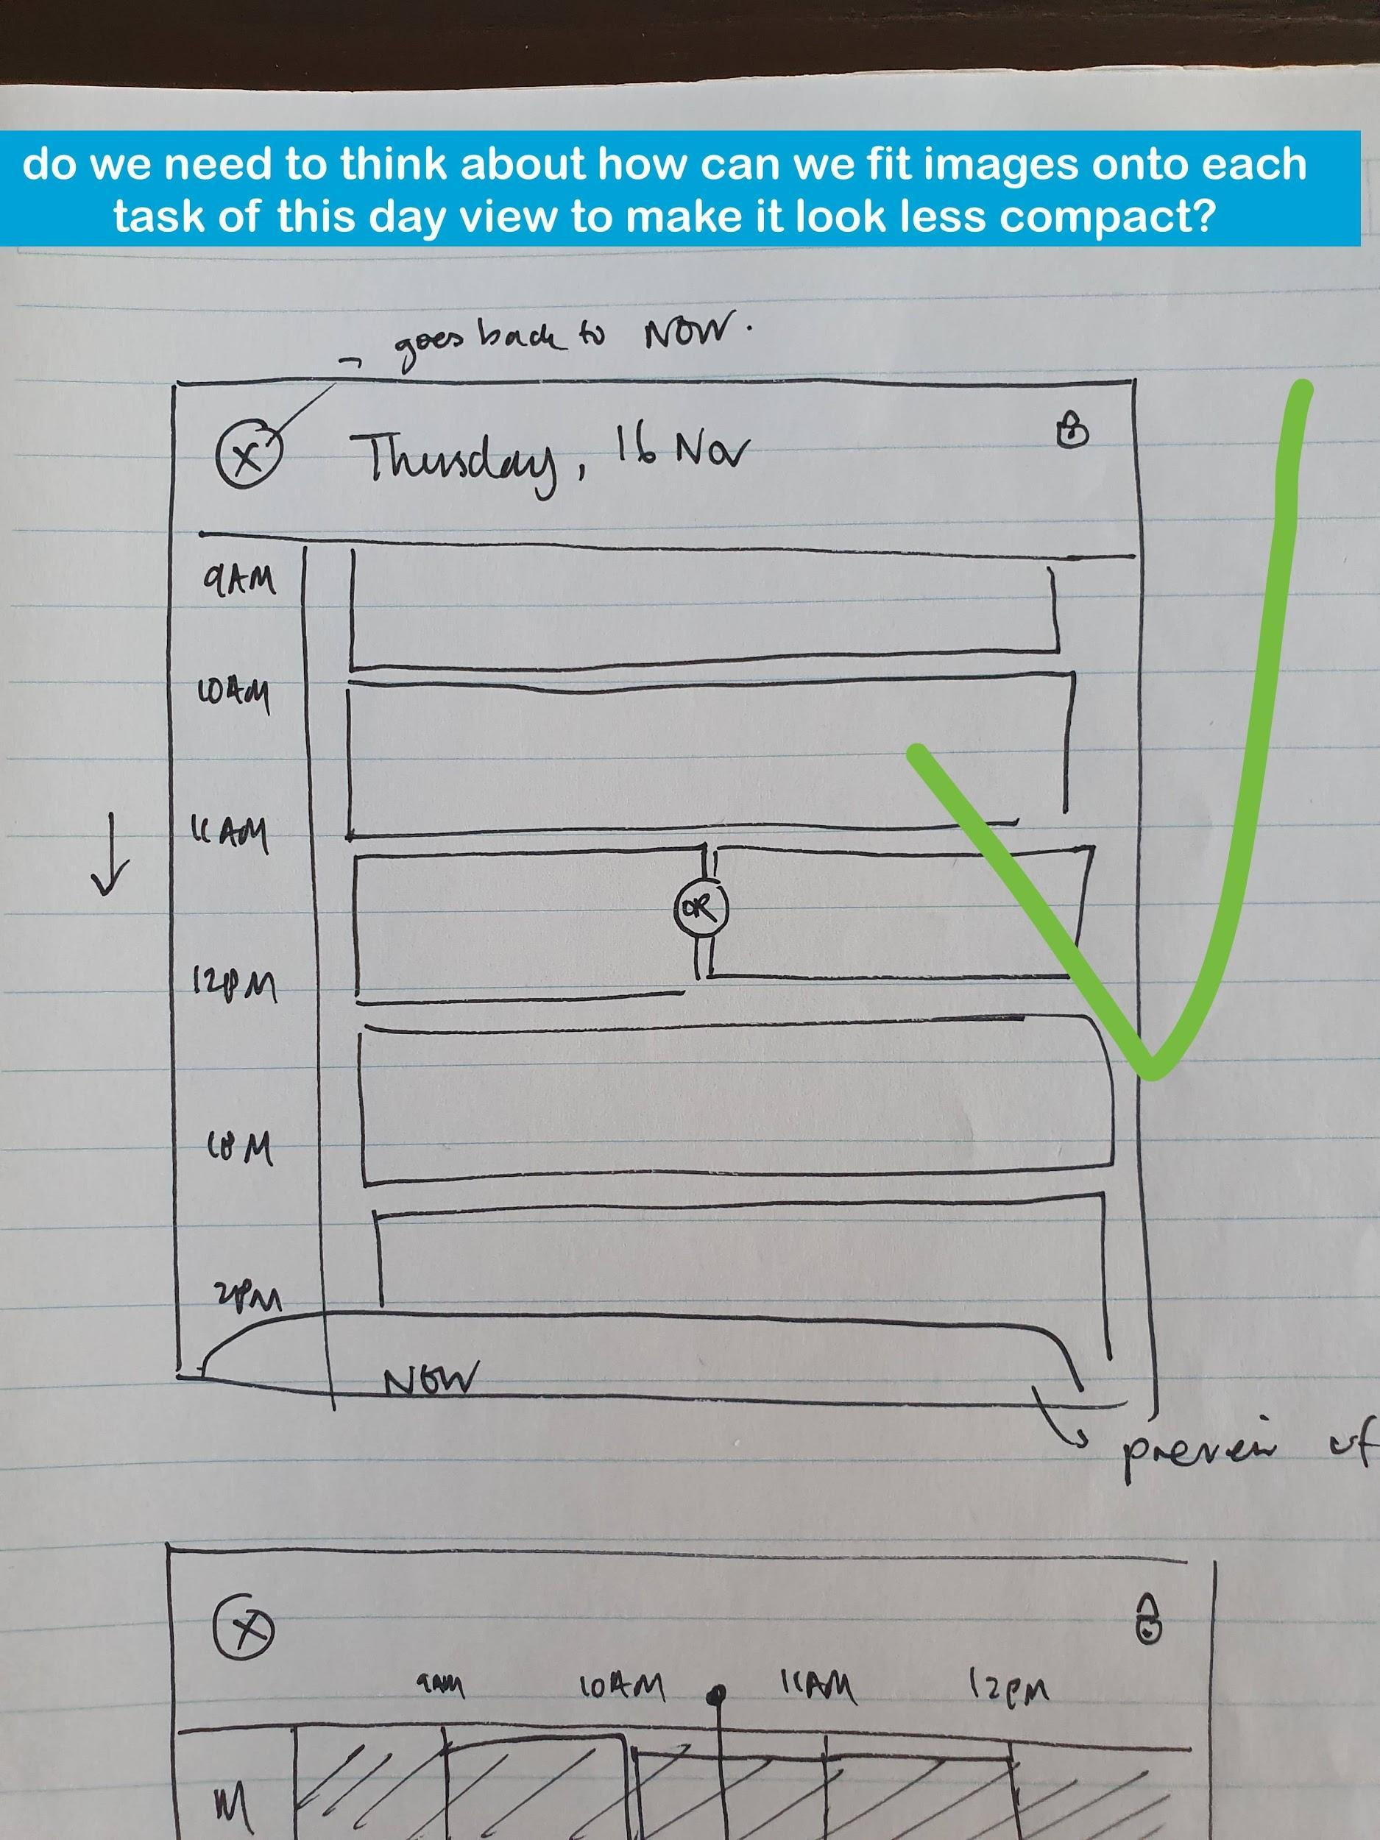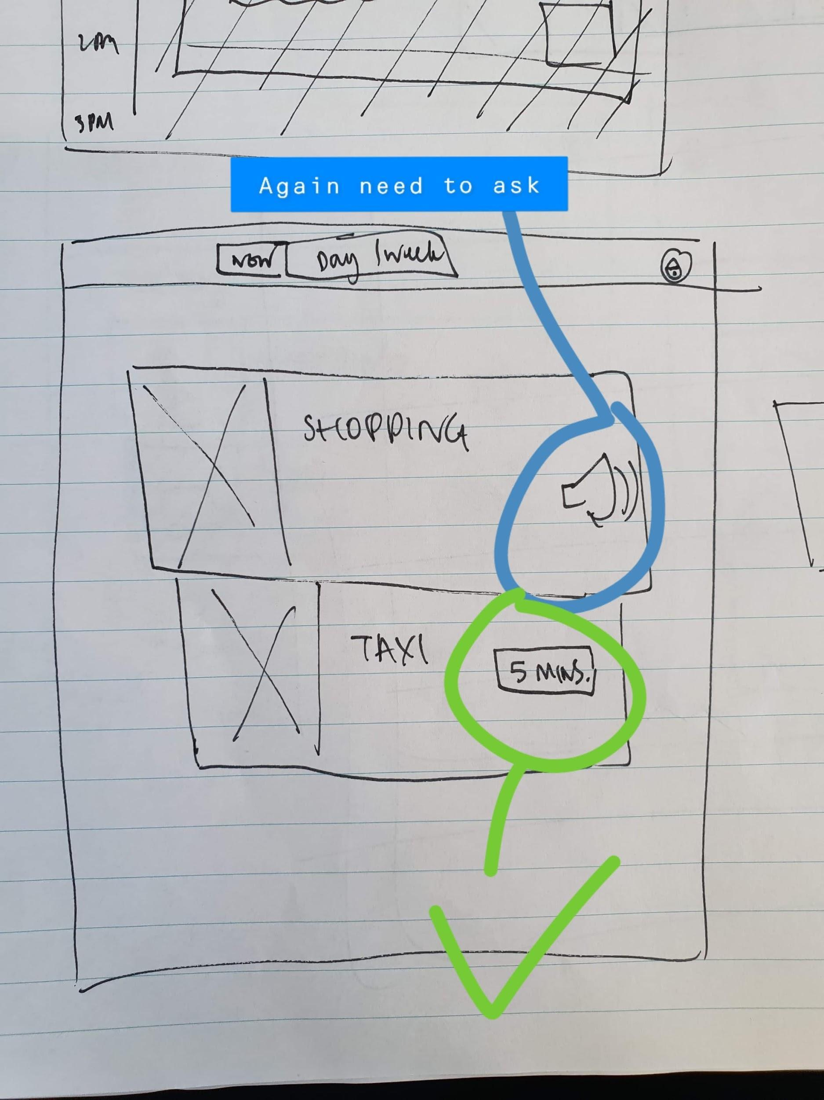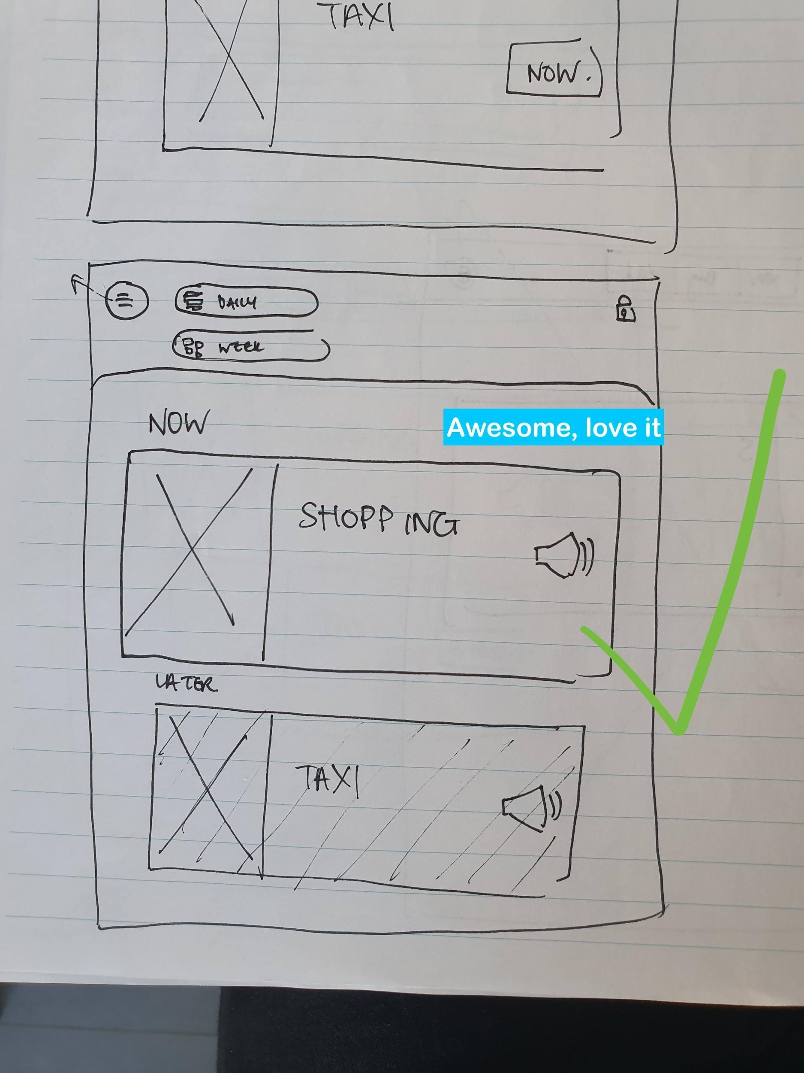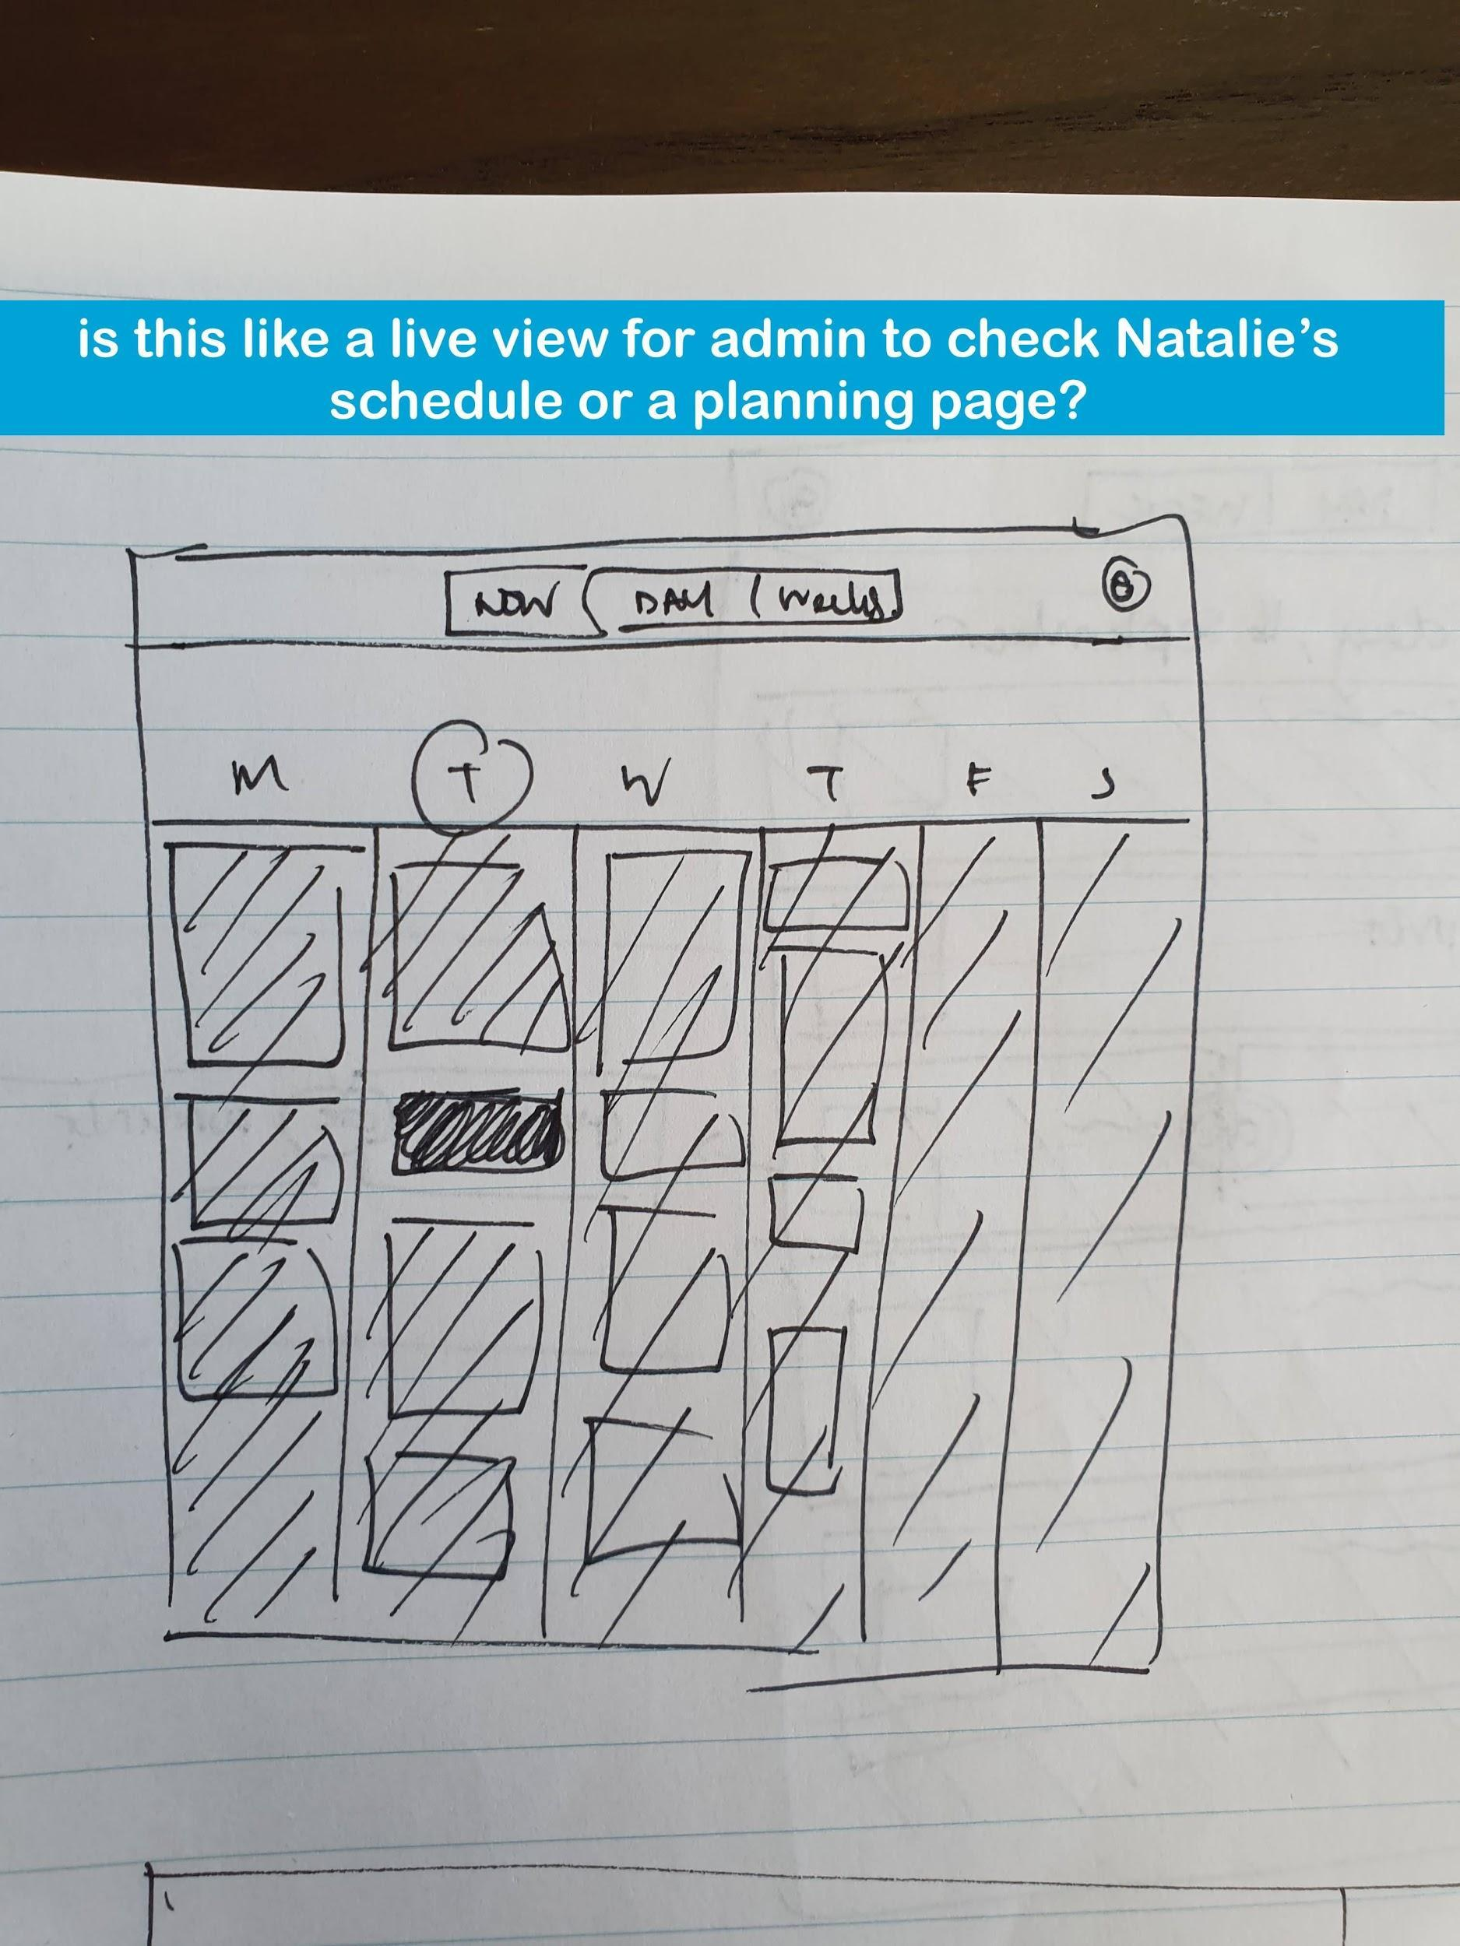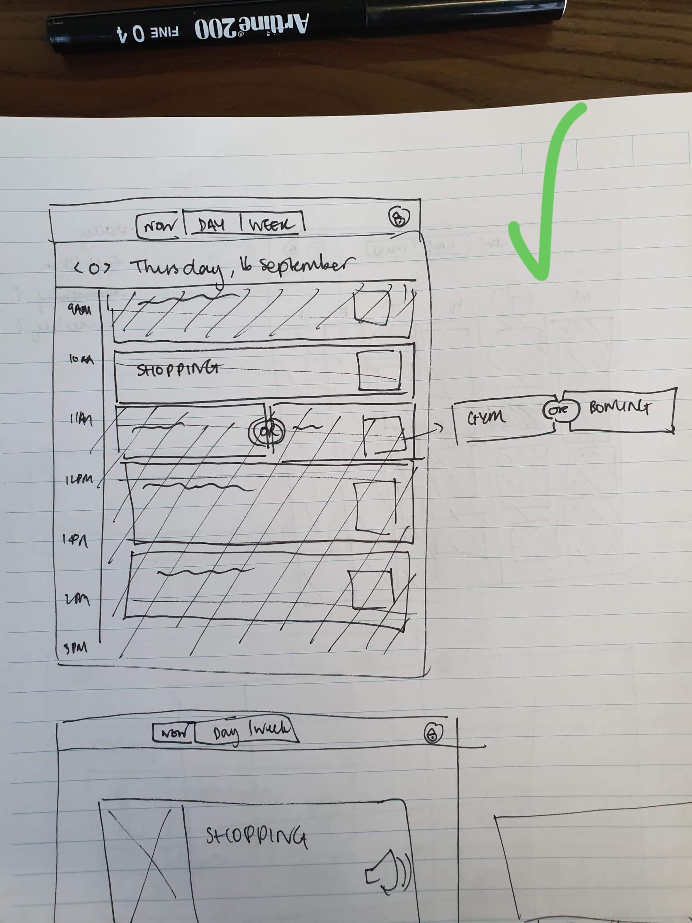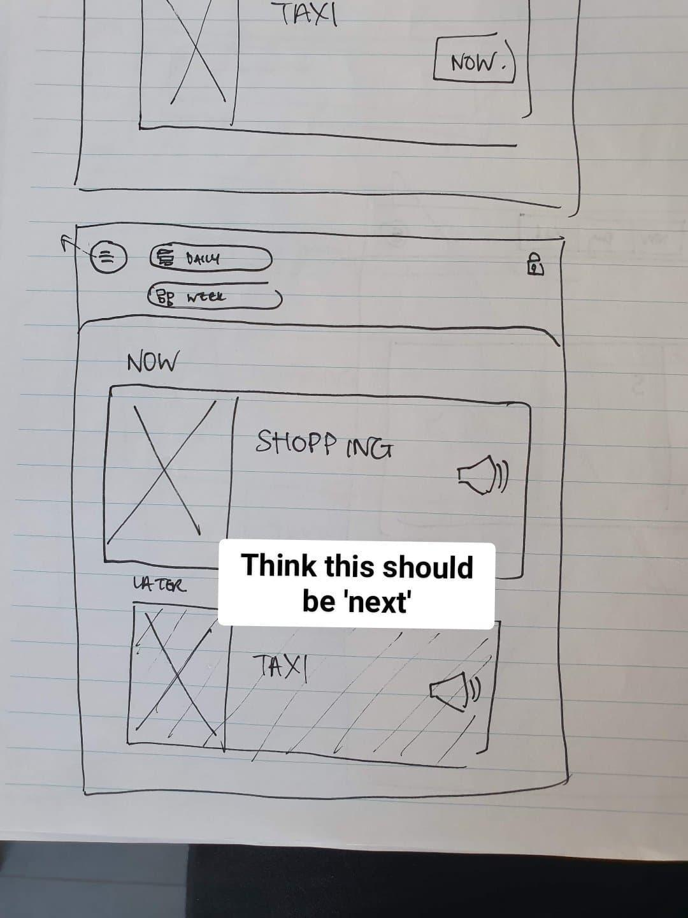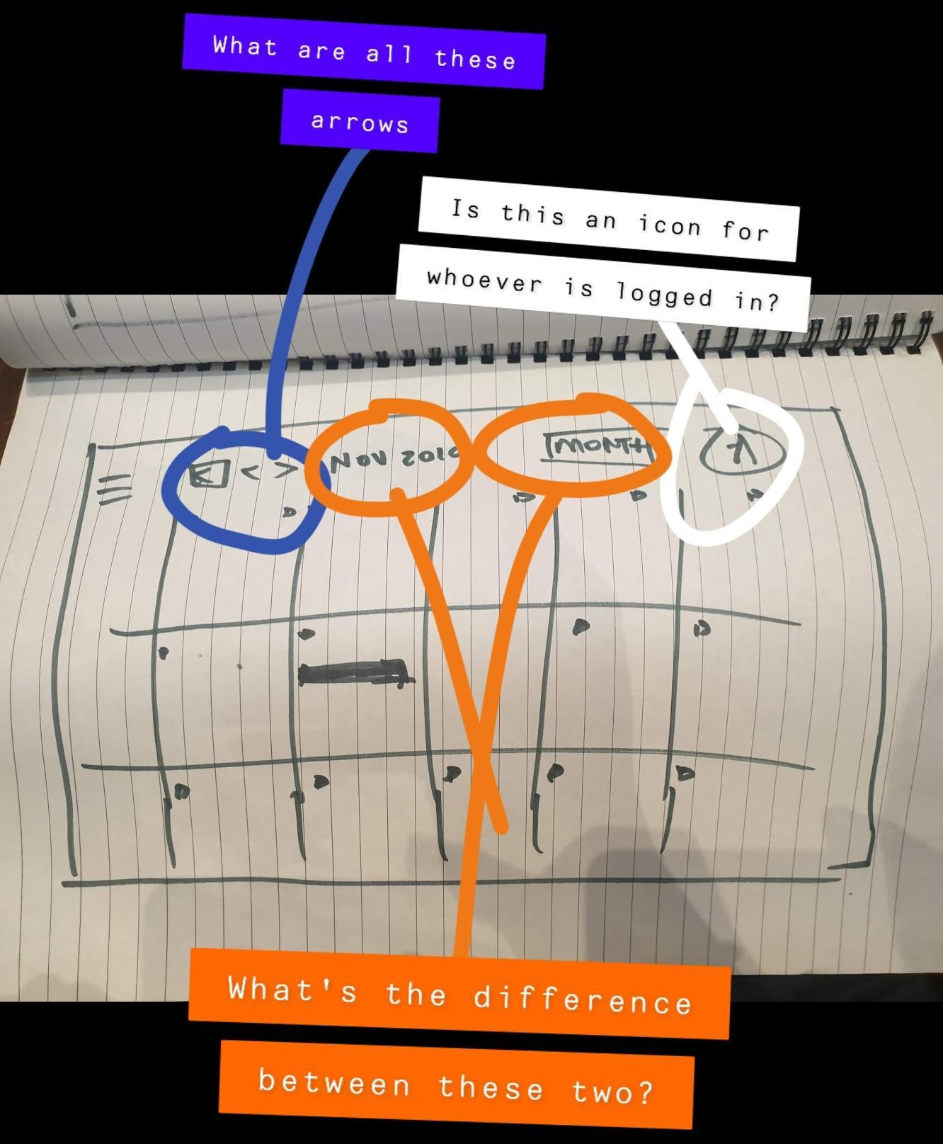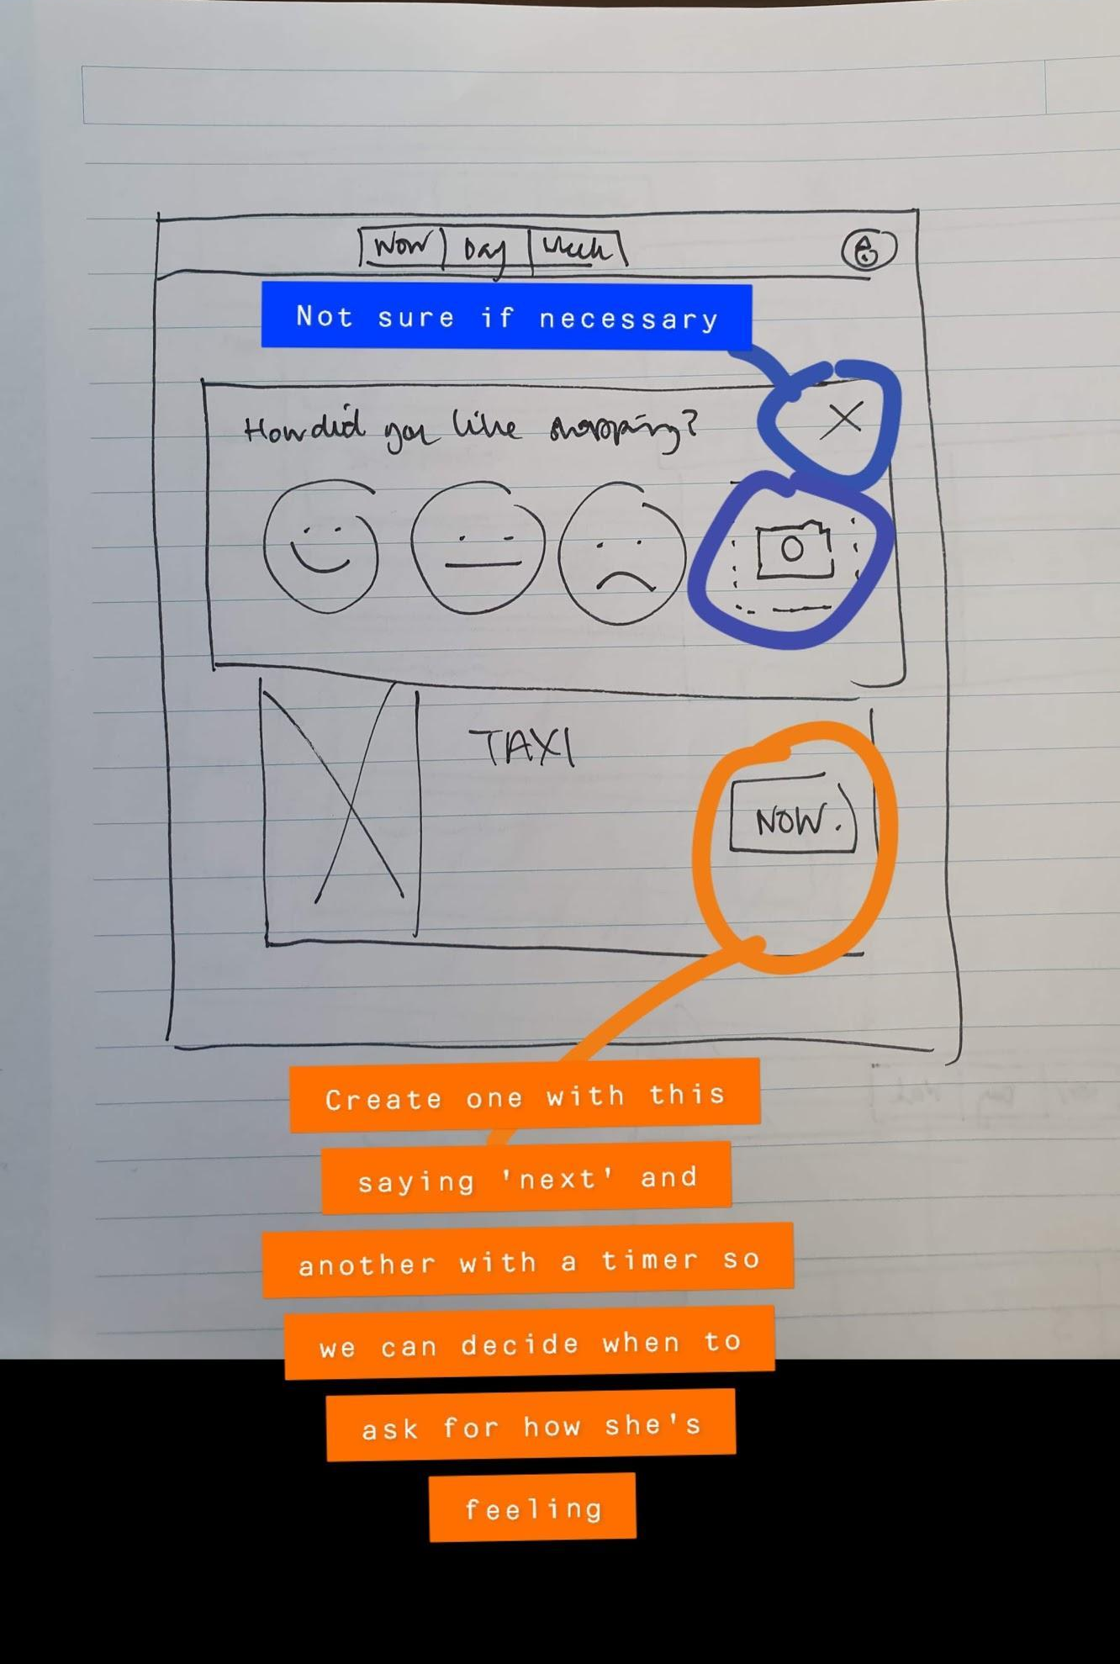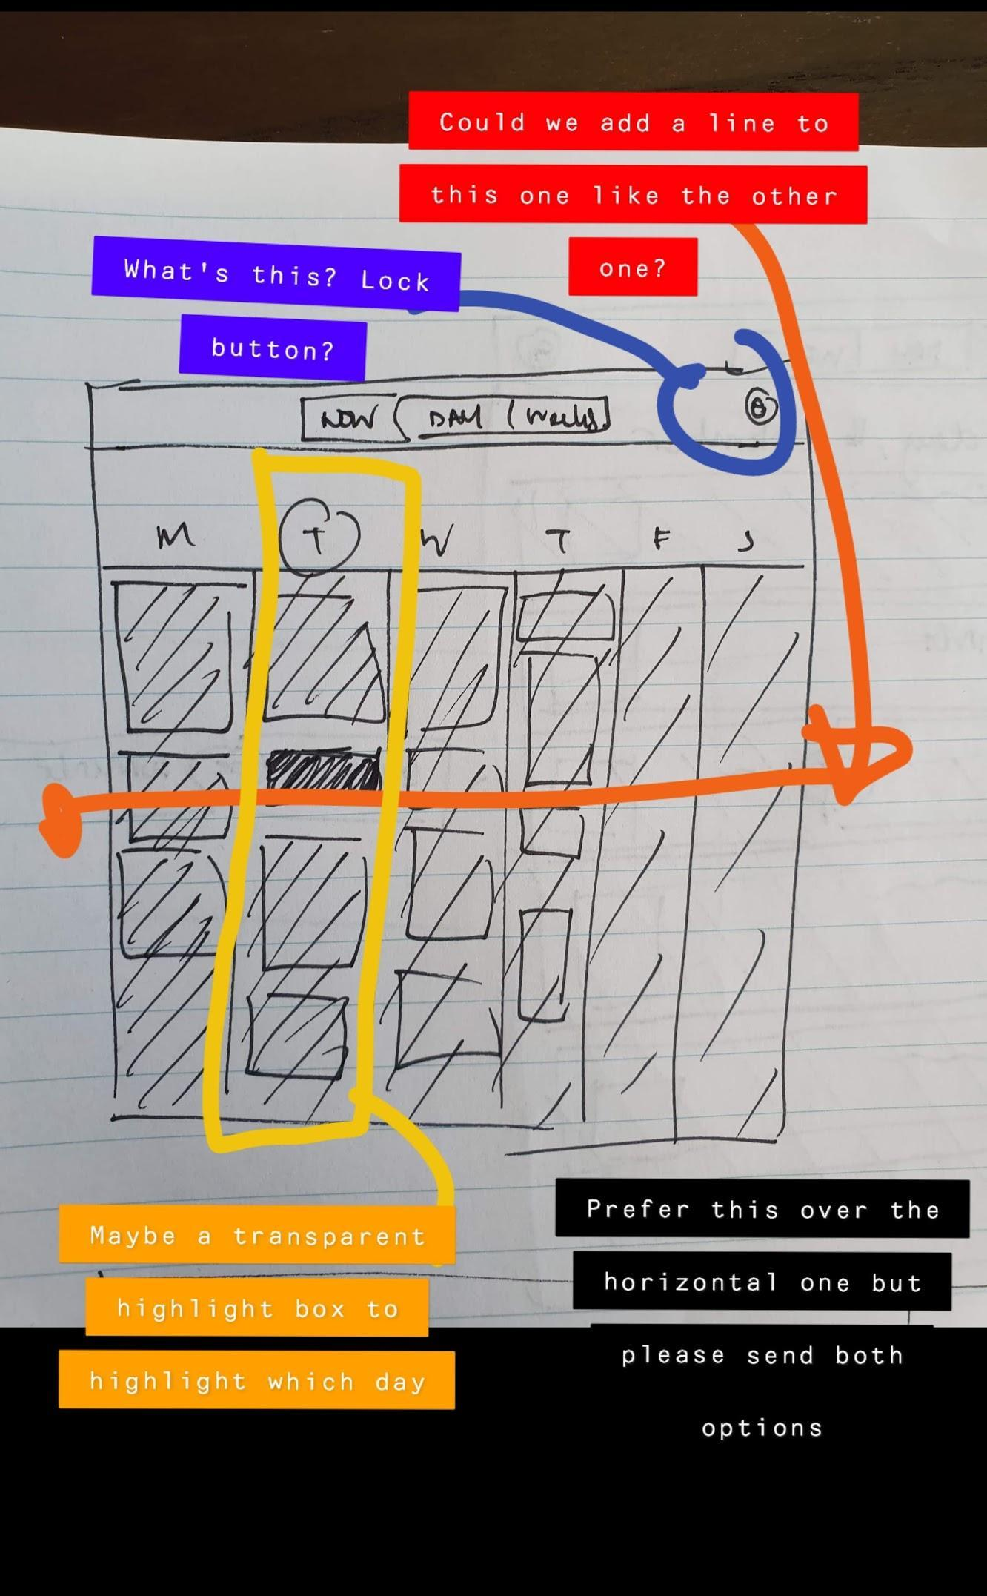
20/11/19 | Meeting 2:  Mockups of designs, colour palettes and feedback  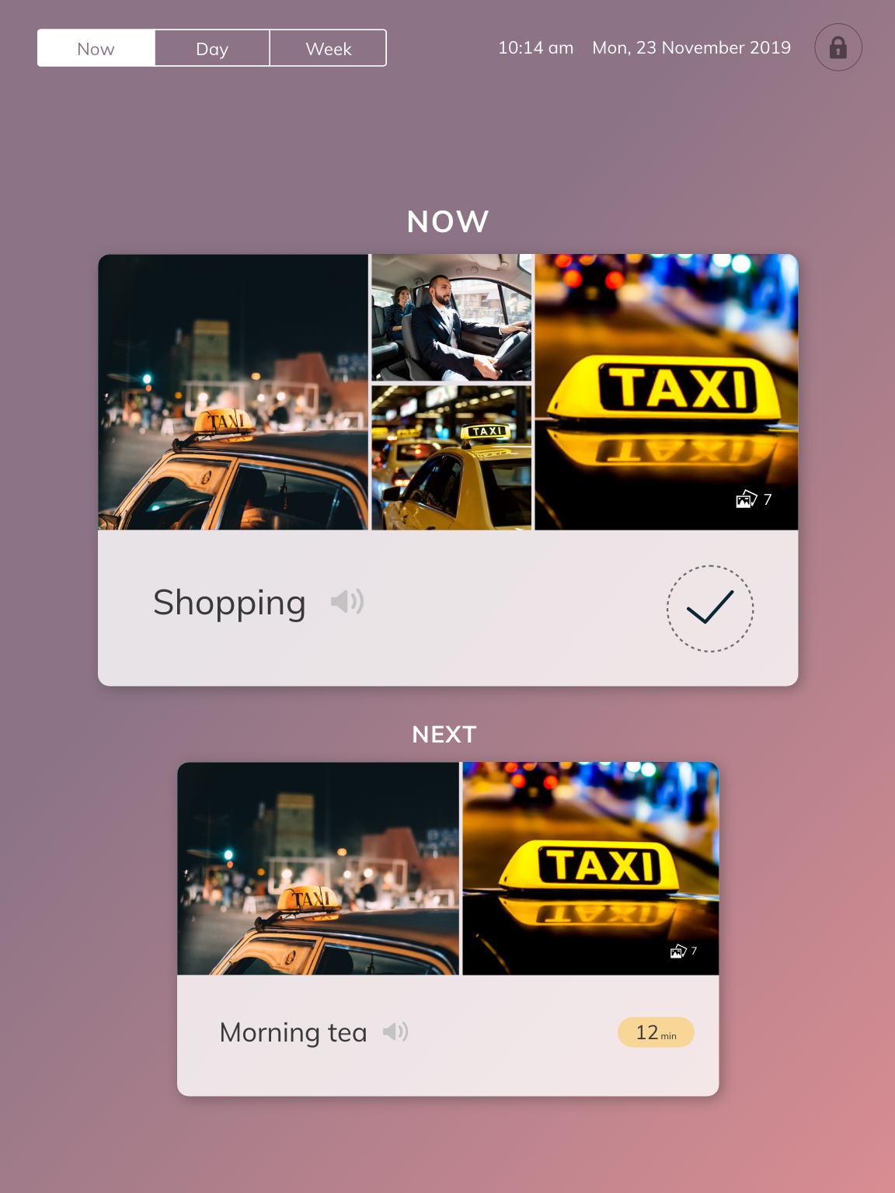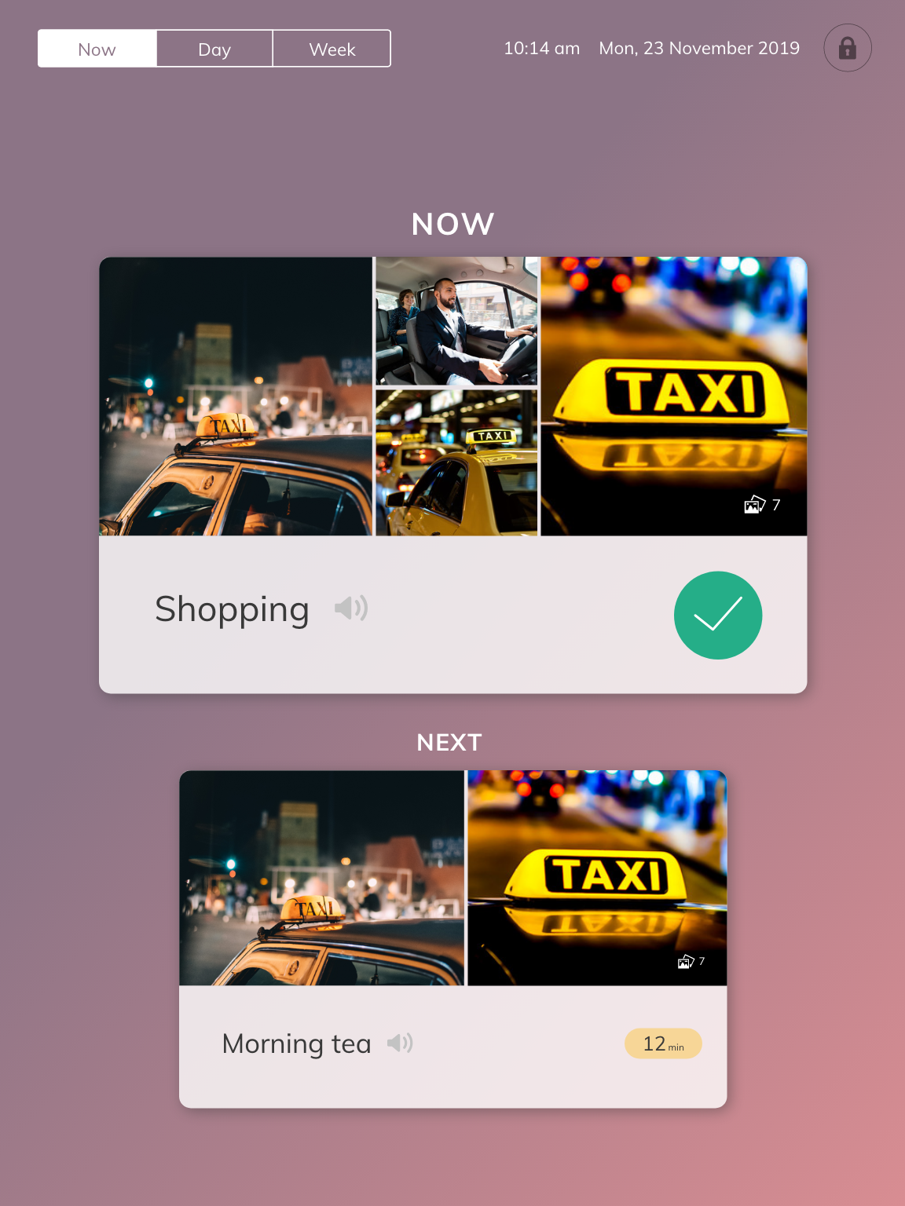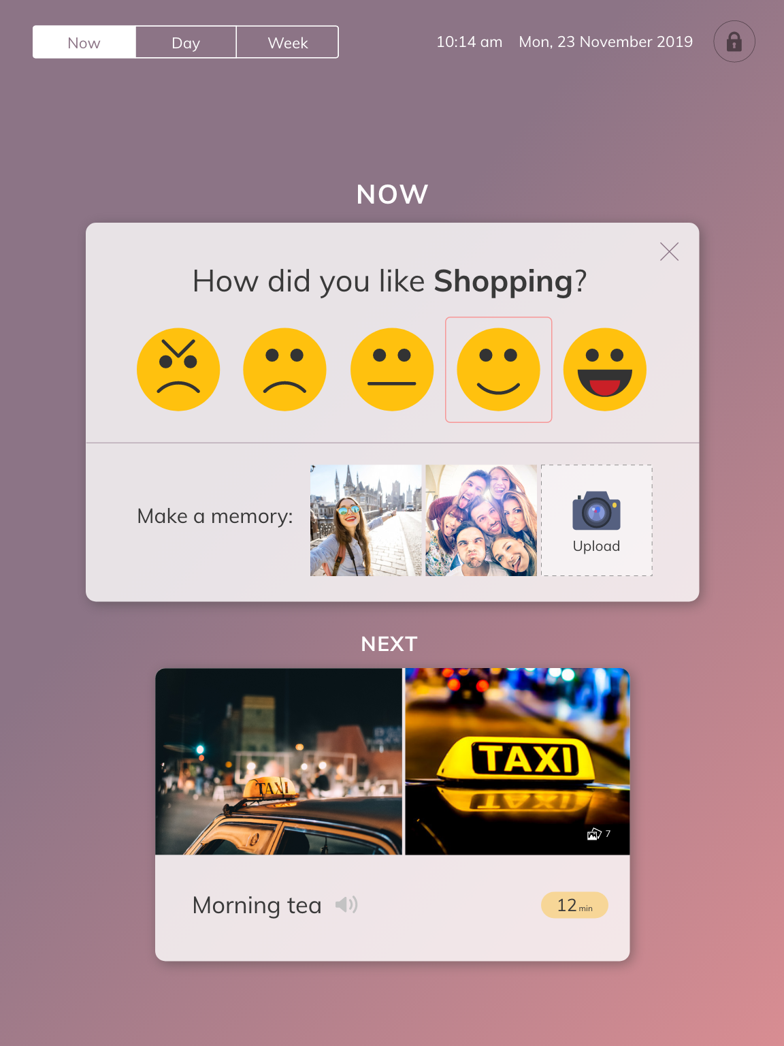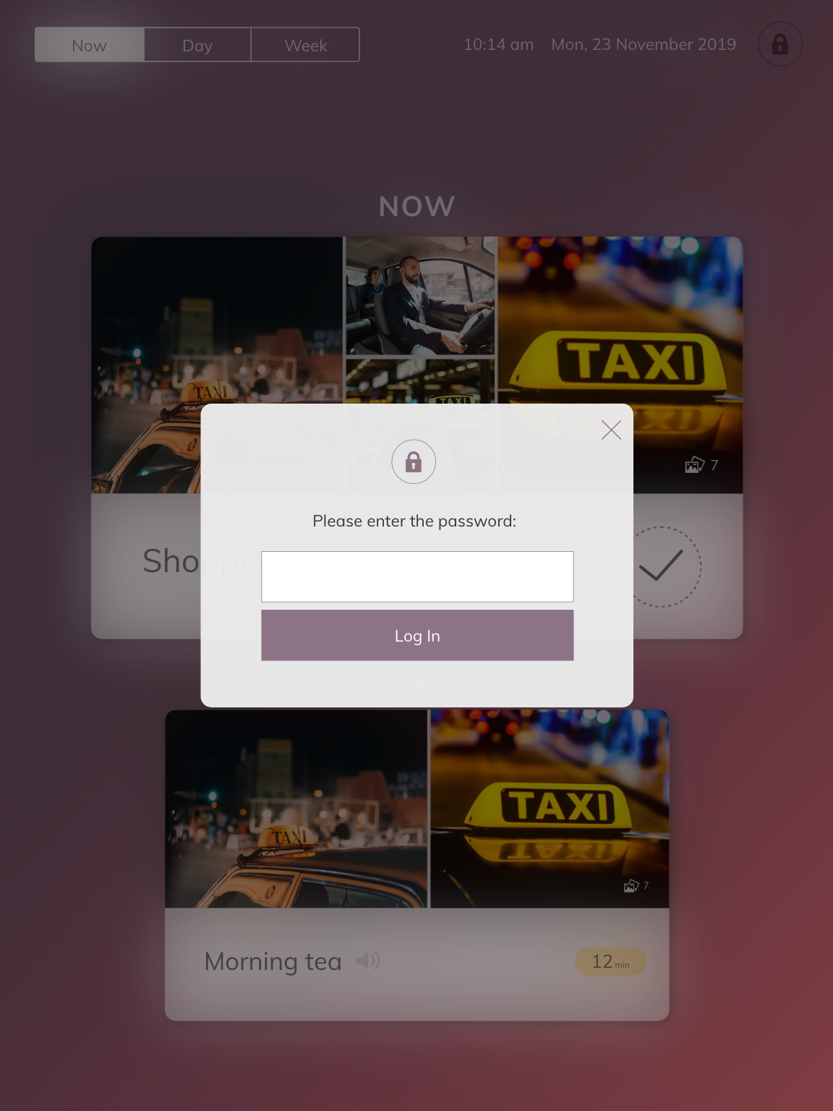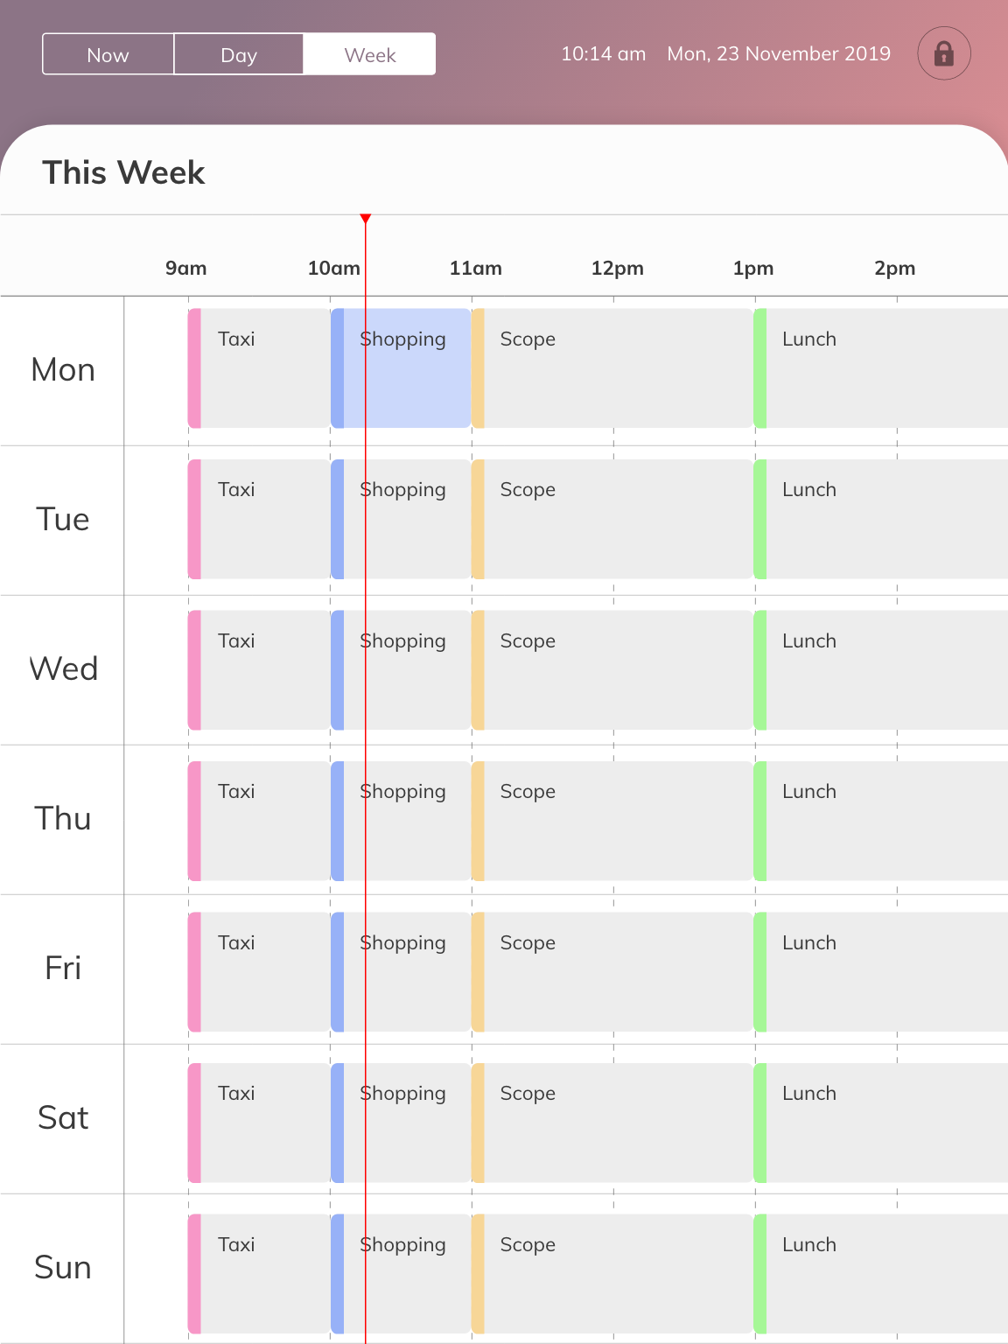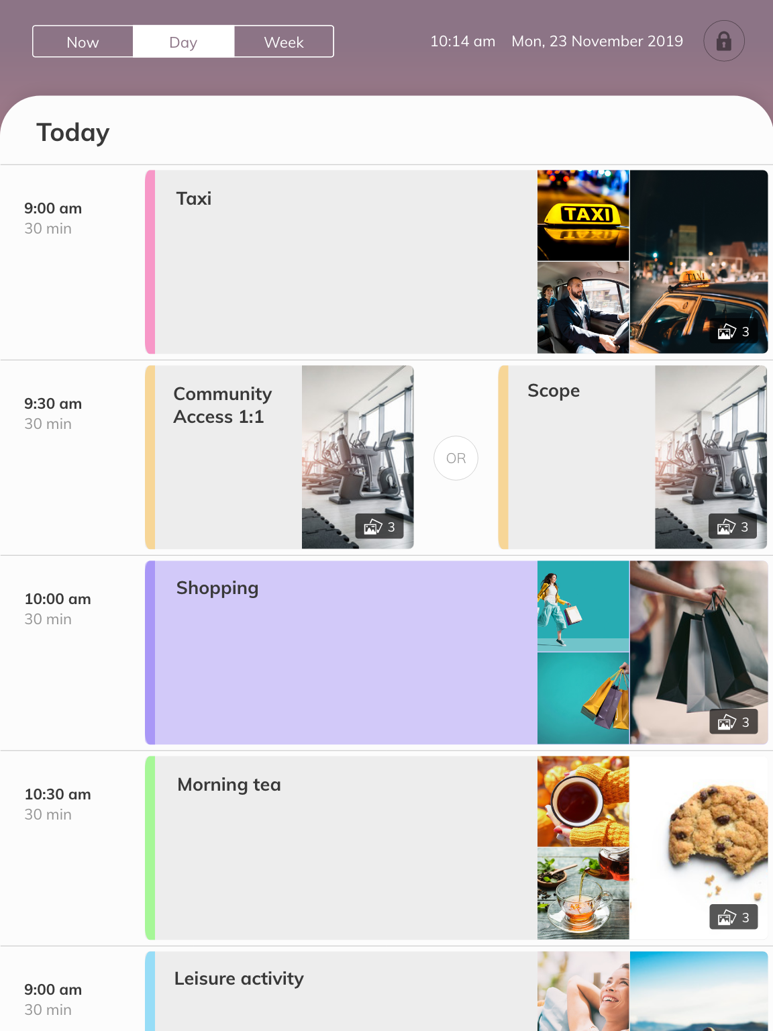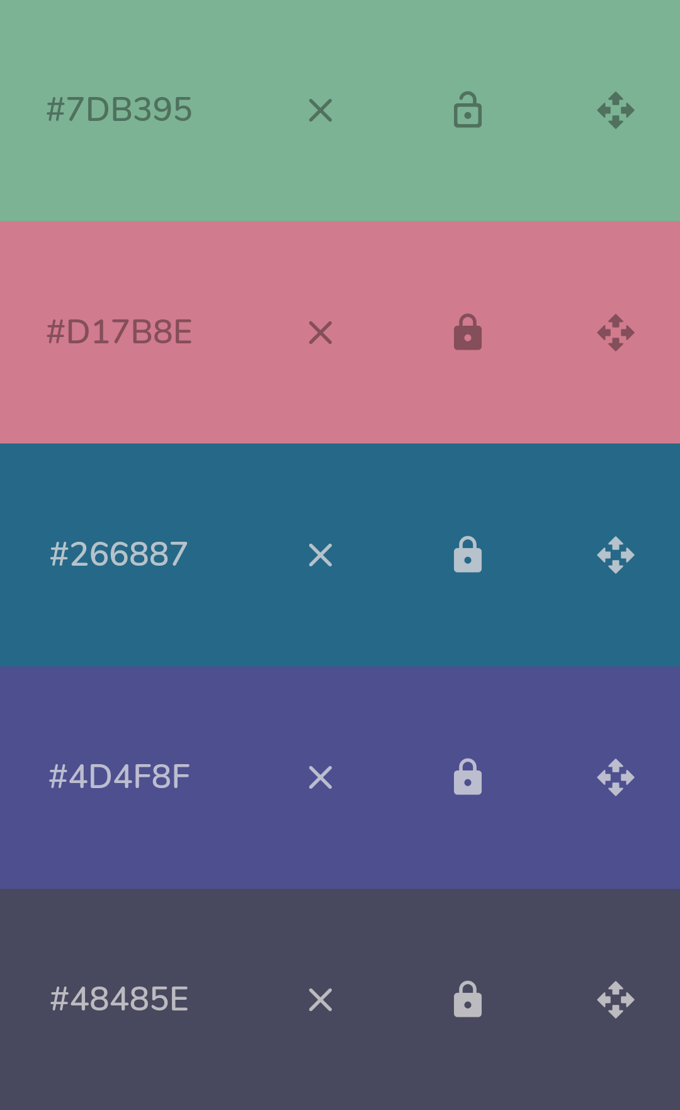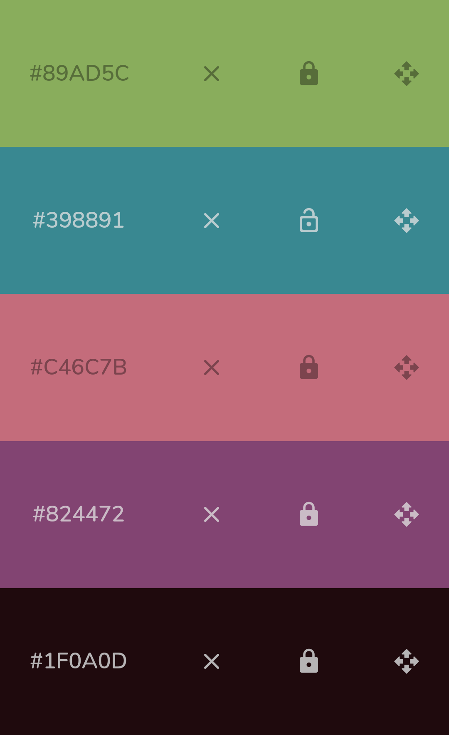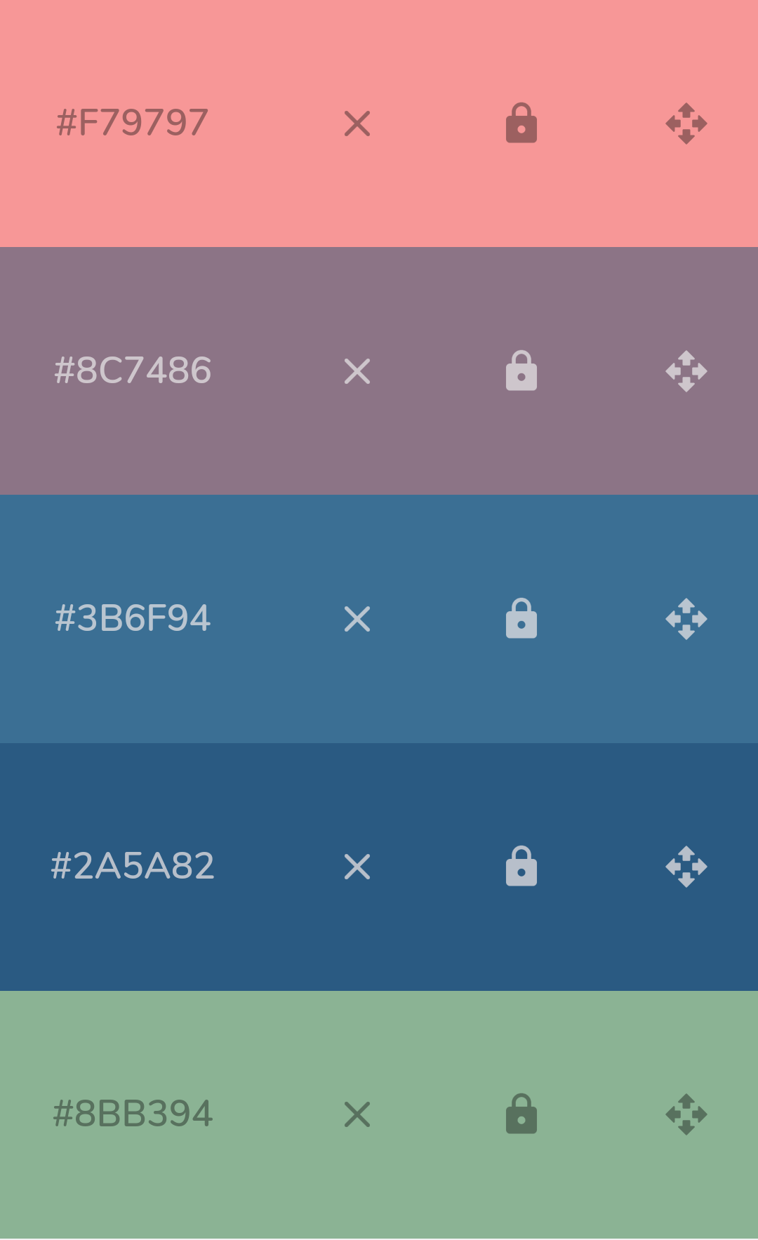  - ‘Zoom in’ on day view to show less activities on one screen  - Use less images for the now-next screen  - Use a plain background  - 3rd colour palette  - Research way to do admin view side (inputting schedule)
18/11/19 | Design Night 2:  Final mockups and designs https://xd.adobe.com/spec/fb31c3c5-a32d-4af0-629a-1598ddf21e85-8d00/  (See ‘Screens’ section)
22/11/19 | Meeting 3:  - Scope of what is possible to have completed by the end of the weekend  - MVP, user stories, features list and prioritisation of features (see Appendix 4. Scope)
23/11/19 - 24/11/19 | TOM: Ballarat Day 1 and 2  - Narrowed down and focused on screens that Natalie will utilise (Now-Next screen, Daily Schedule screen)  - See version 1.1 of this product file for what was completed by the end of 24/11/19

Design Brief Notes
Name: Natalie (Mother: Jennifer, Sister: Tamsin)
Gender: Female
Age: 24
Location: Moe, VIC

Current Equipment:
iPad 5th generation (128GB)
iOS running: 13.2.3

Notes:
- lives in supported accomodation (doesn’t live at home due to family issues)
- can’t read, words help develop the story
- Currently lives at the support house, doesn’t use anything other than going through just a routine that they are doing
- “Comics” shows set routine - good because same as development schools but didn’t flow beyond school
- Has database of photos of Natalie performing tasks -> makes it more real to Natalie
- Has access to ipad (uses app “pictello” suggested by OT)
- House to take photos of task orientated images
- She has access to ipad and use an app program where the speech therapist found which tells her the routine on the activity to take
- Try to broaden her ability to communicate but currently only has some topics she can talk about
- Gives her time to process the next event
- No other Assistive technology except for the ipad
- Habitual, falls into a routine: upsetting for Natalie if she doesn’t stick to her routine: vocal, frustration, anxiety, things in the world aren’t right
- commonly deletes and moves things around (habit of going into calendar and moving things around)
- can be accessed by natalie, support workers, Jennifer
- monthly, daily, ‘first-then’ / ’now-next’

Extra Notes:
- Can’t read social cues or her own cues: another app that expresses how she’s feeling
- Does not have access to phone or other assistive technology
- She needs a cue ->action -> reward routine - to understand that the ipad is what she needs to use
- Best solution for Natalie on the day of the event: to have one trusted person, one voice to calm her and help her 1 on 1. Redirecting her or going to a quiet room to calm down
- Make the world a bit more structured and have a bit more control - have a bit more autonomy
- Can confidently do 1 - 2 activities (get a cup and put on table) - at what point will it be overload of sensory?
- https://ghr.nlm.nih.gov/condition/acrocallosal-syndrome#targetText=Acrocallosal%20syndrome%20is%20a%20rare
- Objective: make nat’s world more structured and reduce anxiety as she doesn’t know what’s coming - helps her to feel more in control, no way of being able to help her control her world
- moving into coping mechanisms for her anxiety.
- Has dogs (golden retrievers), cat called Tiger, Georgie and Yellow: cockatiels
- Word needs to be kept simple
- Triggers: little dogs, high pitch noises

What things make natlie happy?
- She is very social and likes going out spending money and likes buying pyjamas
- Meeting people is her hobby
- She doesn’t like the attention on her, but is sociable

Suggestions:
- Calendar app to talk about what she is going to do or like to do
- Locking an event in place in the calendar
- Lock the calendar (watch the full pictorial before moving into the next section)
- Colour coded
- Playing music as a reward
- Request overload

Jennifer’s Mock Up
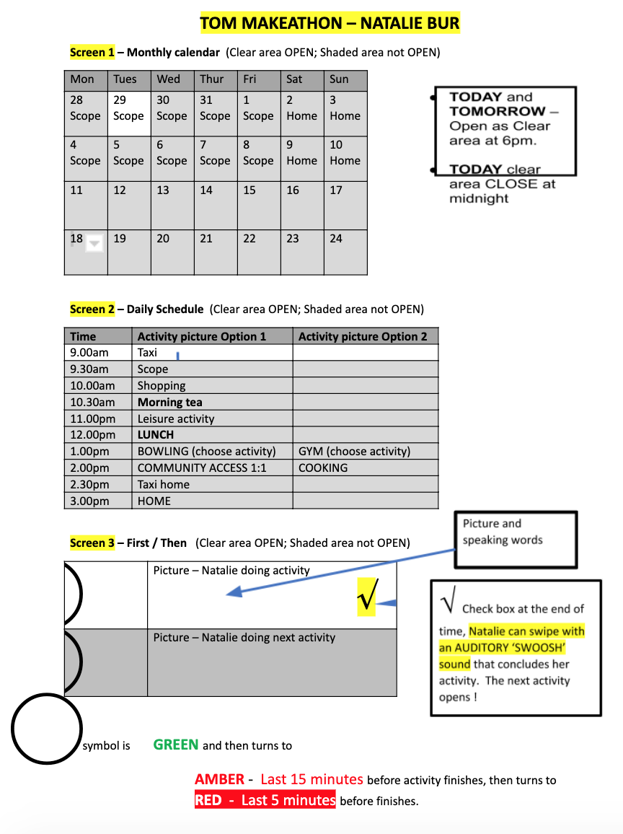

Further Questions
Does Natalie ever stop wanting to do the task in the middle of a task? Hahaha yep! This is part of the purpose of the Calendar App to keep her on task. She is easily distracted and Staff would use the App to bring her back to the task at hand. She attention span is 2-3 minutes. The Day Program co-ordinator stated that she was engaged for a whole 5 minutes when showing other clients or staff the Pictello stories. That would be the longest she has concentrated.

What does Natalie do in that free time if she happens to complete an activity early? She can play games on her iPad or she likes to socialise. She loves pushing the wheelchair clients around and generally being a Mother hen.
Does she ever complete an activity early? I would like to say she is engaged at all times, but we all know that doesn't happen. At times the tasks are boring or she is tired or unwell, and maybe at times she just isn't interested on that particular day. Day Program staff do provide other activity options, that might include going for a walk, doing some craft activity or helping someone with a task, or having lunch early, going to see the Day Program Co-ordinator for a chat. PS she LOVES SHOPPING, especially for PJ's, Handbags, Doona Covers, Chinese Honey chicken and Iced Coffee drinks. Just a few examples.

Does Natalie understand a task is completed or is it guided by someone else? Initially it will be guided by Staff/Carers until she is aware of its purpose and how to complete the task, then she will be capable of being in-charge. (Her favourite past time. She would have been a Teacher or Boss if she didn't have a disability). Anyway, this is an aspect of her life I would like to encourage. After all, she doesn't have much control of anything.

Would Natalie understand/remember to check the box on the iPad app after every task that she completes? Otherwise there might be a build up of tasks which will be confusing. Fair statement. I agree that a build up of tasks would happen. There would be times, however, that being able to be in control would keep her on task. Maybe, after 10 minutes the next task would commence regardless. Only a suggestion.

How often does Natalie's tasks change? Day to day? Weekly? Monthly? Per term? Day program changes every term, but only a few activities, otherwise it would be too distressing. The Scope staff will be able to adjust the Calendar App. They have been proactive when taking photos and developing Pictello stories. The House routine is static. Weekends change weekly due to my availability, her Dad's health and when we can have her home. So Weekends aren't as structured.

Does the workers have access to the iPad? Yes both the House staff and Day program staff have access to the iPad. How often do they check the iPad? Very good question! Scope regularly check and add Pictello stories, but the House less so. This App will assist the House with behaviours when it’s used, so it will become daily.

What is Natalie's favourite colours: Pink, Green, Purple, Blue, Black and songs? Toto (song: Africa); ABBA (anything); Queen (Bohemian Rhapsody); 80's music.

Routines and Schedules
