_____________________________________________

Build Instructions: Wheelchair Table

Custom wheelchair folding table

Developed by: Scott Wallace, Kristina Markovic, Joshua Faraday, Jenny Robinson, Alistair Jones, Adrian Marcon, Andrea McIntyre, Damien Cameron (Makers) and Rebecca Lee Cleveland (Need-Knower)
_________________________________________________________________________

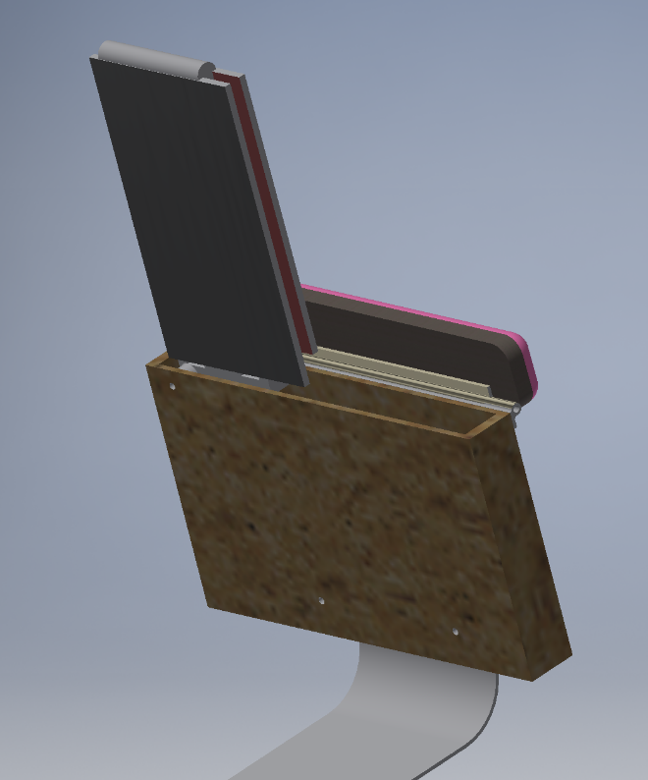

Approximate Cost: $200 (with 3D printed joints) Time Required: in 72 Hours (3Days)

General Warnings and Cautions
- Read through entire manual before attempting to build this device.
- Do not attempt a step if you are unsure of what you are doing. Certain steps in this manual require experience with fabrication tools. <<General Warning>>.
  - For assistance or clarification of any step, contact Scott Wallace.

User Assistance
For any questions regarding the assembly, operation or specifications of this device, please contact: Scott Wallace

Icon Glossary
The following icons may be used throughout this manual—each with its own purpose.
- Caution: The caution icon is used to signify whenever someone attempting the procedure may injure themselves or damage their equipment.
- Note: The note icon is used to signify useful bits of information that complement the instructions.
- Reminder: The reminder icon is used to provide information for after the procedure is completed, such as tips for disassembly.
- Need-Knower Specific: This part or method of manufacture has been designed specifically for a local Need-Knower.

Need-Knower Background:
Our need-knower Rebecca, a 66 year-old lady, uses a power wheelchair and has a non-functional right arm after suffering from a stroke. Her challenge is to create more independence, so she can read books and hold items such as plates and drinks.

Purpose of Device:

Rebecca is seeking an aesthetically pleasing tray solution that folds underneath her left arm that can open and be positioned at different angles depending on its use.

Physical Description:
Wheelchair table
- Base (which allows the user to transfer the device to a park bench for example)
- Box (for the table to provide environmental protection and a place to secure the armrest)
- Fold out table (including hinging mechanisms for the foldout action and the expanding table joint)
- Padded arm rest
- Extras (Coffee cup holder)

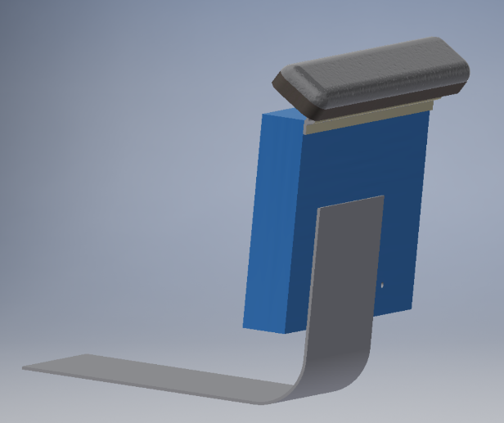

History of Development:
This project began at the 2019 TOM: Melbourne Makeathon. May 24th, 2019 for assistive technology organised by Tikkun Olam Makers Melbourne. The challenge was to allow Rebecca Lee Cleveland have a folding table that allowed her to read a book, write, hold a cup, etc. The table Future iterations will work to improve the comfort and usability of the device

Bill of Materials https://drive.google.com/drive/folders/1QB7NwitZHuZj9_Px2afHUiyw2A55x1hR

Part ID | Part Name | Description | Qty | Units | Supplier | Unit Cost | Cost
A | Base | Seat base / Table box support (Aluminium 600mm x 300mm) | 1.00 |  | Aluminium Trade Centre | $ 12.00 | $ 12.00
B | Box | Used to stow away the table made from Plywood (12mm) 374mm x 1000mm (1 x Sheet 12mm Ply (1220 x 610mm @ $39.70)) | 0.50 |  | Bunnings | $ 39.70 | $ 19.85
 |  | Screws (6G x 20mm) pkt | 1.00 |  | Bunnings | $ 3.98 | $ 3.98
C | Main Hinge | Multi axis hinge parts (x 4 see designs) PLA (~200g) | 0.20 |  | 3D Printed (STL Files) | $ 90.00 | $ 18.00
 |  | Bolt and Nut (M6 x 150mm) x 1 | 1.00 |  | Bunnings | $ 1.17 | $ 1.17
 |  | Bolt and Nut (M6 x 80mm) pkt of 4 | 0.74 |  | Bunnings | $ 3.15 | $ 2.33
D | Arm rest | Arm support Plywood (12mm) 500mm x 100mm | 0.05 |  | Bunnings | $ 39.70 | $ 1.99
 |  | Foam (Peeled) 12mm x 910mm (min purchase 0.5m) | 0.33 |  | Clark Rubber | $ 6.98 | $ 2.30
 |  | Vinyl | 1.00 |  | Clark Rubber |  | $ -
 |  | Staples (6mm) x ~50 | 1.00 |  |  | $ 4.90 | $ 4.90
 |  | Hinge continuous (fixed pin) 305mm | 1.00 |  | Bunnings | $ 6.20 | $ 6.20
 | Decorative | Glue (Contact Adhesive) | 1.00 |  | Bunnings | $ 14.49 | $ 14.49
 |  | Vinyl (Deep Blue) | 0.50 |  | Clark Rubber | $ 18.95 | $ 9.48
E | Table | Expanding table to reduce overall size when stored Plywood (12mm) 600mm x 220mm | 0.20 |  |  | $ 39.70 | $ 7.94
F | Table Hinge | Table hinge lock aluminium (6mm) 300mm x 30mm | 1.00 |  | Aluminium Trade Centre | $ 5.00 | $ 5.00
 |  | Leather (Hinges) 50mm x 720mm | 0.10 |  | Tandy Leather | $ 36.00 | $ 3.60
 |  | Springs (hobby) | 2.00 |  | Jaycar | $ 0.50 | $ 1.00
 |  | T-Slot Linear Rails | 1.00 |  | Carbatec | $ 1.00 | $ 14.00
 |  | ST. STEEL BUTTON HEAD HEX SCREW (M3 x 12mm) Pkt | 1.00 |  | The Fastener Factory | $ 5.00 | $ 5.00
 |  | ST. STEEL BUTTON HEAD HEX SCREW (M3 x 16mm) Pkt | 1.00 |  | The Fastener Factory | $ 6.00 | $ 6.00
 |  | Braces (3mm aluminium) Offcuts ~100mm x 100mm from sheet above | 1.00 |  | Bunnings | $ 1.00 | $ 1.00
 |  | Pop Rivets pkt 3.2 x 12.7mm (100pcs) | 0.20 |  |  | $ 5.88 | $ 1.18
G | Cup Holder | 3D printed or acrylic fold away cup holder (PLA) | 1.00 |  |  | $ 4.00 | $ 4.00
 |  |  |  |  |  |  | $ -
 | Misc | Glue (Araldite) | 1.00 |  | Bunnings | $ 10.79 | $ 10.79
 |  | Leather Glue shoefix (50ml) | 1.00 |  | Bunnings | $ 6.95 | $ 6.95
 |  |  |  |  |  |  | $ -
 |  | Paint (500ml tin) | 1.00 |  | Bunnings | $ 14.00 | $ 14.00
 |  | Paint Brush | 1.00 |  | Bunnings | $ 2.37 | $ 2.37
 |  |  |  |  |  | TOTAL | $ 179.51

NOTE:

Tools Required:
Wood working  - Saw  - Drill  - Trimmer  - Table Router  - Table Saw | Metal working  - Angle Grinder / Saw  - Jewelers Saw  - Drill  - Tap (M5)  - File | Leather working  - Leather shaver  - Edge Beveller  - Punches  - Awl
Other  - 3D printer  - Pop Riveter  - Drill bits for screws | - Sandpaper  - Allen / Hex Keys  - Screwdrivers | - Shifter  - Socket Set

Parts Inventory (Assembly):

Part No. | Part Name | Description | Qty | Units
A | Base | Seat base / Table box support | 1
B | Box | Used to stow away the table | 1
C | Main Hinge | Multi axis hinge to allow for easy table removal | 2
D | Arm rest | Arm support | 1
E | Table | Expanding table to reduce overall size when stored | 1
F | Table Hinge | Folding table hinge mechanism | 1
G | Cup Holder | Fold away cup holder for the table | 1

Assembly drawing with parts numbers:

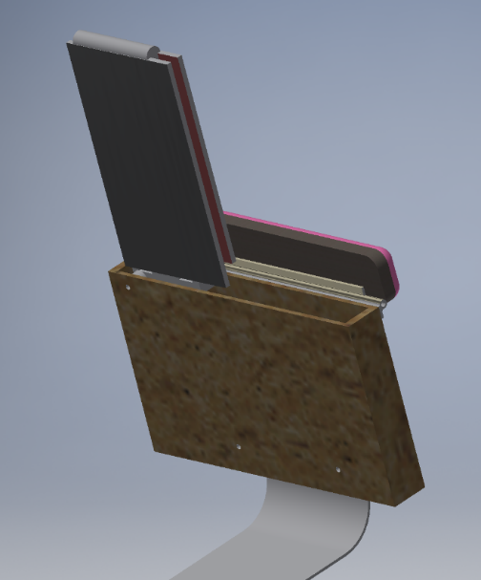
A
B
F – See Assembly Instructions
C
E
D

The new arm rest contains the folding table under a hinged armrest.
      - Flip the armrest to expose the table
      - Using the handle / grip the table and pull upward
      - Fold the table flat toward the centre of the wheelchair
      - Flip the second part of the table over and rest on the second arm of the wheelchair.

Part No. | Part Name
A | Base
B | Box
C | Main Hinge (not shown - inside the box)
D | Arm rest
E | Table and Mechanism
F | Cup Holder (Not Shown)

Assembly

Step 1: Base (A)
Parts and Tools Used in this Step:
- Part A (x1)
- Angle Grinder
- Drill

- Cut base to desired length
- Need final Length (If changed) and bolt hole locations
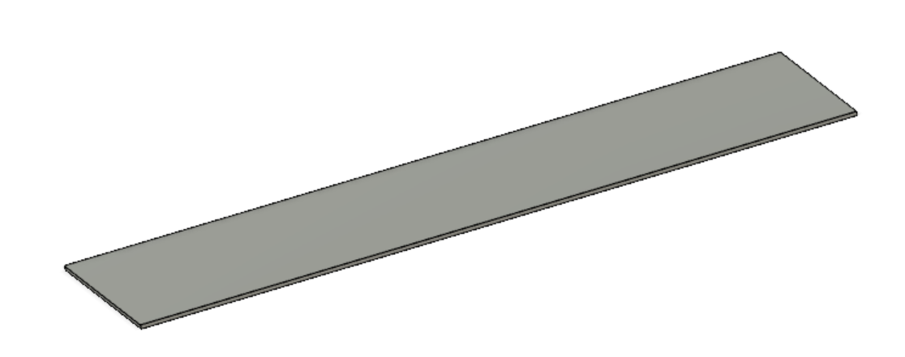

NOTE: The base can be adjusted to suit the user / wheelchair. With our design the base plate design was 520mm x 200mm for the box (armrest with table) attachment.
The box should be screwed into the base plate as per the user’s requirements

- Link: Drawing

- Caution: The caution icon is used to signify whenever someone attempting the procedure may injure themselves or damage their equipment.
- Need-Knower Specific: This part or method of manufacture has been designed specifically for a local Need-Knower.

Step 2: Box (B) Requires drawings and instructions check
Parts and Tools Used in this Step:
- Drill
- Table Saw
- Screwdriver

Box
Tools and equipment
- 12mm marine ply
- Glue
- Screws

Instructions
- Cut timber pieces (see drawing)12mm marine ply
- Glue and screw together (3 screws per edge per side)

- Link: Drawing

- Caution: The caution icon is used to signify whenever someone attempting the procedure may injure themselves or damage their equipment.
- Need-Knower Specific: This part or method of manufacture has been designed specifically for a local Need-Knower.

Step 3: Main Hinge (folding table) (C)
Parts and Tools Used in this Step:
- 3D Printer
- Screwdriver, shifter, socket set

- Main Hinge Assembly
- Print parts (A, B, C, D)
- Sandwich Part C between Part A and B noting orientation.
- Locate Part D into Part C noting orientation and secure with Bolt G (150mm M6 and nut Part F)
- Bolts (Part E) (Size required) and Nuts (Part F) are used to secure the assembly inside the box.

A
B
C
D
E
F
F
G
- Link: Engineering Drawing
- Link STL files

- Caution: The caution icon is used to signify whenever someone attempting the procedure may injure themselves or damage their equipment.
- Note: The note icon is used to signify useful bits of information that complement the instructions.
- Reminder: The reminder icon is used to provide information for after the procedure is completed, such as tips for disassembly.
- Need-Knower Specific: This part or method of manufacture has been designed specifically for a local Need-Knower.

Step 3B: Main Hinge and Box Assemblies complete
NOTE: The rails of the Main Hinge will slide onto the linear rail in the Table (Step 5)

Step 4: Arm Rest (D)
Parts and Tools Used in this Step:
- Saw
- Staple Gun
- Glue

- Arm rest
- Cut arm rest to suit the length of the box. In this case our arm rest is 600mm x 100mm with radius edges (20mm)
- Attach the foam with glue. Thickness dependent on the user
- Wrap the assembly with vinyl (trimmed to shape) and staple underneath into the wood (~10-20mm from the edge of the wood.

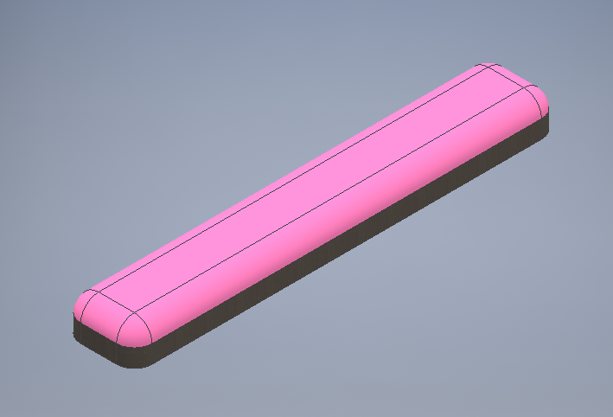

- Link: Arm rest base (Fusion 360 File)

- Caution: The caution icon is used to signify whenever someone attempting the procedure may injure themselves or damage their equipment.
- Need-Knower Specific: This part or method of manufacture has been designed specifically for a local Need-Knower.

Step 5: Table and Hinge Mechanism (E)
Parts and Tools Used in this Step:
- Part A (x1)
- Angle Grinder
- Drill

Step Description (Detailed Instructions HERE)
Link to all drawing files for detailed measurements located here.
Parts and tools
∙Printer
∙Marking pen
∙Band saw
∙File
∙Drill 4mm
∙M5 tap

Instructions
∙Print drawing scaled 1:1
∙Trace sketch onto aluminium bar and mark lines and holes
∙Band saw
∙File edges
∙Drill and tap holes

Spring mechanism
∙Attach spring to cut out holes on cross section
∙Attach to low profile screw with washer hex bolt, spring closed by nut.

Cover for spring
∙Print 3D cover
∙Screw 3D printed cover over spring mechanism. 4 screws

Leather loop
Attach loop of leather by glue and needle and thread. Other options like screws, rivets, etc depending on time etc to countersink potential protrusion risks.
Trim leather using leather shaver
Parts and tools
∙Leather strap
∙Leather shaver
∙Leather glue
∙Needle and thread
∙Bevell
∙Leather stamp and punch

Instructions
∙Trim end 30mm by half thickness and loop.
∙Glue end 30mm to make loop
∙Drill hole in loop and screw through slider bar
∙Table top

Tools and equipment

Instructions
∙Cut 2 table top pieces
∙Router slots as per plan on top and bottom

Leather hinge
Tools and equipment
∙Knife
∙Bevelle tool
∙Edge smoother
∙Gouged
∙Leather shaver
∙Contact adhesive
∙Pop rivet gun and 16 pop rivets

Instructions
∙Cut length to fit recess
∙Bevelle edges
∙Seal edges
∙Gouge Centre line on back of leather and v cut
∙Shave to thin to thickness of router
∙Glue to table top (clamp) to dry
∙Rivet each piece x 4

Cup holder
∙Tools and equipment
∙3D printed cup holder
∙Screw and nut

Instructions
∙Print cup holder
∙Fix using bolt to underside of table

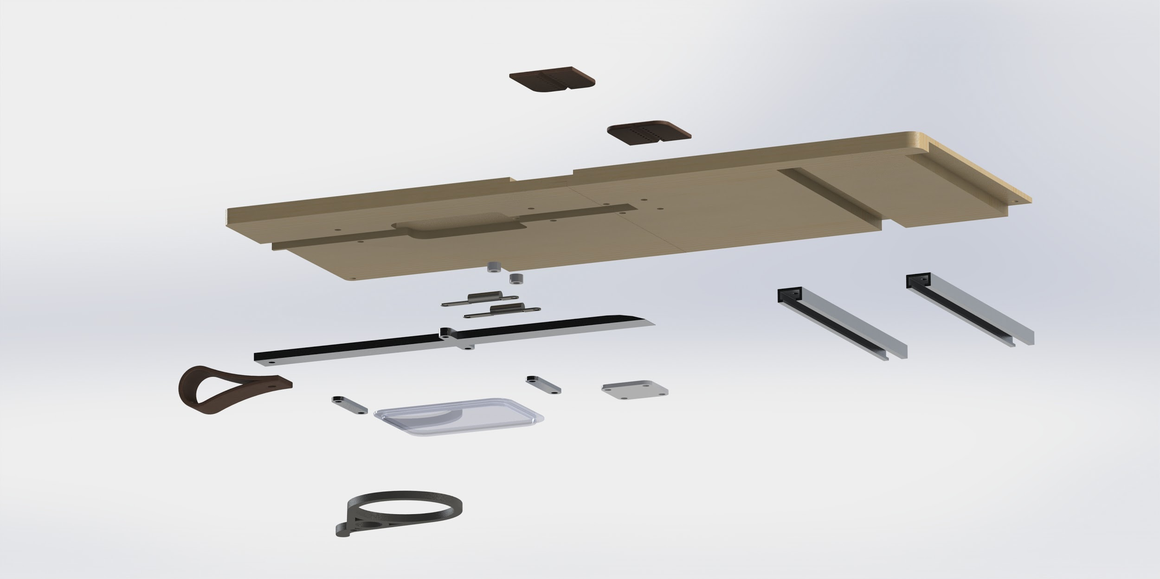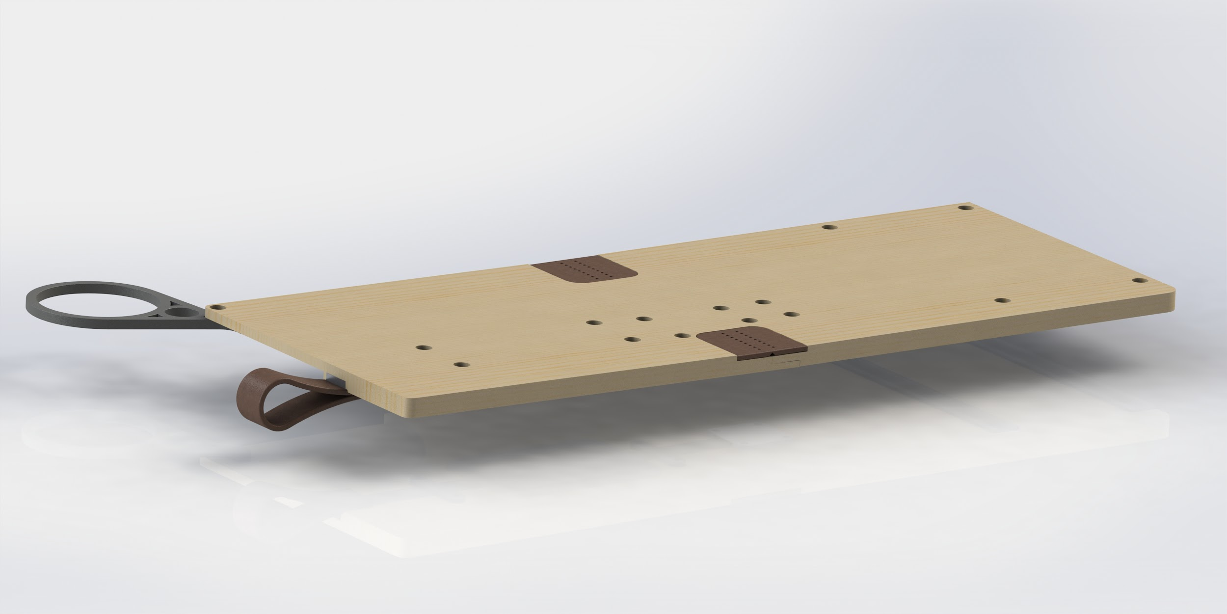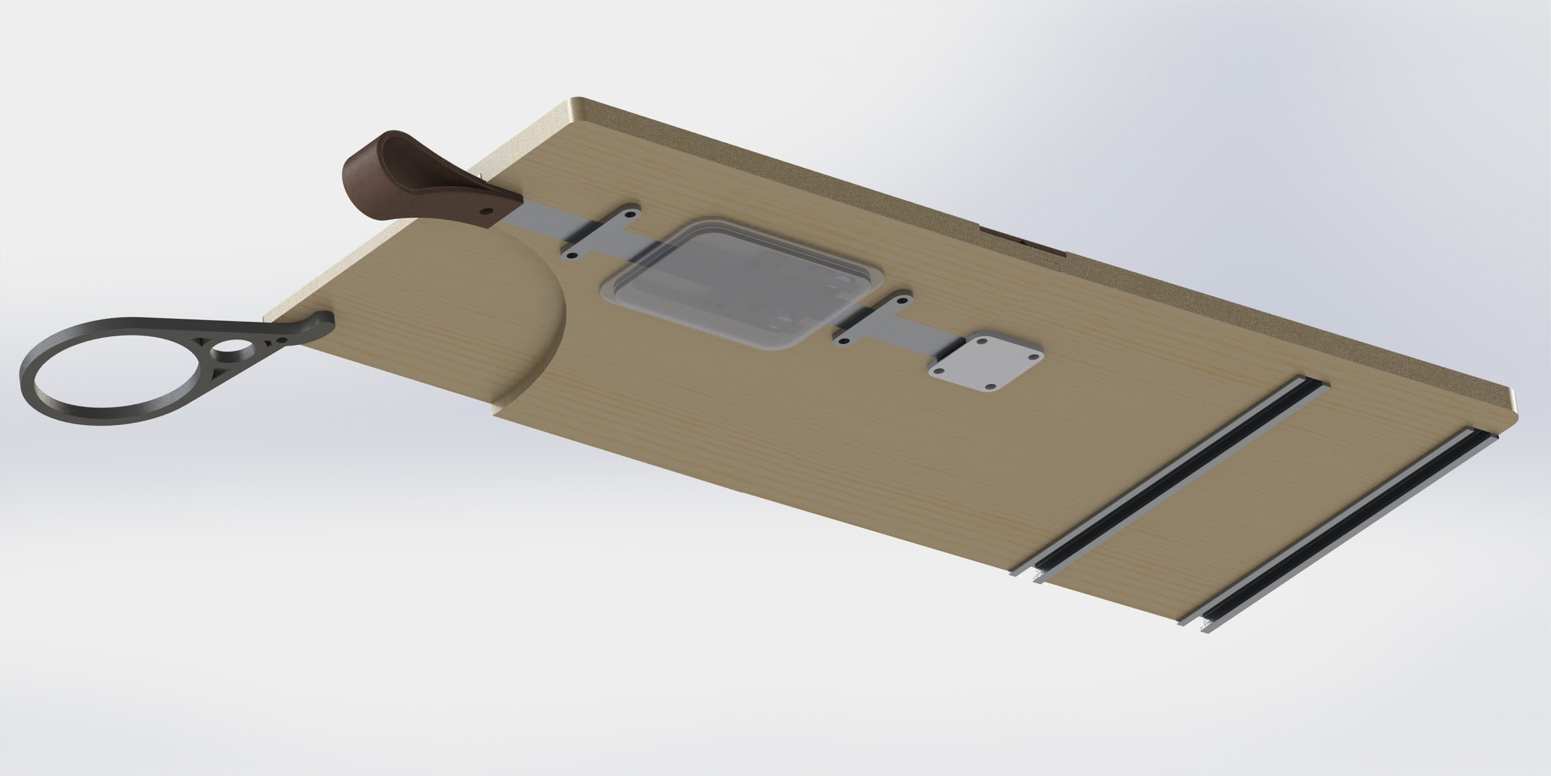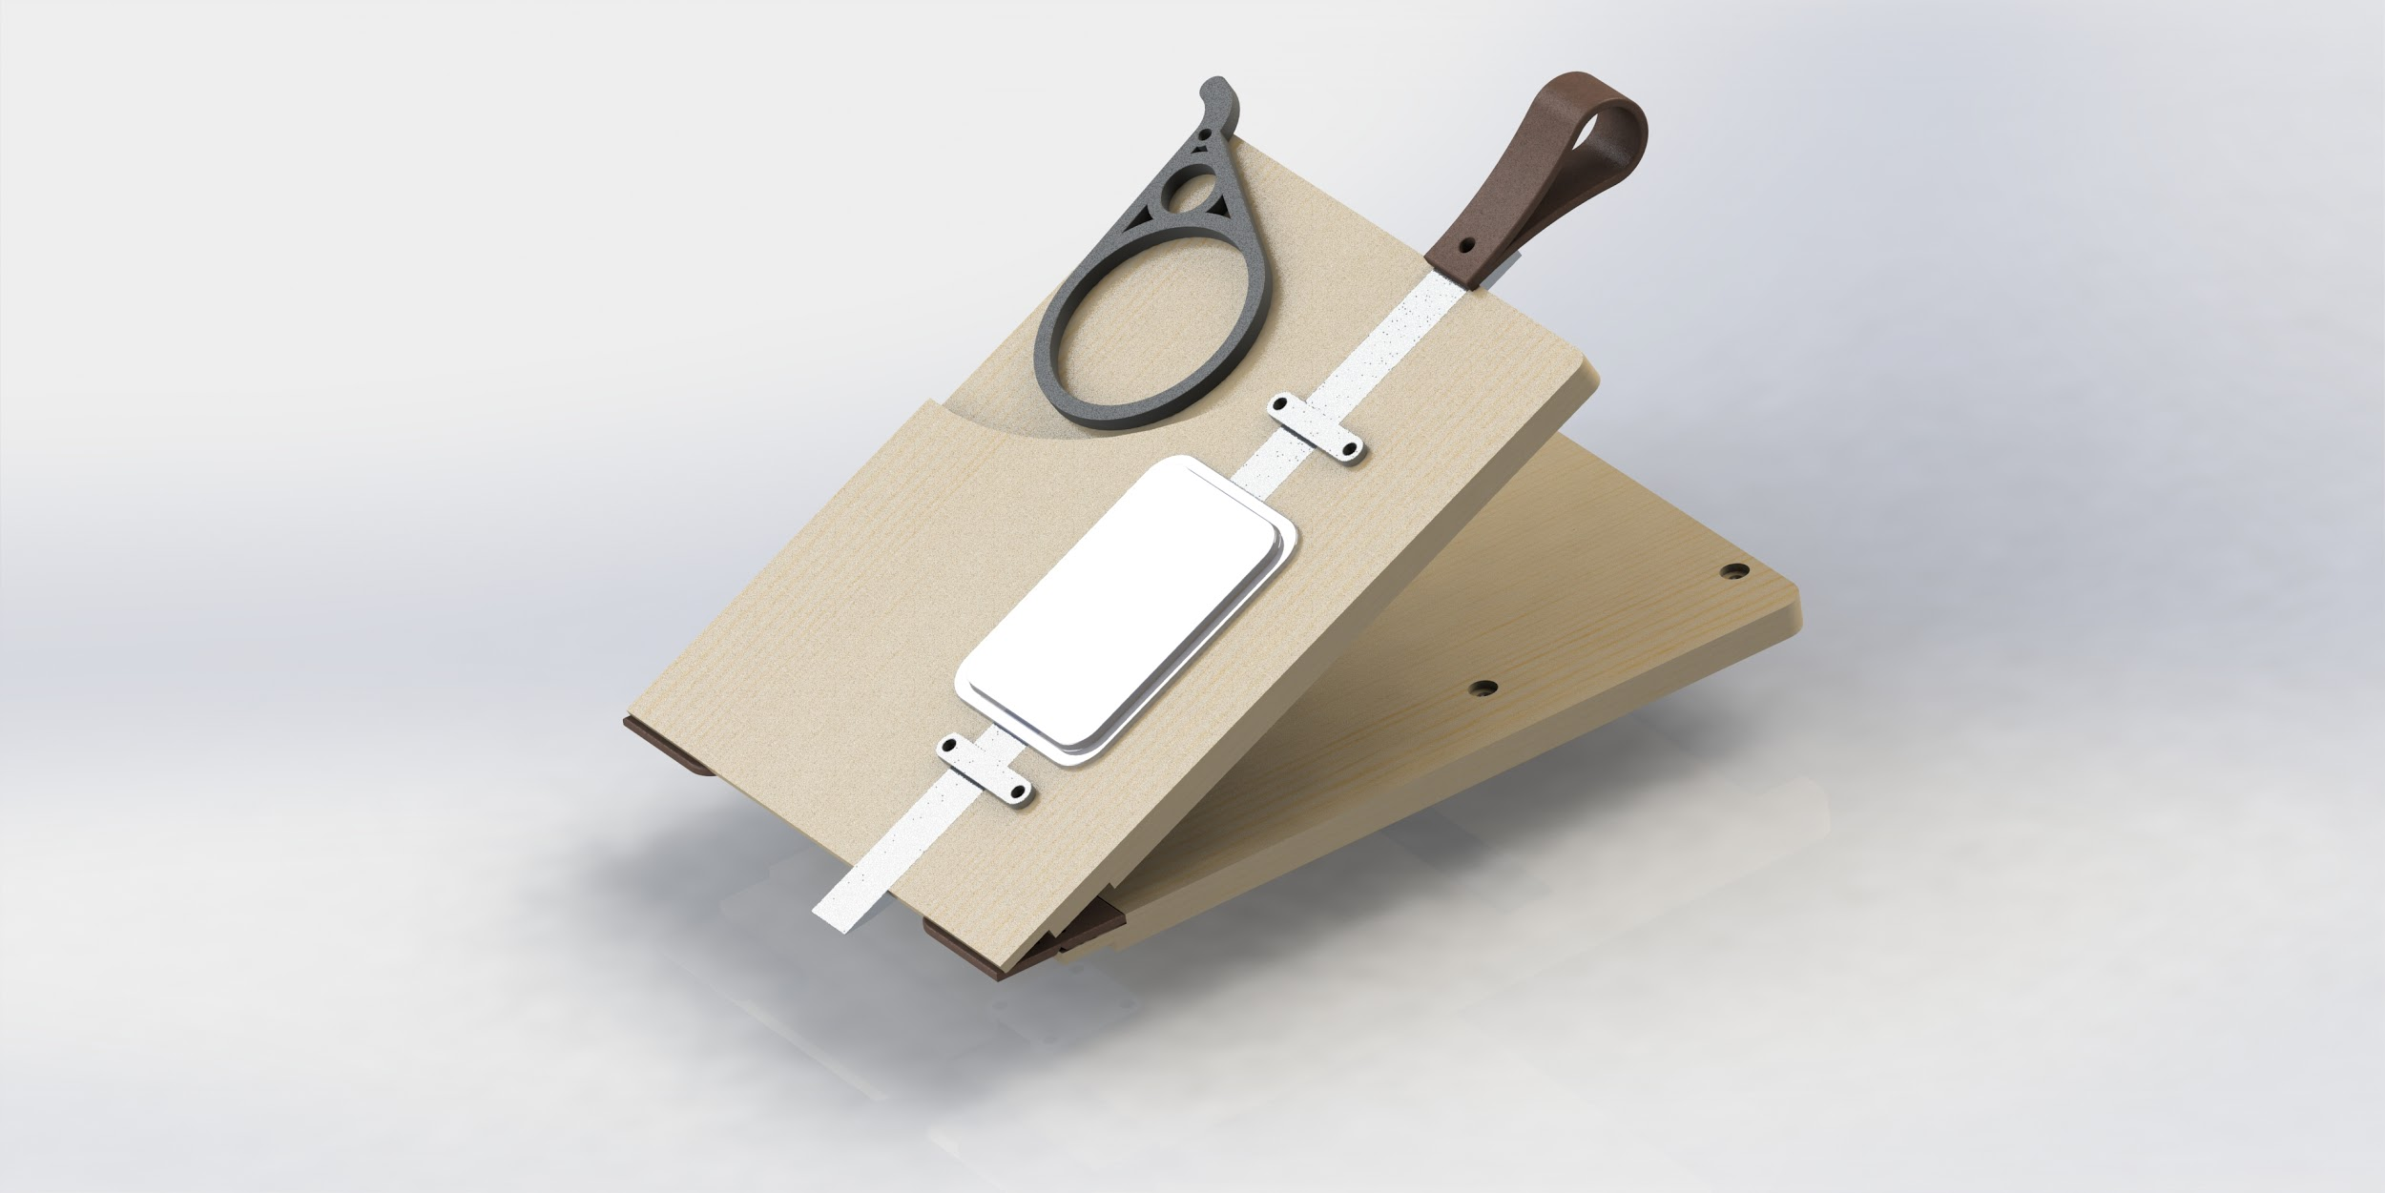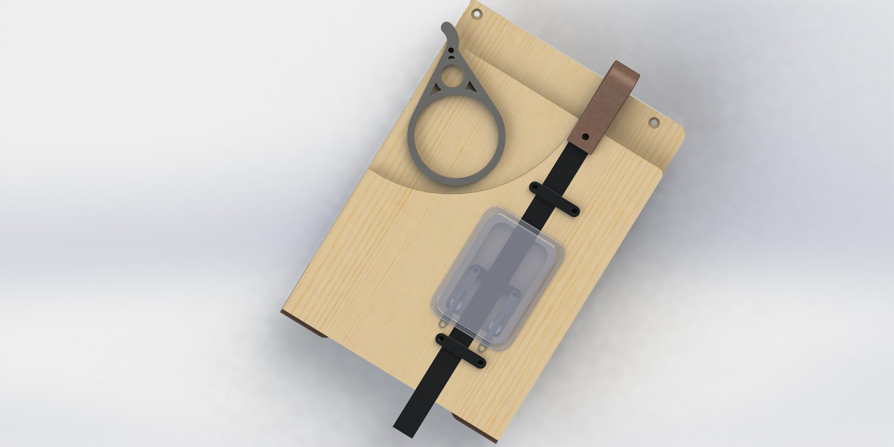
- Link: Files and Drawings

- Caution: The caution icon is used to signify whenever someone attempting the procedure may injure themselves or damage their equipment.
- Note: The note icon is used to signify useful bits of information that complement the instructions.
- Reminder: The reminder icon is used to provide information for after the procedure is completed, such as tips for disassembly.
- Need-Knower Specific: This part or method of manufacture has been designed specifically for a local Need-Knower.

Step 6: Cup Holder (F)
Parts and Tools Used in this Step:
- 3D Printer
- Screwdriver for installation into the table (See Drawing)

- Print the cup holder and install as per the Table Drawings (link above)

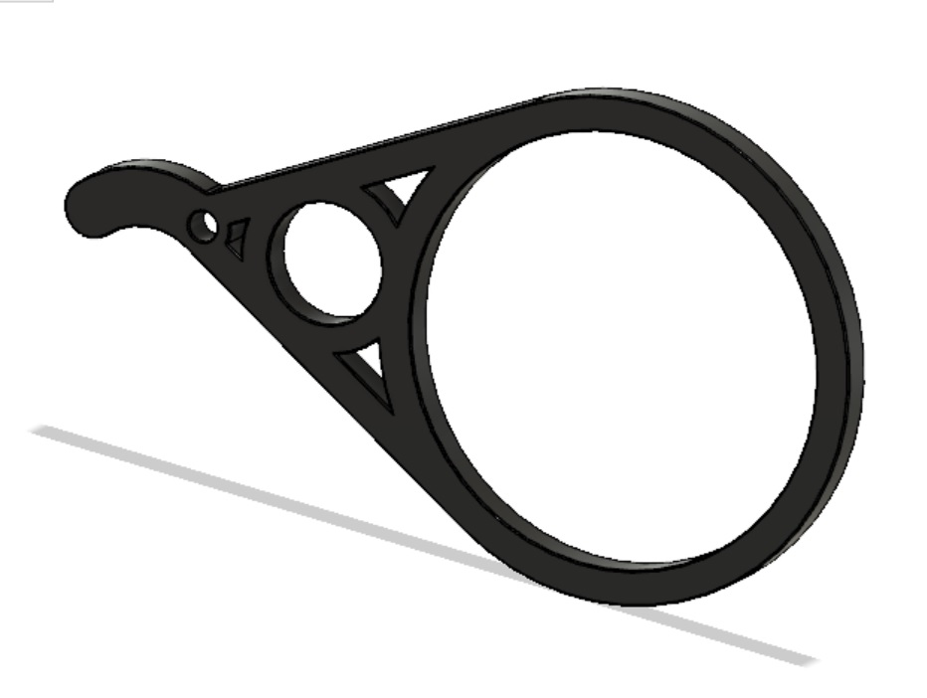
- Link: STL FIle

- Caution: The caution icon is used to signify whenever someone attempting the procedure may injure themselves or damage their equipment.
- Note: The note icon is used to signify useful bits of information that complement the instructions.
- Reminder: The reminder icon is used to provide information for after the procedure is completed, such as tips for disassembly.
- Need-Knower Specific: This part or method of manufacture has been designed specifically for a local Need-Knower.

